Escuela Normal de Preescolar

B1.2 Becoming Independent Learners

UNIT 11 “RITES OF PASSAGE”

WRITING TASK

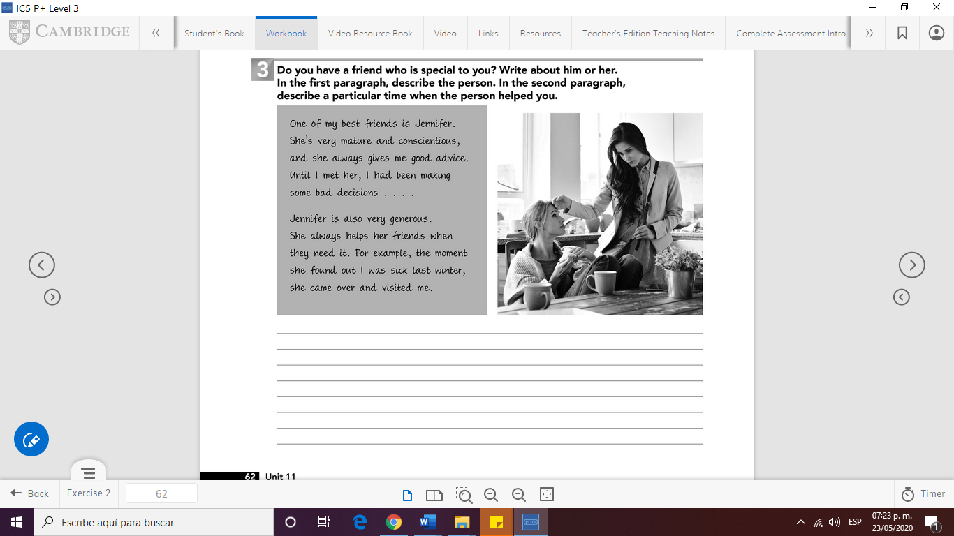

WRITE YOUR PARAGRAPH HERE (150 WORDS)

________________________________________________________________________________________________________________________________________________________________________________________________________________________________________________________________________________________________________________________________________________________________________________________________________________________________________________________________________________________________________________________________________________________________________________