**ESCUELA NORMAL DE EDUCACIÓN PREESCOLAR**

**ENGLISH A1.2 DEVELOPING ELEMENTARY CONVERSATIONS**

**UNIT 10 – What sports do you like?**

**ACTIVITY 1**

Listen to the conversations and complete the chart. *You can find the audio for this activity in Escuela en Red.*

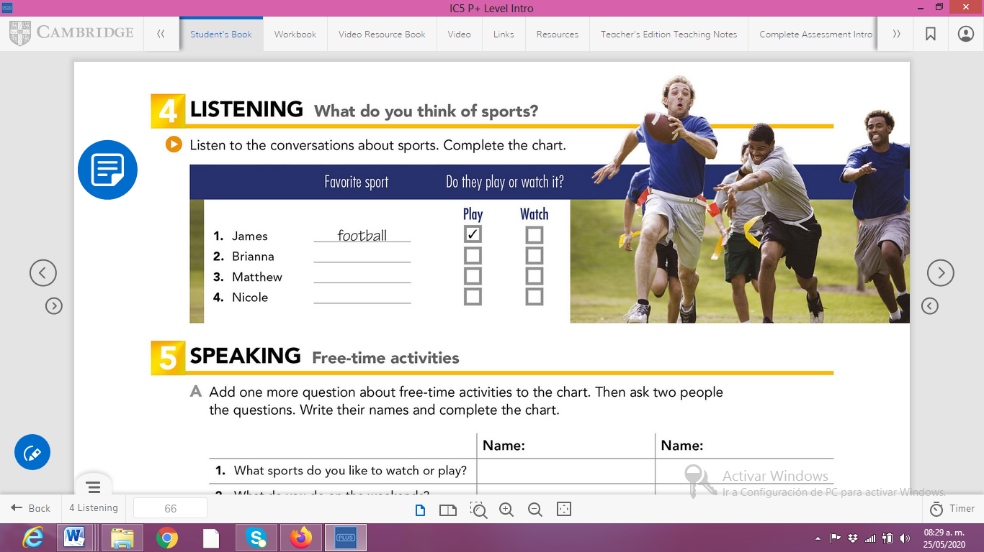

**ACTIVITY 2**

Let’s practice WH questions with do/does

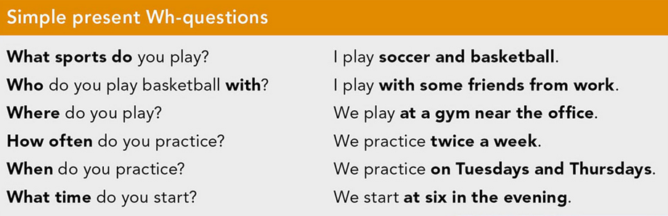

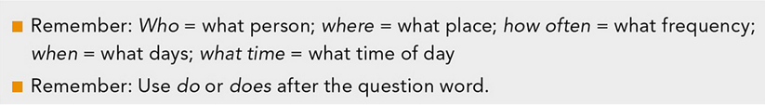

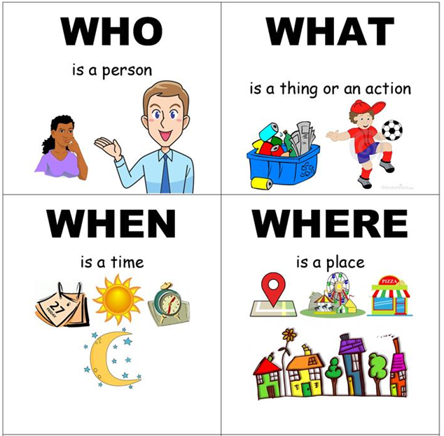

|  |  |  |  |  |
| --- | --- | --- | --- | --- |
| **WH- QUESTIONS STRUCTURE** | | | | |
| **WH WORD + DO/DOES + SUBJECT + VERB + COMPLEMENT?** | | | | |
| WHAT SPORT | DO | YOU | PLAY? |  |
| WHEN | DO | YOU | PRACTICE | SOCCER? |
| WHERE | DOES | YOUR BROTHER | PLAY | BASEBALL? |

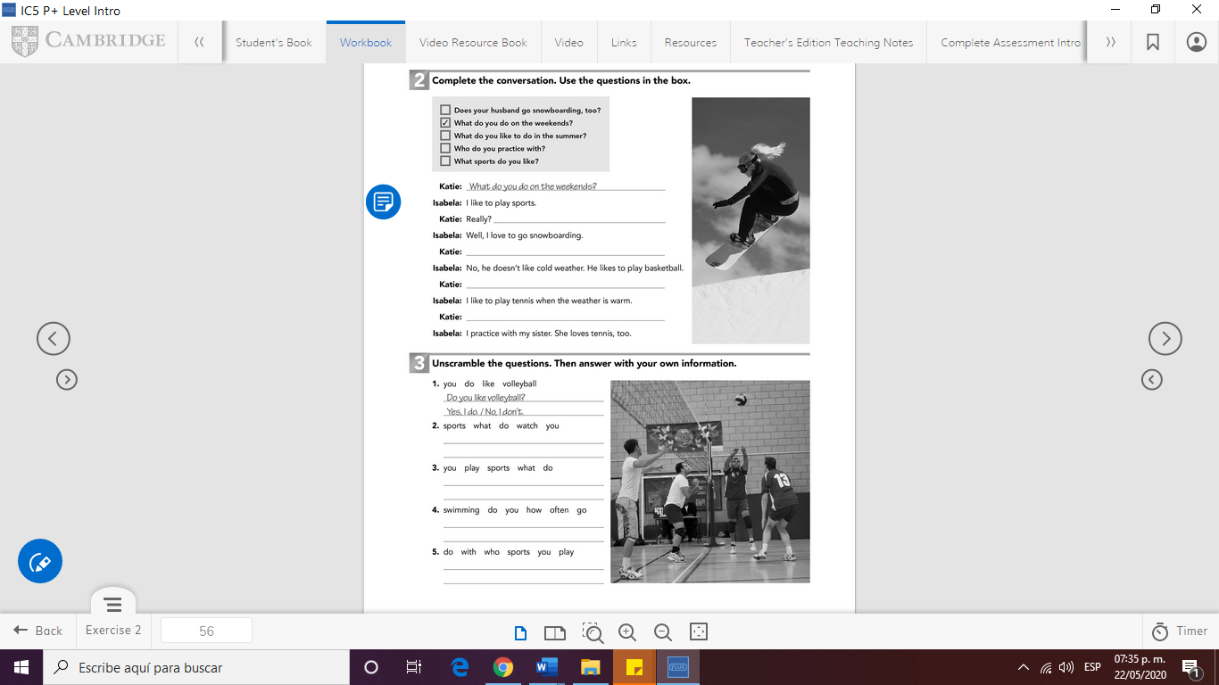

Write your answers here:



Write your answer here:

CLICK ON THE LINK BELOW TO CHECK YOUR ANSWERS

<https://drive.google.com/open?id=1I9piA7ZvHo2A0z0jtBock0TGi2_1RwX->