**ESCUELA NORMAL DE EDUCACIÓN PREESCOLAR**

**ENGLISH B1. 2 BECOMING INDEPENDENT LEARNERS**

**UNIT 3-FINAL EVIDENCE**

**“GLOBAL EVALUATION PROJECT”**

**Aim :** Give students practice expressing regrets and talking about hypothetical situations.

**Prepare:** Watch the video “Live and Learn”. Three people are talking about some of their most embarrassing moments and the thinks they regret (they should/shouldn’t have done).

<https://www.youtube.com/watch?v=e-AliT232U0>

**Instructions:**

* You will make a short video (2 minutes) talking about an embarrassing* moment and telling hypothetically what you should/shouldn’t have done or how something would have been different if **you had…**
* The video must include a cover with an introduction*
* 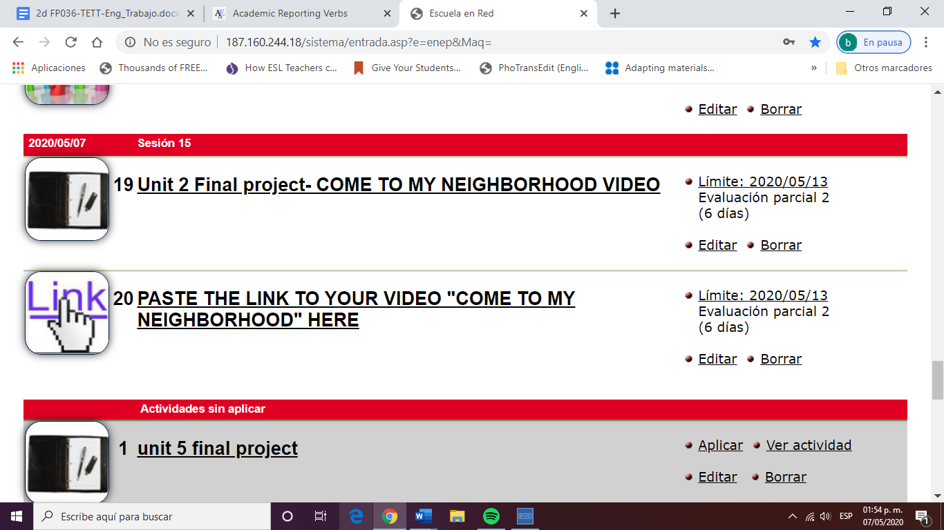Upload your video to **Youtube or Google Drive** and upload **this** ***Word document with the link*** to Escuela en Red you must also paste the link in the activity with this icon:

**Important!**

* Use time clauses (before, until, the moment…) to connect the events*
* Use should+ have+ past participle / clause If + had + past participle*
* Do not read your presentation (remember that we are assessing your fluency).*

THIS VIDEO WILL COUNT AS YOUR FINAL EVIDENCE FOR THE GLOBAL EVALUATION. HENCE, YOU SHOULD DELIVER A SUCCESSFUL TASK.

GRADING CRITERIA

|  |  |  |  |  |  |
| --- | --- | --- | --- | --- | --- |
|  | **POOR** | **FAIR** | **GOOD** | **VERY GOOD** | **EXCELLENT** |
| **FLUENCY** | 1 | 2 | 3 | 4 | 5 |
| **GRAMMAR** | 1 | 2 | 3 | 4 | 5 |
| **VOCABULARY** | 1 | 2 | 3 | 4 | 5 |
| **PRONUNCIATION** | 1 | 2 | 3 | 4 | 5 |

Fluency = ability to speak quickly, naturally, and without many pauses Grammar = ability to use correct grammar and sentence structures Vocabulary = ability to use vocabulary words and phrases Pronunciation = ability to use correct stress, rhythm, and intonation patterns

**NOTE: THE ADDITION OF THE POINTS DIVIDED BY 2 WILL GIVE THE FINAL SCORE**

**Your link here :**