**ESCUELA NORMAL DE EDUCACIÓN PREESCOLAR**

**ENGLISH B1.2 BECOMING INDEPENDENT COMMUNICATORS**

**UNIT 1 – THAT’S MY KIND OF FRIEND**

**READING 1**

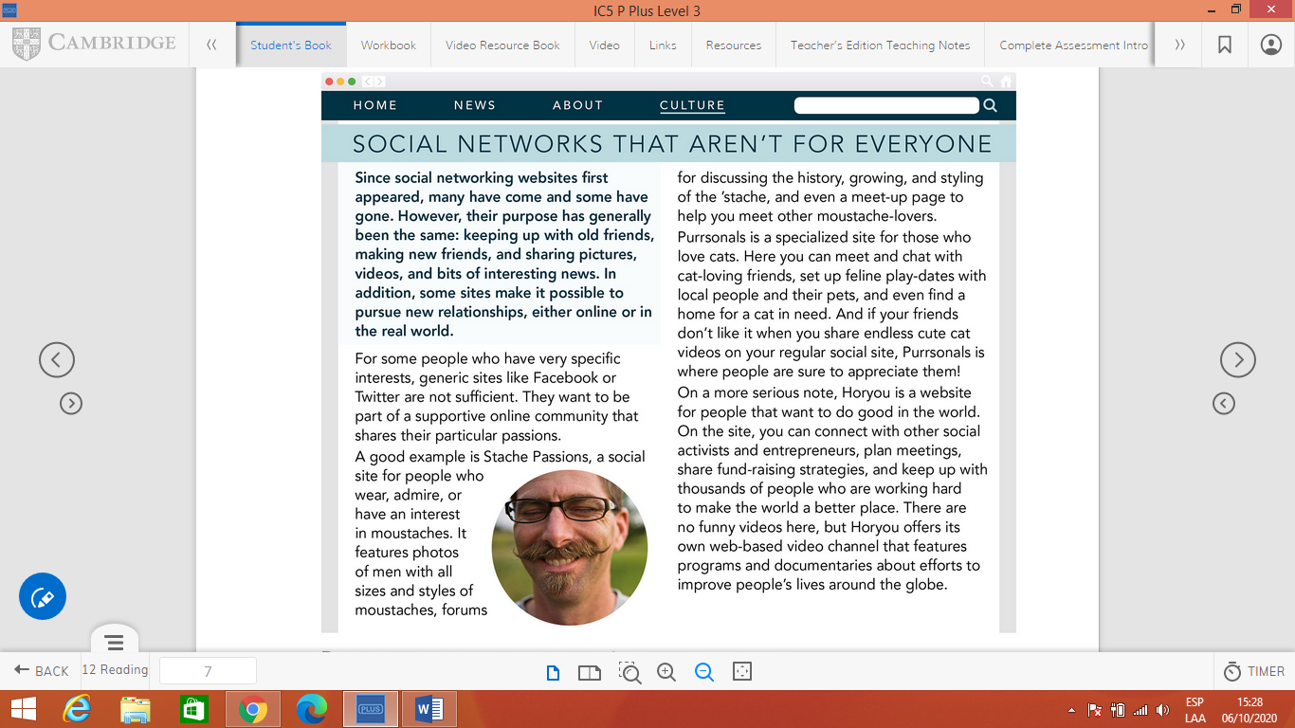

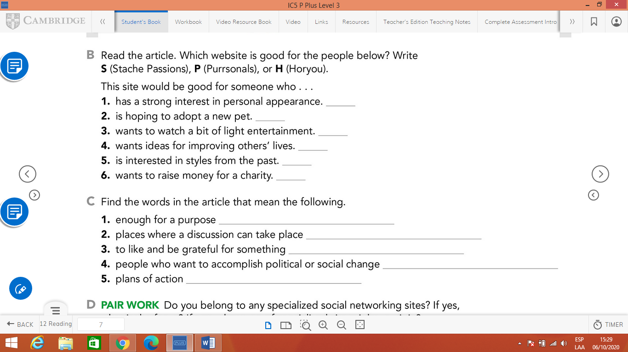

**READING 2**

