**ESCUELA NORMAL DE EDUCACIÓN PREESCOLAR**

**ENGLISH B2+ ONLINE**

**UNIT 1 – TROUBLES AT HOME**

**LESSONS 1 TO 5 EXTENSION ACTIVITIES**

1. **HOUSEHOLD PROBLEMS**

* Identify and write five household problems you have had at home or at school.
* Research the name of some tools you need to fix each problem from your list.
* Find the names of the people whose job is to fix the problems from your list.
* Find two other problems each person fixes.

|  |  |  |  |  |
| --- | --- | --- | --- | --- |
|  | **Household problem** | **Tools** | **People / job** | **Additional problems** |
| **1** |  |  |  |  |
|  |
| **2** |  |  |  |  |
|  |
| **3** |  |  |  |  |
|  |
| **4** |  |  |  |  |
|  |
| **5** |  |  |  |  |
|  |

1. **Choose one of the problems and write a description of the steps to fix it (use simple present).**
2. **Read the learning points again and write five causative sentences about each one of the problems from your list.**

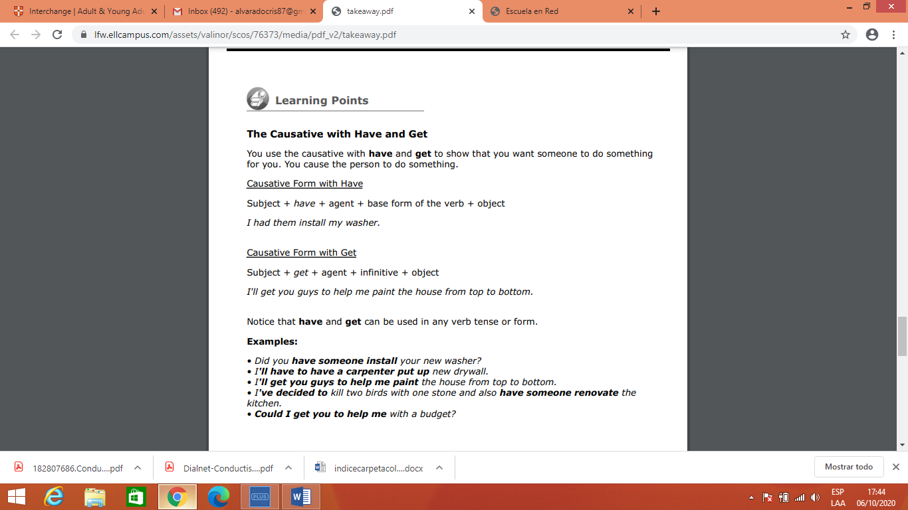

1.

2.

3.

4.

5.

1. **Find a tongue twister with sh and ch sounds on the Internet. Paste it here and practice to share it with your classmates on Friday.**