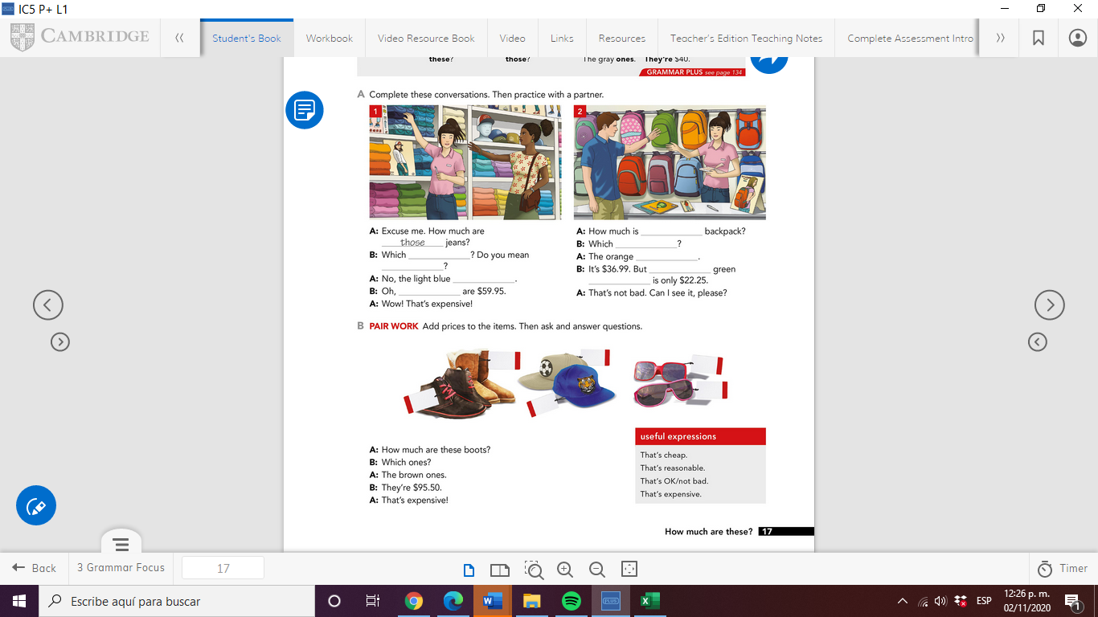**THIS IS YOUR SPEAKING TASK:**

**STUDY THESE USEFUL EXPRESSIONS**

**STUDY THE LANGUAGE AND TRY TO USE AS MANY EXPERSSIONS AS POSSIBLE IN YOUR SPEAKING TASK.**