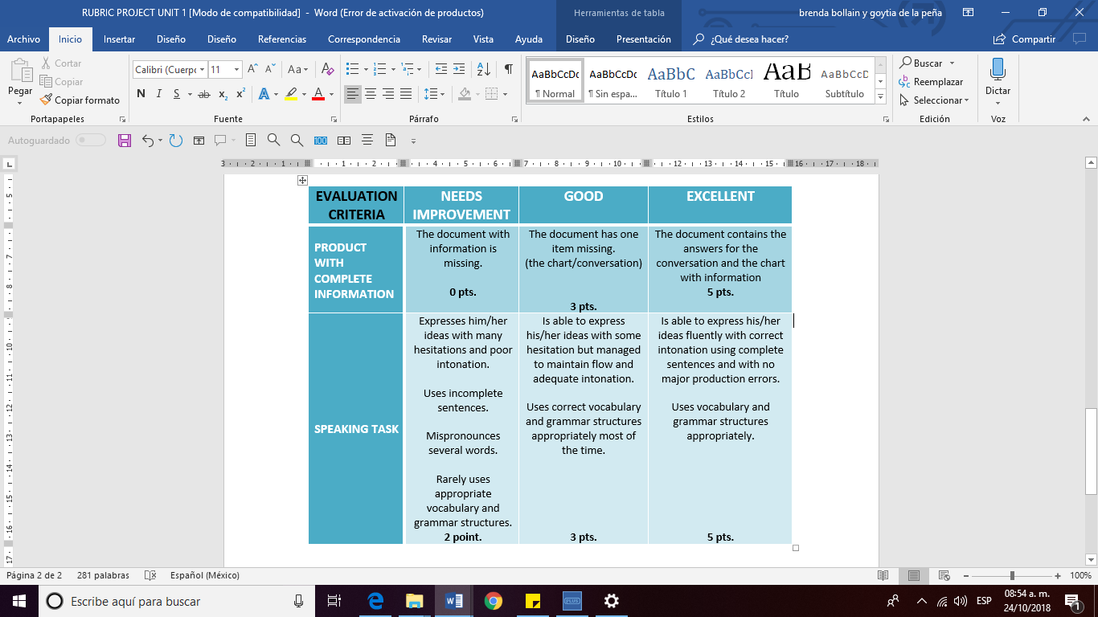

**ESCUELA NORMAL DE EDUCACIÓN PREESCOLAR**

**ENGLISH A2.1 SHARING INFORMATION AND IDEAS”**

**ENGLISH PROJECT**

**UNIT 3: HOW MUCH IS THAT?**

**Aim:** To describe prices and discuss preferences. To use demonstratives, one, and ones in a conversation to ask about prices while shopping

**Instructions**: You must upload *this* word document in Escuela en red. with your full name, your team´s number, the answers for the conversation and your list of items for sale. (individually) **Prepare for your oral presentation.**

**Evaluation:** The use of correct structures, vocabulary from the unit, and clear presentation of your task will be evaluated.

**Due date to upload the document:** October. Monday 28, 2018.

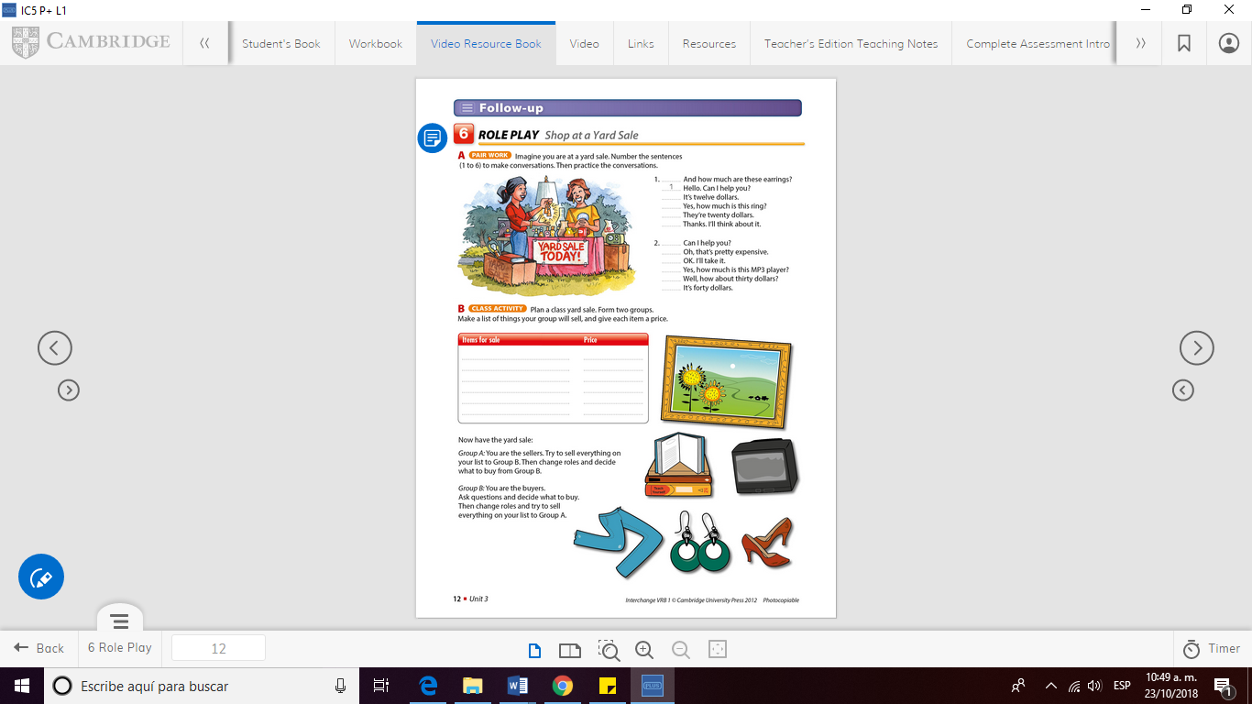**Prepare**: imagine you are at a yard sale. Number the sentences (1-6) to make conversations.

**Answers:**

Plan a yard sale. Make a list of things your

group will sell and give each item a price.

|  |  |
| --- | --- |
| Items for sale | price |
| ____________________ ____________________ ____________________ ____________________ ____________________ ____________________ ____________________ ____________________  ____________________ | ______  ______  ______  ______  ______  ______  ______  ______ |



Price tag

The day of your presentation. Bring real items to your classroom and price tags for each item. Display everything on a table and role play. Divide your team into two groups A and B.

