**ESCUELA NORMAL DE EDUCACIÓN PREESCOLAR**

**ENGLISH A2.2**

**UNIT 8 – HOW’S THE NEIGHBORHOOD?**

**GRAMMAR**

Dear students, during the week we will practice asking about and describing places. You will learn how to describe a neighborhood.

RECUERDA QUE LAS ACTIVIDADES DEBERÁN SER RESPONDIDAS A MANO EN TU LIBRO, O BIEN EN EL DOCUMENTO O COPIANDO LAS ACTIVIDADES EN TU CUADERNO. SUBE FOTOS DE TU TRABAJO.

**ACTIVITY 1 – THERE IS / THERE ARE – 40 PTS.**

Al describir un lugar o en este caso, un vecindario, usamos preposiciones de lugar como las que practicaste en tu actividad anterior (in, on, in front of, next to, accross from) y también:

* **Para hablar en singular:** 
  + **THERE IS**: Ex. ***There is*** *a grocery store in front of my house. / Hay un supermercado en frente de mi casa.*
  + **THERE IS NOT / THERE ISN’T**: Ex. ***There isn’t******a*** *gas station near my house. / No hay una estación de gasolina cerca de mi casa.*

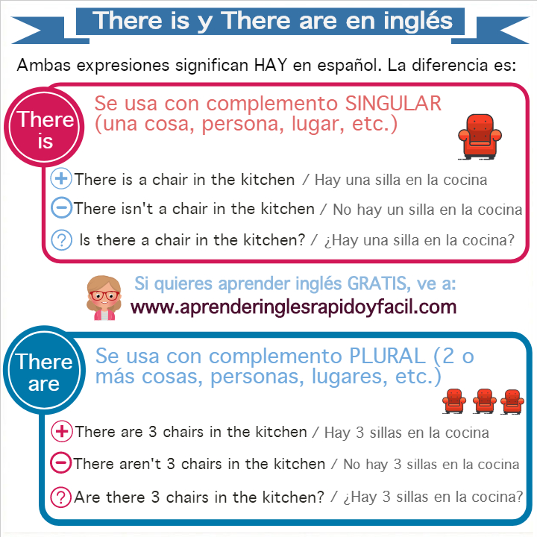

* **Para hablar en plural:**
  + **THERE ARE:** Ex. ***There are*** *many schools on Musa Boulevard. / Hay muchas escuelas en el boulevard Musa.*
  + **THERE AREN’T (ARE NOT) ANY:** Ex. ***There aren’t any*** *newsstands on the main street. / No hay revisterías en la calle principal.*



* Fill in the blanks with THERE IS or THERE ARE.

I live in a neighborhood in the north of the city. There is a park in front of my house where children can play. There are a lot of schools on the main street, there are also a lot of restaurants to buy delicious food. There is a hospital in the corner of Jose Ma. Rodríguez and José Musa. There is also, a shopping mall in front of a big school named UANE. It’s a great neighborhood.

* Look at the map below and write sentences using *there is / there isn’t a / there are / there aren’t any* and the following words. Example: *There isn’t an ATM in the neighborhood.*

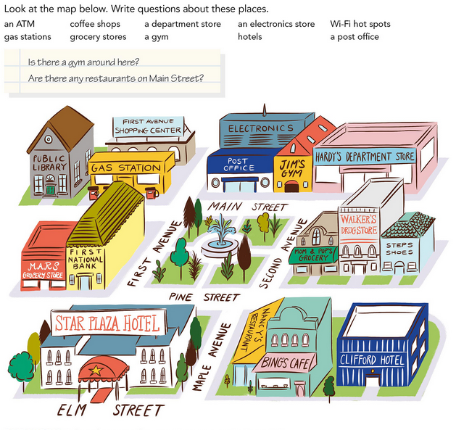



There isn’t an AMT around the neighborhood

There is a gas stations Behind the first national bank

There aren’t a grocery stores in the neighborhood

There is a post office infront the electronics store

There is a caffe shope on the maple avenue

* Write about your neighborhood, fill the chart with three examples for each category. Examples: *There is* a school in front of my neighborhood. / *There are some* restaurants on the main street. / *There isn’t a* grocery store near my house. / *There aren’t any* parks in my neighborhood.

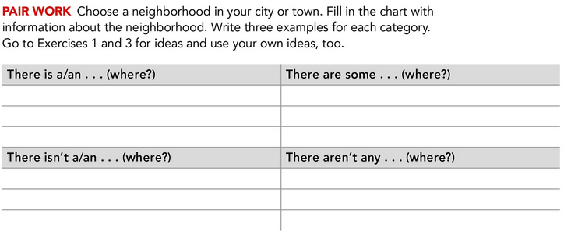

There is a park in my neighborhood there are some stores near my house

There is a grocery store on the main Street there are some hospital on the main street

There isn’t a gym in front my neighborhood there aren’t any aparments near my house

There isn’t a school in my neighborhood there aren’t any stores in my neighborhood

**ACTIVITY 2 – QUESTIONS PART 1 – 30 PTS.**

Para preguntar si hay algo cerca o hay algo en algun lugar del vecindario utilizamos:

* **IS THERE** – para singular. Ex. *Is there a bank near here? / Hay un banco cerca de aquí?* Respuesta: Yes, there is. (se dice donde) / No, there isn’t. (se puede decir donde hay una)
* **ARE THERE ANY** – para plural. Ex. *Are there any gas stations on 5th Avenue? / Hay gasolineras en la 5ª Avenida?* Respuesta: Yes, there are. (se dice donde) / No, there aren’t. (se puede decir donde hay)

Lee y analiza los siguientes ejemplos:

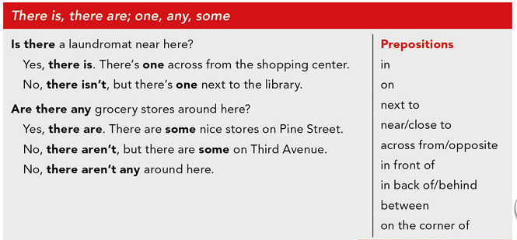

* Complete the conversations. Choose the correct word.

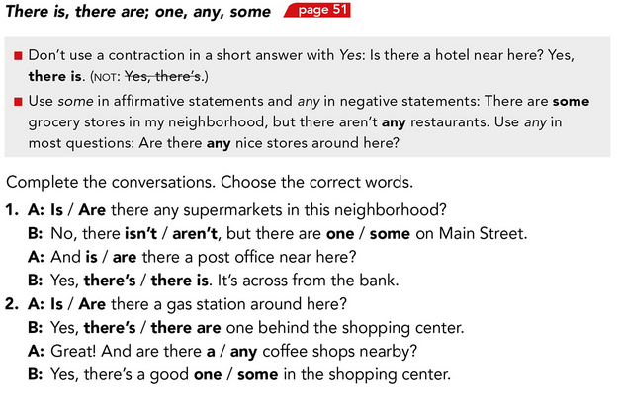



* Look at the map below and answer the questions.

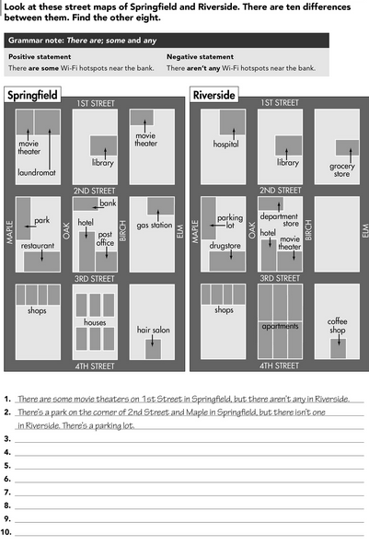

1. No there isn’t, the grocery store i son 2nd Street
2. Yes there are some apartments in the neighborhood
3. No there isn’t, the hospital is near the library
4. Yes there are some shops in the neighborhood
5. Yes there is
6. Is there a grocery store on Maple Street?
7. Are there any apartments in the neighborhood?
8. Is there a hospital near the coffee shop?
9. Are there any shops in the neighborhood?
10. Is there a movie theater on 3rd Street?

**ACTIVITY 3 – QUESTIONS PART 2 – 30 PTS.**

Para preguntar si hay mucho de algo en un lugar, una ciudad, un vecindario utilizamos:

* **MANY /A FEW** para sustantivos contables (restaurants, banks, coffee shops) *Ex. Are there many parks in your city? / ¿Hay muchos parques en tu ciudad?*
* **MUCH / A LITTLE** para sustantivos no contables (crime, noise, parking) *Ex. Is there much crime in Saltillo? / ¿Hay mucho crimen en Saltillo?*

Para preguntar CUÁNTO hay de algo utilizamos:

* **HOW MANY** para sustantivos contables. *Ex. How many sisters do you have? / ¿Cuántas hermanas tienes? I have 3 sisters.*
* **HOW MUCH** para sustantivos no contables. *Ex. How much noise is there in your neighborhood? / ¿Cuánto ruido hay en tu vecindario? There is a lot of noise.*

Lee y analiza los siguientes ejemplos:

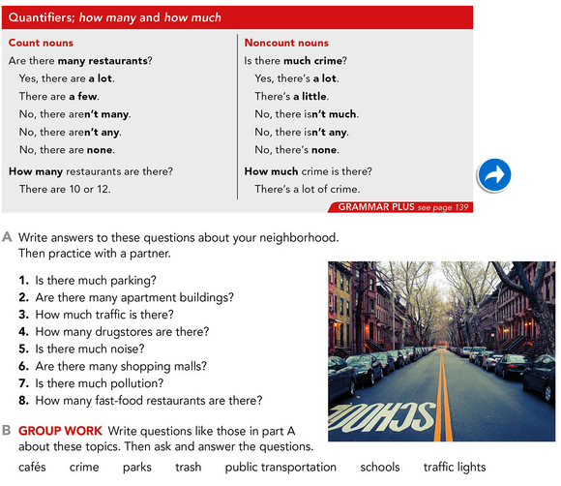

* Complete the conversations. Choose the correct word.

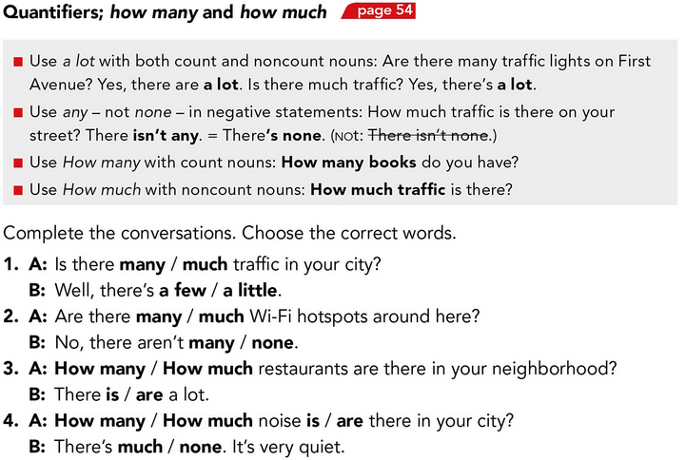



* Write questions using ***How much…?*** or ***How many…?*** Then look at the picture and write answers to the questions. Use the expressions in the box.

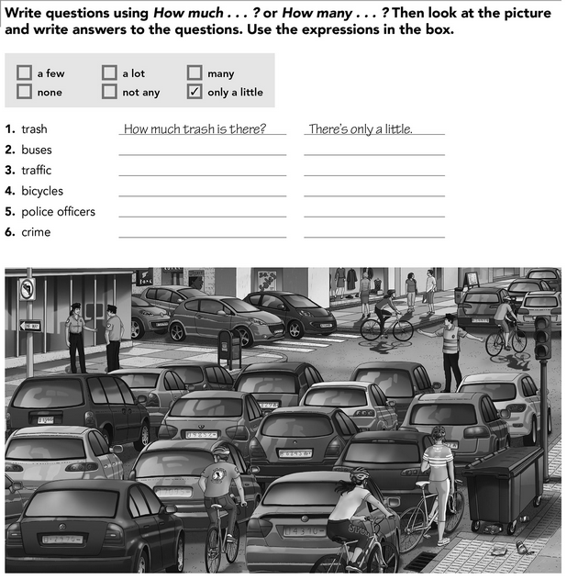

How many buses are there? There are not many

How much traffic is there? There is a lot

How many bicycles are there? There are a few

How many pólice officers are there? There are many

How much crime is there? There is none

* Answer the following questions with information about your neighborhood.



1. Yes there are
2. Yes there are many aparments
3. No there aren’t
4. There are none
5. There are not many
6. Yes there are
7. Yes there are