**ESCUELA NORMAL DE EDUCACIÓN PREESCOLAR**

**ENGLISH A2.2**

**UNIT 8 – HOW’S THE NEIGHBORHOOD?**

**GRAMMAR**

Dear students, during the week we will practice asking about and describing places. You will learn how to describe a neighborhood.

RECUERDA QUE LAS ACTIVIDADES DEBERÁN SER RESPONDIDAS A MANO EN TU LIBRO, O BIEN EN EL DOCUMENTO O COPIANDO LAS ACTIVIDADES EN TU CUADERNO. SUBE FOTOS DE TU TRABAJO.

**ACTIVITY 1 – THERE IS / THERE ARE – 40 PTS.**

Al describir un lugar o en este caso, un vecindario, usamos preposiciones de lugar como las que practicaste en tu actividad anterior (in, on, in front of, next to, accross from) y también:

* **Para hablar en singular:** 
  + **THERE IS**: Ex. ***There is*** *a grocery store in front of my house. / Hay un supermercado en frente de mi casa.*
  + **THERE IS NOT / THERE ISN’T**: Ex. ***There isn’t******a*** *gas station near my house. / No hay una estación de gasolina cerca de mi casa.*

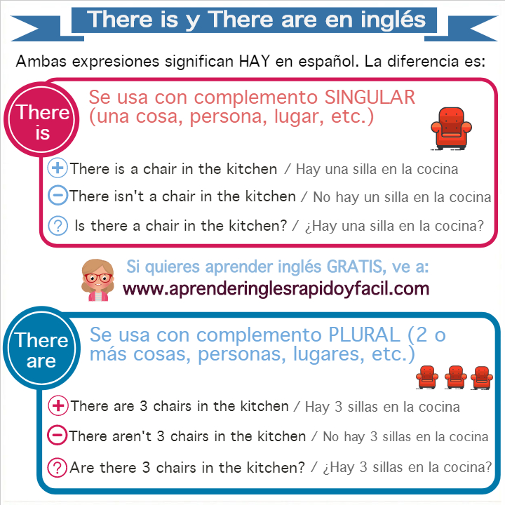

* **Para hablar en plural:**
  + **THERE ARE:** Ex. ***There are*** *many schools on Musa Boulevard. / Hay muchas escuelas en el boulevard Musa.*
  + **THERE AREN’T (ARE NOT) ANY:** Ex. ***There aren’t any*** *newsstands on the main street. / No hay revisterías en la calle principal.*



* Fill in the blanks with THERE IS or THERE ARE.

I live in a neighborhood in the north of the city. _____ a park in front of my house where children can play. _____ a lot of schools on the main street, _____ also a lot of restaurants to buy delicious food. _____ a hospital in the corner of Jose Ma. Rodríguez and José Musa. _____ also a shopping mall in front of a big school named UANE. It’s a great neighborhood.



* Look at the map below and write sentences using *there is / there isn’t a / there are / there aren’t any* and the following words. Example: *There isn’t an ATM in the neighborhood.*

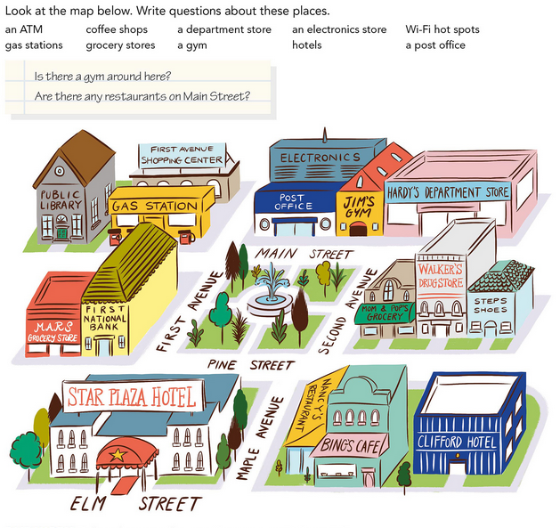



* Write about your neighborhood, fill the chart with three examples for each category. Examples: *There is* a school in front of my neighborhood. / *There are some* restaurants on the main street. / *There isn’t a* grocery store near my house. / *There aren’t any* parks in my neighborhood.

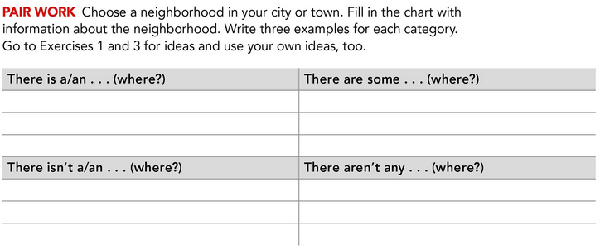

**ACTIVITY 2 – QUESTIONS PART 1 – 30 PTS.**

Para preguntar si hay algo cerca o hay algo en algun lugar del vecindario utilizamos:

* **IS THERE** – para singular. Ex. *Is there a bank near here? / Hay un banco cerca de aquí?* Respuesta: Yes, there is. (se dice donde) / No, there isn’t. (se puede decir donde hay una)
* **ARE THERE ANY** – para plural. Ex. *Are there any gas stations on 5th Avenue? / Hay gasolineras en la 5ª Avenida?* Respuesta: Yes, there are. (se dice donde) / No, there aren’t. (se puede decir donde hay)

Lee y analiza los siguientes ejemplos:

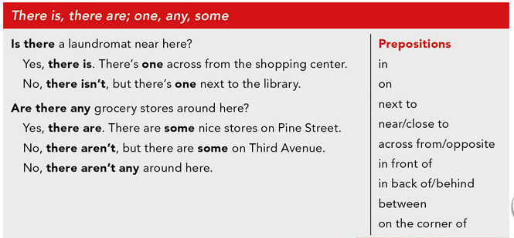

* Complete the conversations. Choose the correct word.

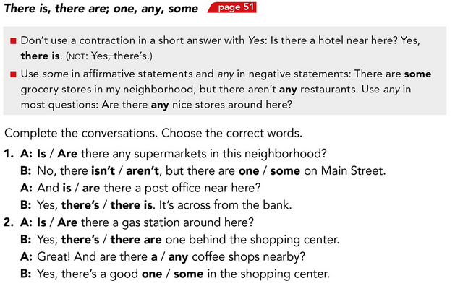



* Look at the map below and answer the questions.

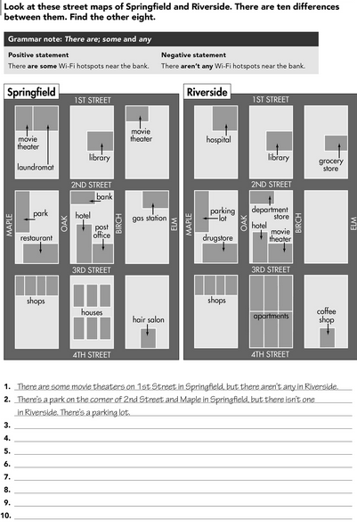

1. Is there a grocery store on Maple Street?
2. Are there any apartments in the neighborhood?
3. Is there a hospital near the coffee shop?
4. Are there any shops in the neighborhood?
5. Is there a movie theater on 3rd Street?

**ACTIVITY 3 – QUESTIONS PART 2 – 30 PTS.**

Para preguntar si hay mucho de algo en un lugar, una ciudad, un vecindario utilizamos:

* **MANY /A FEW** para sustantivos contables (restaurants, banks, coffee shops) *Ex. Are there many parks in your city? / ¿Hay muchos parques en tu ciudad?*
* **MUCH / A LITTLE** para sustantivos no contables (crime, noise, parking) *Ex. Is there much crime in Saltillo? / ¿Hay mucho crimen en Saltillo?*

Para preguntar CUÁNTO hay de algo utilizamos:

* **HOW MANY** para sustantivos contables. *Ex. How many sisters do you have? / ¿Cuántas hermanas tienes? I have 3 sisters.*
* **HOW MUCH** para sustantivos no contables. *Ex. How much noise is there in your neighborhood? / ¿Cuánto ruido hay en tu vecindario? There is a lot of noise.*

Lee y analiza los siguientes ejemplos:

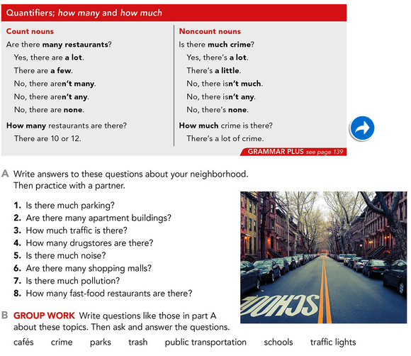

* Complete the conversations. Choose the correct word.

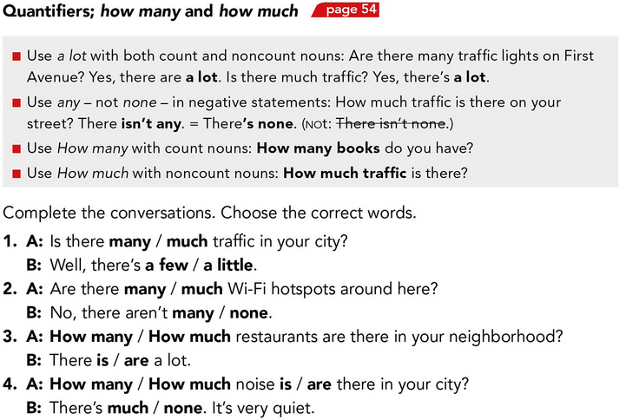



* Write questions using ***How much…?*** or ***How many…?*** Then look at the picture and write answers to the questions. Use the expressions in the box.

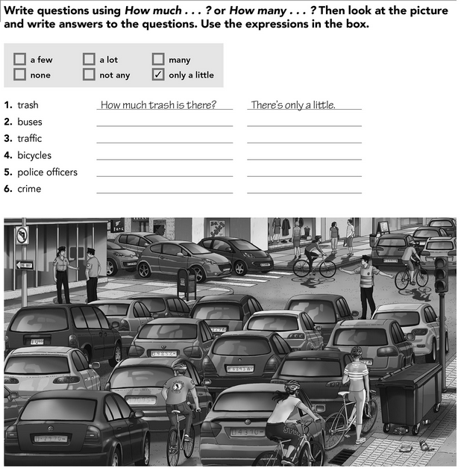

* Answer the following questions with information about your neighborhood.



