**ENGLISH A1.2. DEVELOPING ELEMENTARY CONVERSATIONS**

**UNIT 8**

**WHERE DO YOU WORK?**

1. You can use the following adjectives to describe a job. Use internet or a dictionary to find the meaning of the words, and match them with the picture that better shows its meaning.

  **Stressful**

** Dangerous**

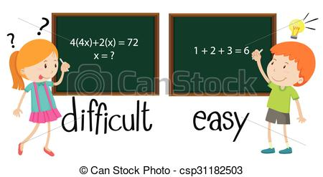 **Interesting**

** Exciting**

** Boring**

** Difficult**

** Easy**

** Relaxing**

1. Look at the pictures and use the vocabulary above to answer the following questions:



**What does he do?**

*He is a* ***doctor****.*

**Where does he work?**

*He works in a* ***hospital****.*

**What’s his job like?**

*It´s* ***stressful****.*



**What does she do?**

_______________________________

**Where does she work?**

_______________________________

**What’s her job like?**

_______________________________



**What does she do?**

_______________________________

**Where does she work?**

_______________________________

**What’s her job like?**

_______________________________



**What does he do?**

**Where does he work?**

**What’s his job like?**

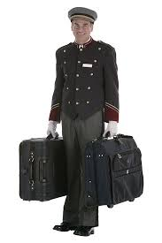

**What does he do?**

**Where does he work?**

**What’s his job like?**



**WHAT ABOUT YOU? DO YOU HAVE A JOB?**

**What do you do?**

_______________________________

**Where do you work?**

_______________________________

**What’s your job like?**

_______________________________