**ESCUELA NORMAL DE EDUCACIÓN PREESCOLAR**

**ENGLISH B1.1.2**

**UNIT 8 – PAST SIMPLE VS PAST CONTINUOUS**

**DURING THIS UNIT YOU WILL LEARN HOW TO USE THE PAST CONTINUOUS AND THE SIMPLE PAST TO TELL STORIES.**

Review the class from Friday May 22nd and solve the following exercises.

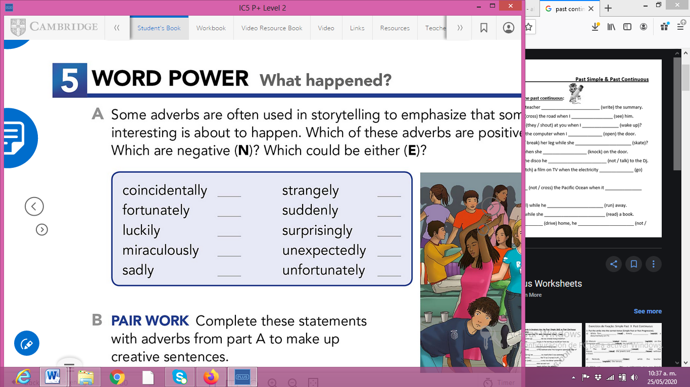

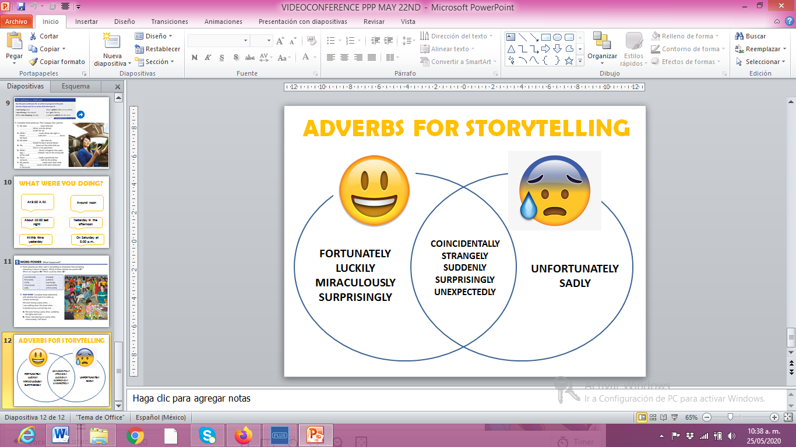

**ACTIVITY 1 – GRAMMAR PRACTICE**

Complete the sentences with an adverb for storytelling. There is more than one correct answer for each sentence.

1. I was walking on the street when, __________, I saw my friend John.
2. My friend and I were shopping when, ___________, we remembered that we didn’t have our wallets.
3. I was driving to school when, ___________, I saw a terrible accident.
4. I was watching T. V. at home alone when, ___________, I heard a voice calling my name.
5. The man was having a normal day when, ___________, he found a lot of money in his backyard.

**ACTIVITY 2 – WHO IS TELLING THE TRUTH?**

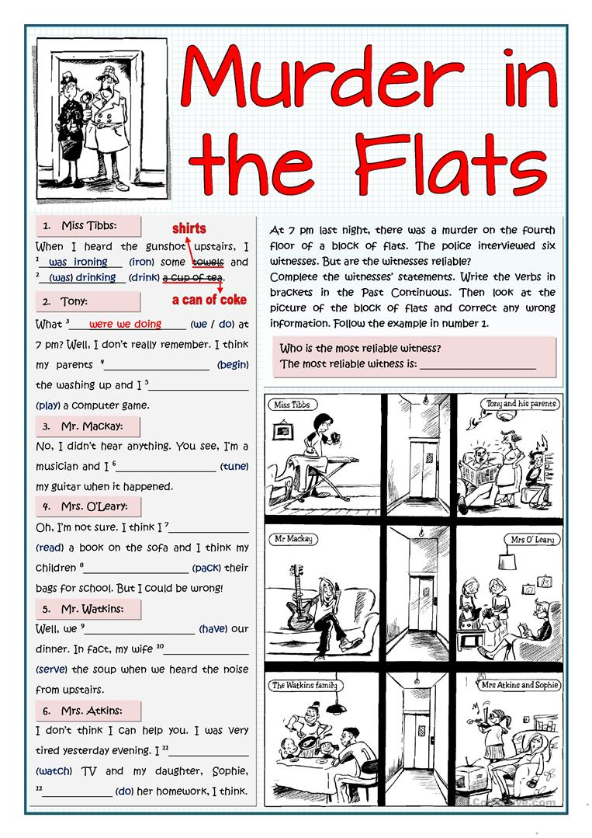

**The witness that is telling the truth is: ______________________________**



**ACTIVITY 3 – DISCUSSION FORUM**

Write an entry in the discussion forum in Escuela en Red telling a short story about something interesting than happened to you. Include sentences in past continuous and simple past tense, and adverbs from the previous exercise. Your entry must have at least 80 words.

*Example:*

