**ESCUELA NORMAL DE EDUCACIÓN PREESCOLAR**

**ENGLISH B1. 2 BECOMING INDEPENDENT LEARNERS**

Dear students,

In this activity you will learn how to express regrets and how to talk about hypothetical situations.

Read the comments of these two college graduates. Are they happy with the decisions they made?

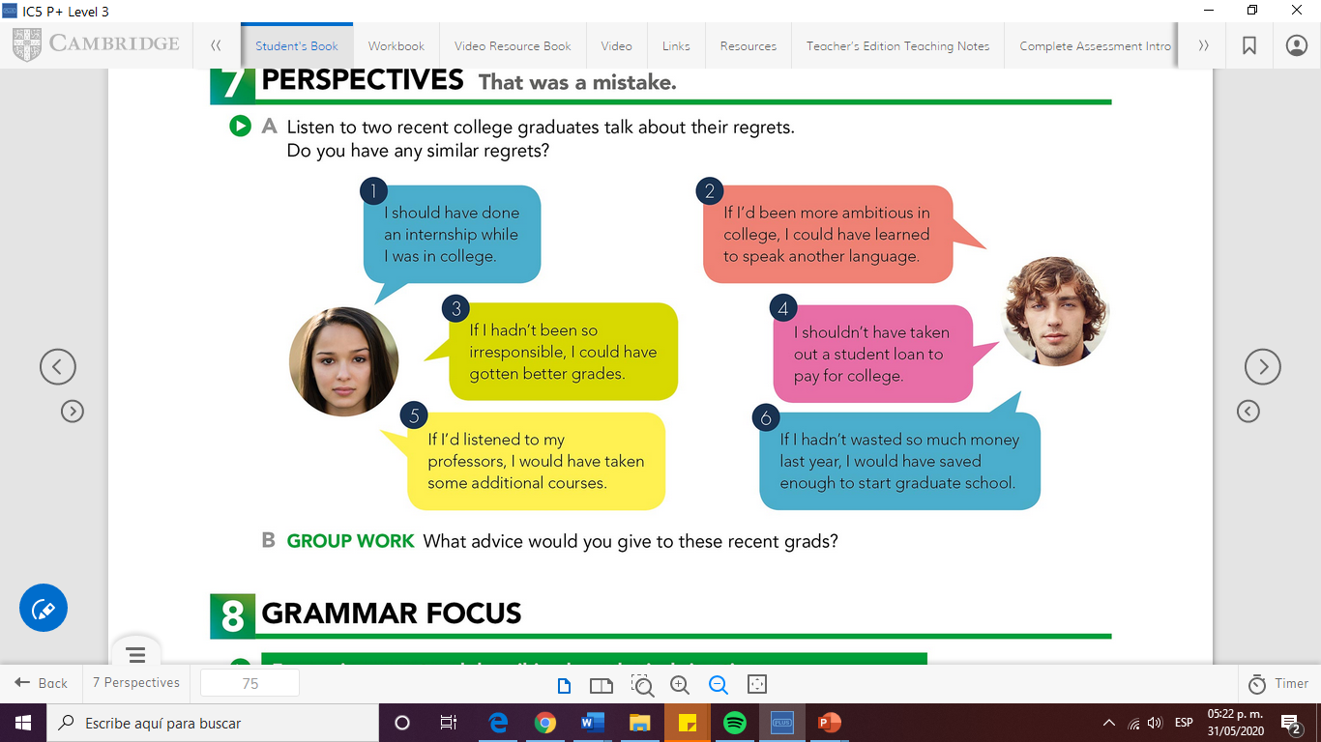

Anna

Claudio

**Underline the statement that has the same meaning than the one expressed by Anna and Claudio.**

1. **Claudio was ambitious and learned another language**
2. Anna did an internship.
3. Anna wants to do an internship
4. **He didn’t learn another language because he lacked ambition**
5. **Anna didn’t get good grades due to her irresponsibility**
6. **Anna was responsible and got good grades**
7. **Claudio didn’t pay for college**
8. **Claudio took a loan and payed for college**

**a)Anna listened to her professors and took additional courses**

**b) She didn’t listen to her professors and didn’t take the courses**

1. **Claudio saved money and can start graduate school**
2. **He didn’t save money and now he can’t pay for graduate school**

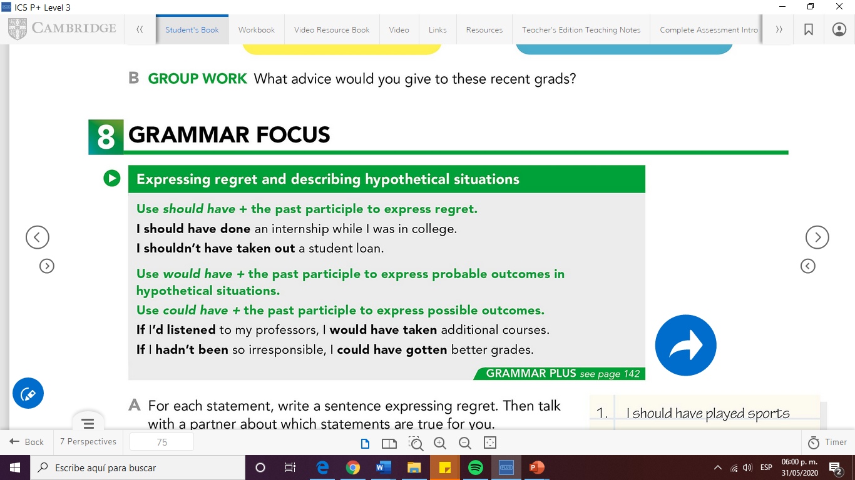 **Study the following chart with the structure**

1. **Express REGRET about each person’s situation.**

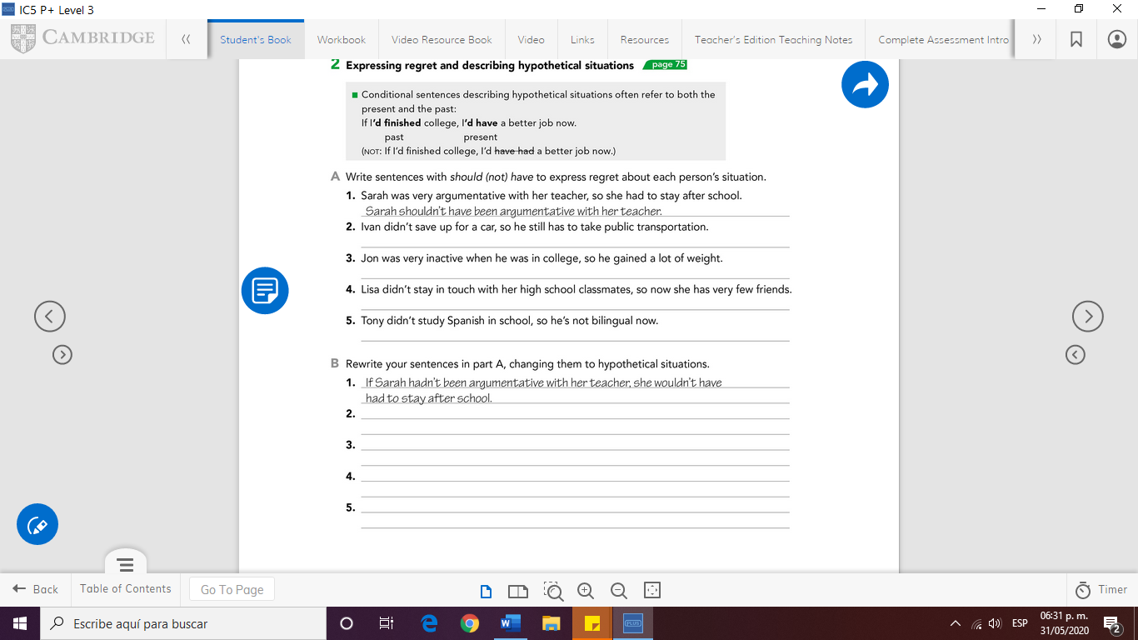**Use should /shouldn’t + have + past participle**

**2. _**

**3._**

**4._**

**5._**

1. 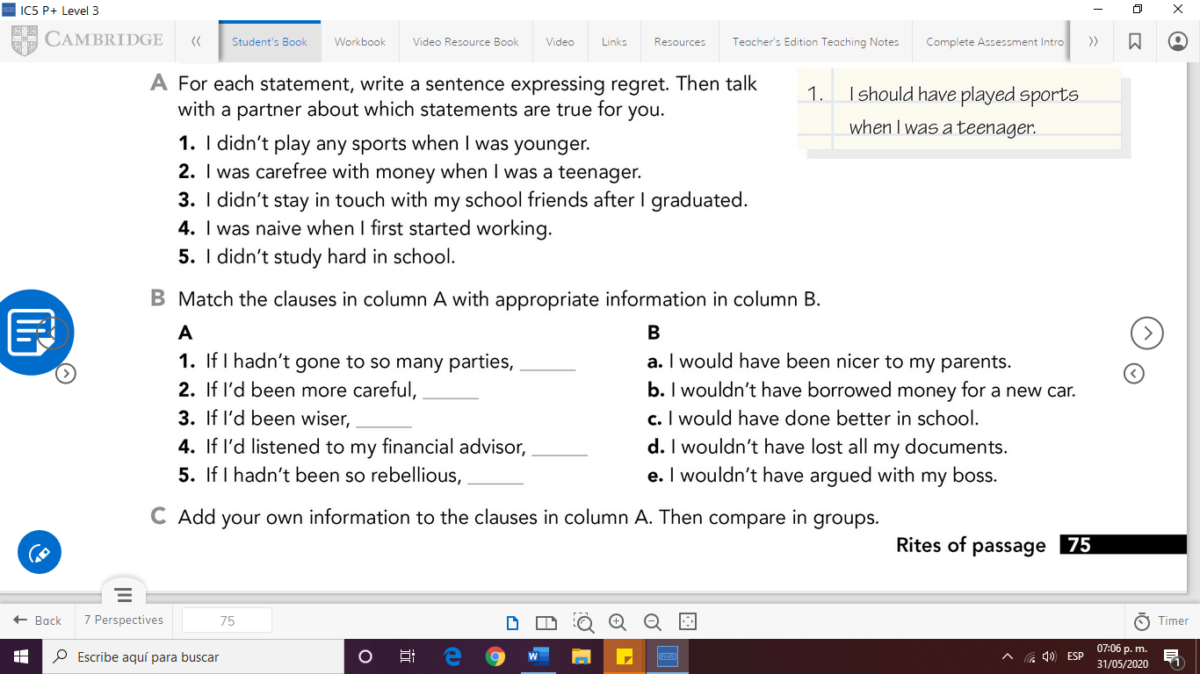**Match the columns to complete the hypothetical situations**
2. **Rewrite your sentences in part A.**

**Change them to HYPOTHETICAL SITUATIONS**

**Use If + + had/hadn’t + past participle**

**And would / wouldn’t + have + past participle**

2._

3._

4._

5._