**ESCUELA NORMAL DE EDUCACIÓN PREESCOLAR**

**ENGLISH A2.2 SHARING INFORMATION AND IDEAS**

**Instructions:**

**Complete the following activities from the workbook.**

**Note: if you have your workbook, complete the activities and take a picture of them. Paste the pictures in this document and upload it in escuela en red.**

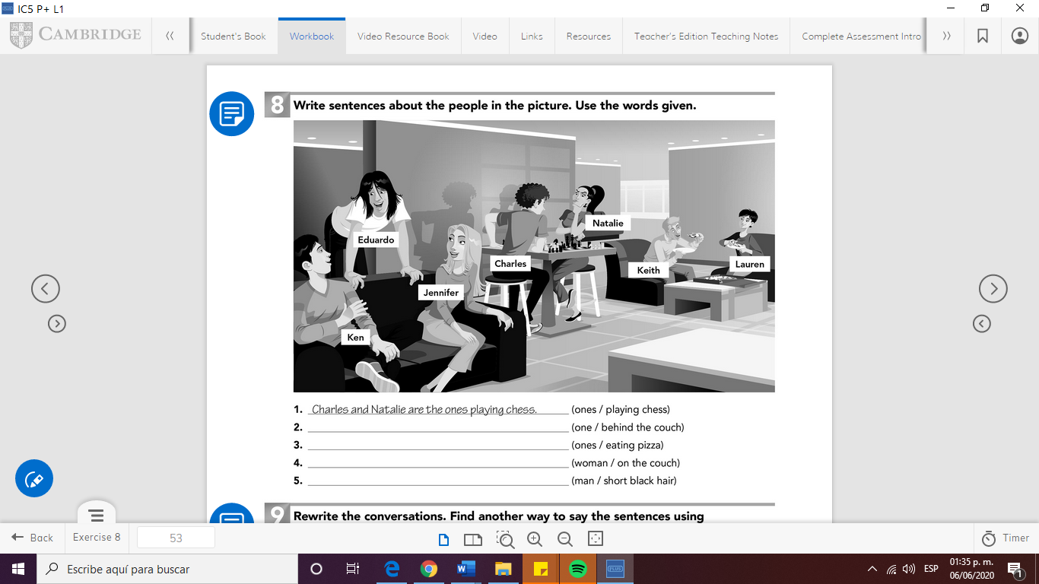

Answers:

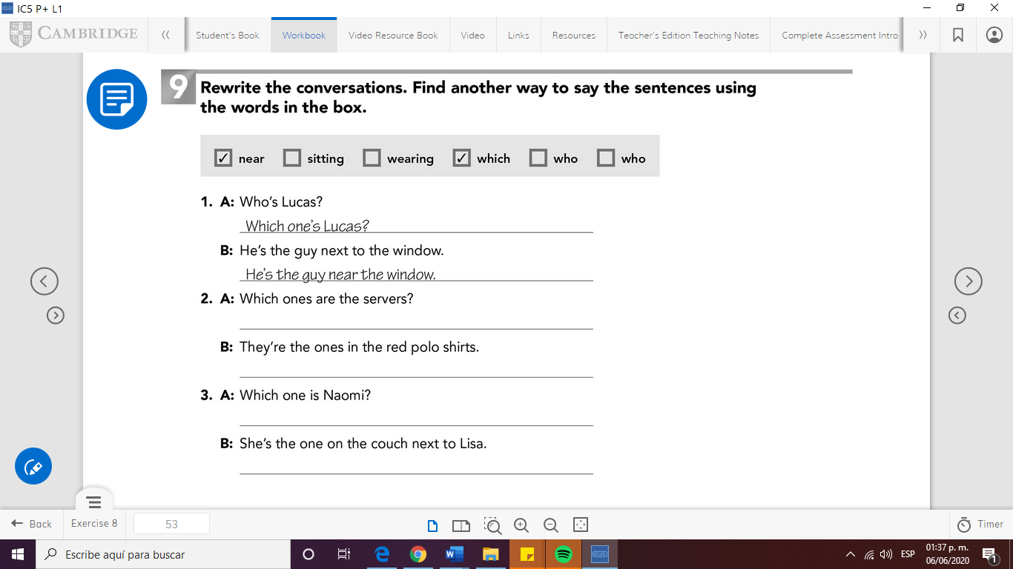

**Answers:**

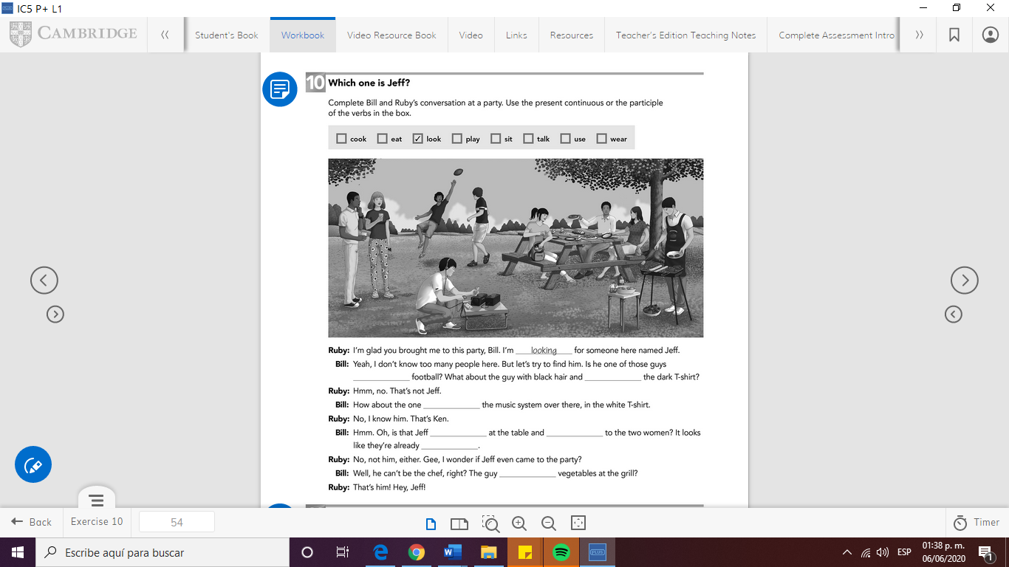

**Answers:**