**ESCUELA NORMAL DE EDUCACIÓN PREESCOLAR**

**ENGLISH B1.2**

**UNIT 3 “LEND A HAND”**

**GRAMMAR**

Remember that we have two kinds of requests: direct and indirect. Complete the exercises and focus on the grammar structures for each kind of request.

* **VIDEO – DIRECT REQUESTS**

Go to https://www.youtube.com/watch?v=GQryco2Ih10 and watch the video analyzing the examples presented. Pay attention on the use of the verb (present, past or gerund).

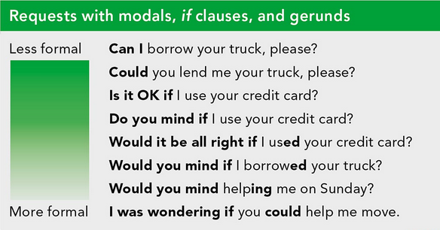

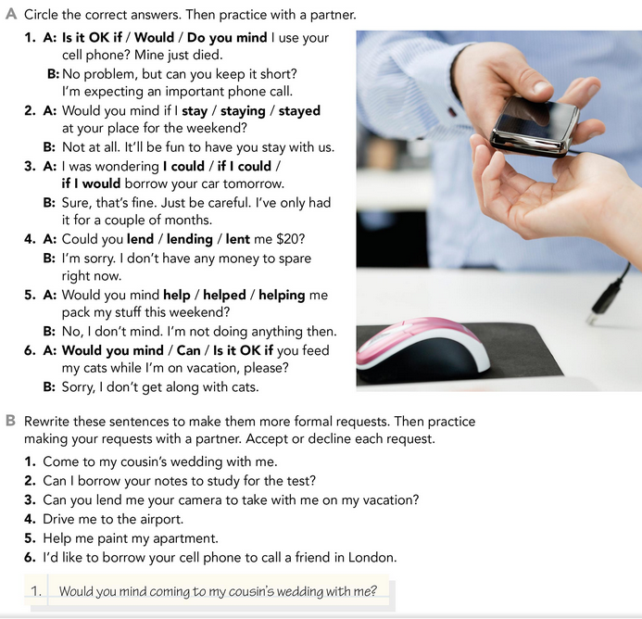

* **PRACTICE**



2.

3.

4.

5.

6.

* **PRACTICE**

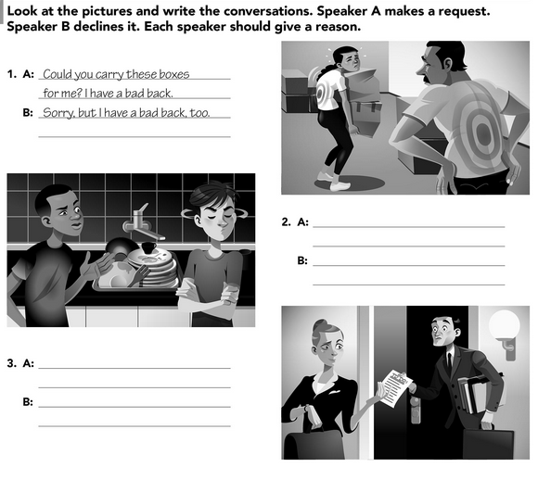

* **VIDEO – INDIRECT REQUESTS**

Go to <https://www.youtube.com/watch?v=fAXjwcFInko&t=83s> and watch the video analyzing the examples presented.

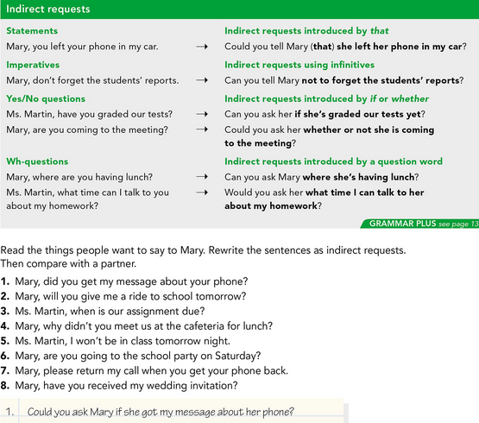

* **PRACTICE**



2.

3.

4.

5.

6.

7.

8.

* **PRACTICE**

