**ESCUELA NORMAL DE EDUCACIÓN PREESCOLAR**

**ENGLISH B1.2**

**BOOK UNIT 4 – WHAT HAPPENED?**

**GRAMMAR – PAST PERFECT**

Dear students, during the week we will review the **past perfect tense.** Complete your activities and upload your document to Escuela en Red in PDF format.

**ACTIVITY 1 – PAST PERFECT– 60 PTS.**

**WATCH THE VIDEOS:**

<https://www.youtube.com/watch?v=PQ6s89XUvz4>

<https://www.youtube.com/watch?v=wvhb40-Ap94>

**READ AND ANALYZE:**

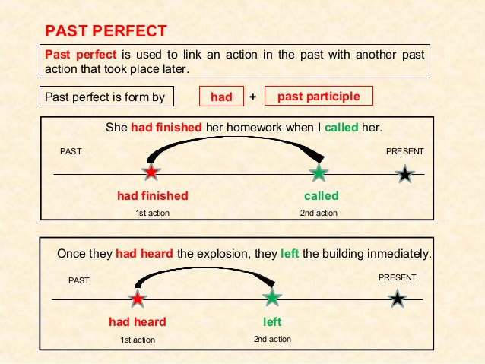

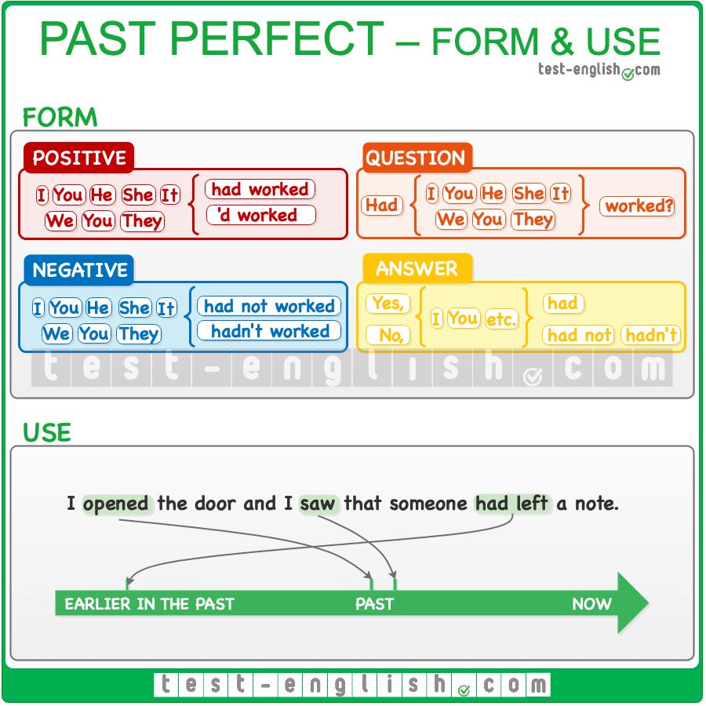

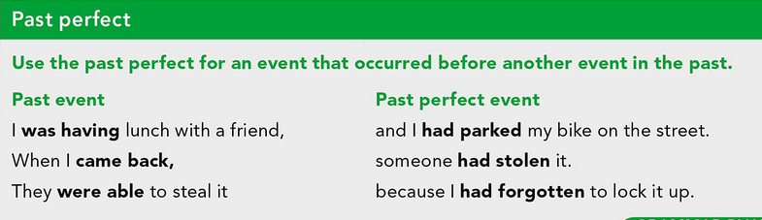

**PRACTICE:**

Visit the following websites and complete the exercises to practice the past perfect, CHECK YOUR ANSWERS AND THEN PASTE A SCREENSHOT OF YOUR WORK HERE.

Affirmative statements:

<https://www.ego4u.com/en/cram-up/grammar/past-perfect-simple/exercises?03>

Negative statements:

<https://www.ego4u.com/en/cram-up/grammar/past-perfect-simple/exercises?04>

Questions:

<https://www.ego4u.com/en/cram-up/grammar/past-perfect-simple/exercises?05>

**ACTIVITY 2 – PAST PERFECT – 40 PTS.**

