**ESCUELA NORMAL DE EDUCACIÓN PREESCOLAR**

**ENGLISH B1.2**

**UNIT 5 PROJECT**

**“EXPANDING YOUR HORIZONS”**



**Aim of the project:**

Give students practice discussing living abroad and talking about their greatest concerns.

**Preparation:**

* + - Choose a country you want to learn more about.
    - Read about the customs and lifestyle in this country and complete the preparation activities.
    - Make a 3 minute video with pictures and talk about the **customs** in the country you chose, you must also talk about how it would be for you to travel to this country (your concerns).

**Development:**

* Use varied time expressions to talk about your biggest concerns when living abroad and to talk about customs in a foreign country. Use grammar and vocabulary from the unit.
* Record a video where you include pictures and talk about the **customs** in the country you chose, you must also talk about how it would be for you to travel to this country (your concerns).**TRY NOT TO READ.**

**Products:**

* You must upload this **document** to Escuela en Red with the preparation activities completed.
* Go to <https://padlet.com/alvaradocris87/btrml0zwovpq7dv2> and upload your **video** to the Padlet.

**PREPARATION ACTIVITIES**

**Read these five cross-cultural situations. Write sentences describing what the visitors did wrong. USE THE EXPRESSIONS IN THE BOX.**

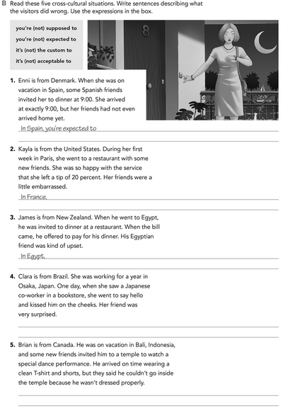

**Imagine you are going to travel to a country you have never visited before. Write sentences using the factors and feelings given. Then add another sentence explaining your feelings. Look at the example.**

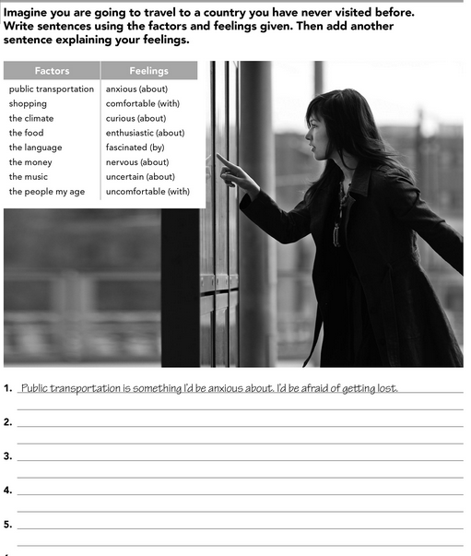

**Complete these sentences with information about yourself (1-4) and about a country you know well (5-8).**

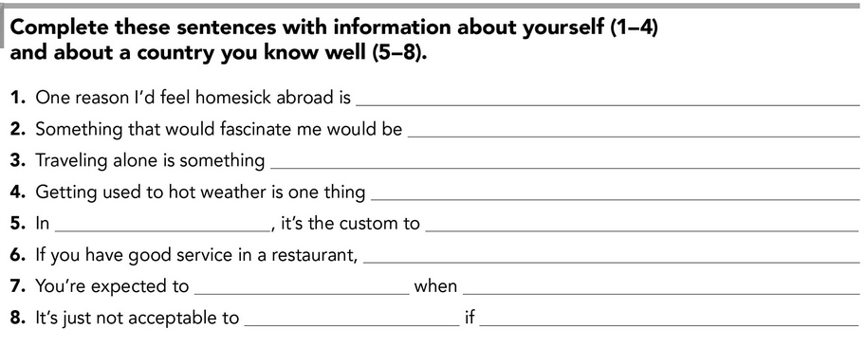

**DEVELOPMENT**

**Look at the example and complete the chart with your own pictures and sentences. Remember to include varied time expressions and verbs in affirmative and negative sentences.**

**NAME OF THE COUNTRY YOU CHOSE: _____________________________________**

**FIND TEN CUSTOMS FROM THIS COUNTRY AND WRITE THEM USING THE FOLLOWING EXPRESSIONS:**

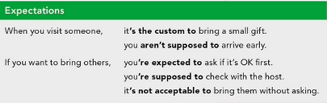



**Write about how would your experience be if you had to move to the country you chose. Use some of the expressions below:**

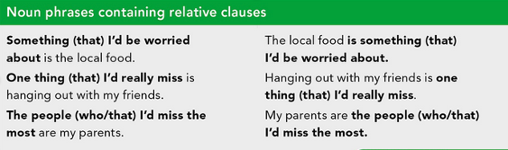

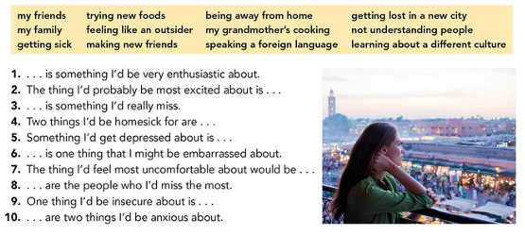



**NOW FIND SOME PICTURES RELATED TO THE THINGS YOU WROTE ABOUT, RECORD YOUR VIDEO AND UPLOAD IT TO THE PADLET.**

**RUBRIC**

