**ESCUELA NORMAL DE EDUCACIÓN PREESCOLAR**

**ENGLISH A2.2**

**UNIT 9 – WHAT DOES SHE LOOK LIKE?**

**GRAMMAR**

Dear students, during the week we will practice describing people’s physical appearance and identifying people describing how they look and what they’re doing. Let’s start with some useful vocabulary!

**ACTIVITY 1 – PHYSICAL APPEARANCE – 30 PTS.**

Review the expressions used to describe people’s appearance.

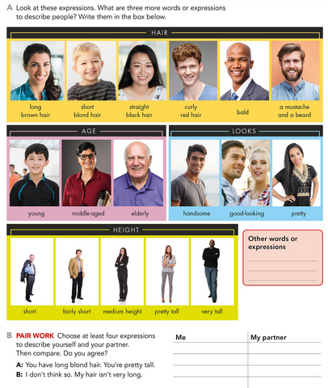

Al describir a una persona podemos hablar sobre su apariencia general, su cabello, su edad, su estatura, etcétera. Para realizar una descripción utilizamos:

* SUBJECT + BE (AM, IS, ARE) – You are young. She is pretty tall. He is handsome. I am 20 years old. My grandfather is bald.
* SUBJECT + HAVE/HAS – He has brown eyes. She has long curly hair.

**Read the descriptions and write the name of the character.**

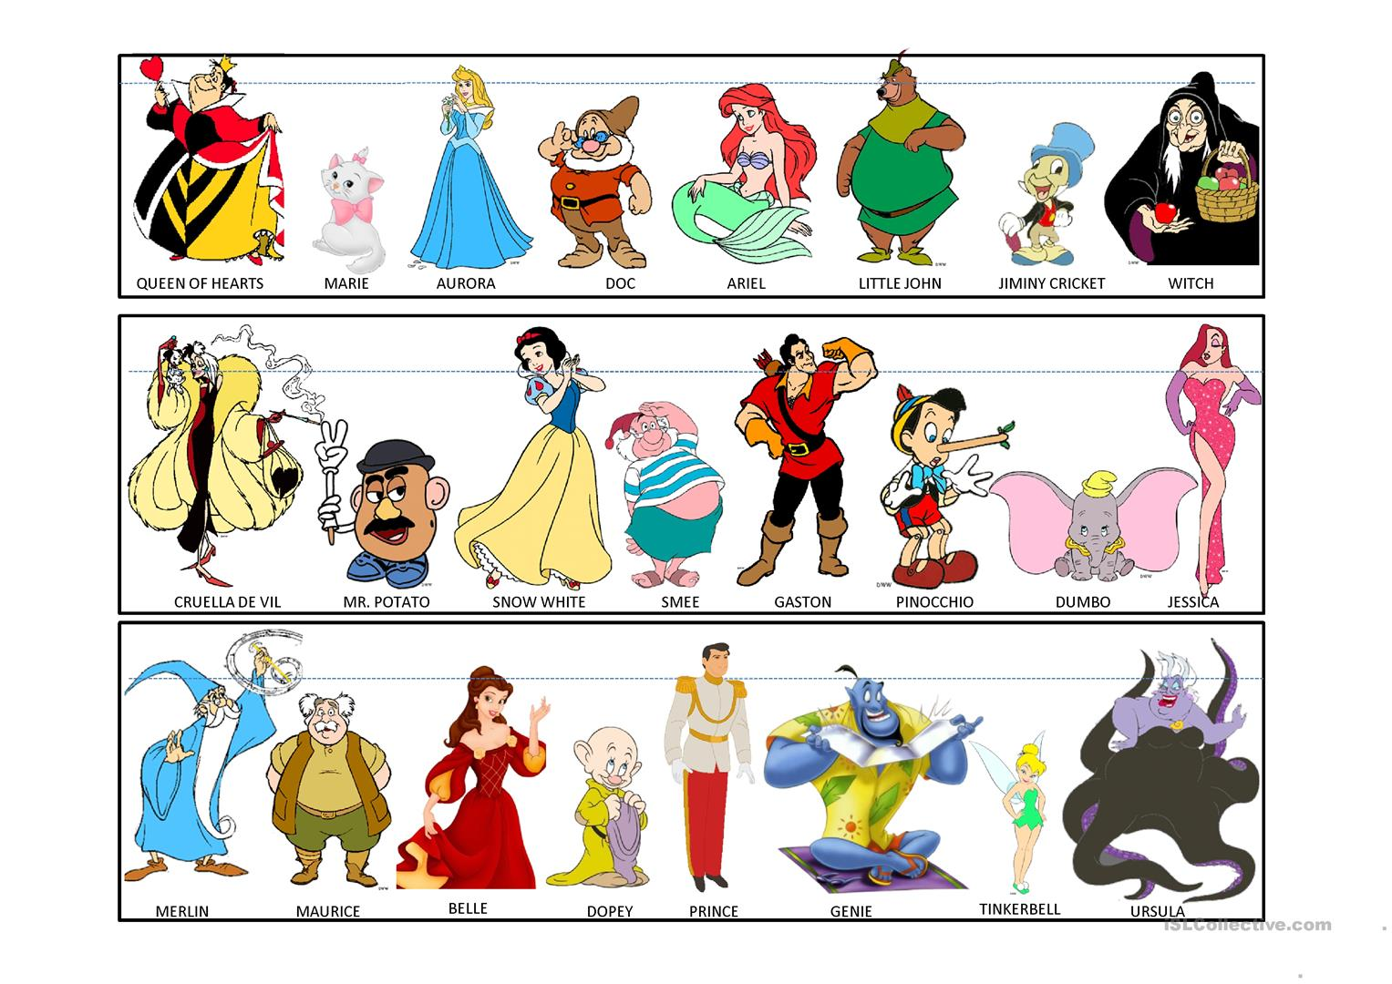

1. She is pretty tall and good looking. She is young. She has short black hair and she is wearing a blue and yellow dress. She isn’t fat. Who is she? ___________________
2. He is an elderly man. He has a mustache and a beard, and he is wearing a blue hat and a blue robe. Who is he? _________________
3. He is a good-looking man. He is very tall, he has black short hair, he is in his twenties and he is wearing a white jacket and red pants. Who is he? ___________
4. She is a middle-aged woman. She is very tall and good-looking. She has red long hair and she is wearing a pink long dress. Who is she? __________________
5. He is an old man. He is very short and has white hair and a mustache. He is wearing a yellow t-shirt and green pants. Who is he? __________________

**Circle two things in each description that do not match the picture. Then correct the information.**

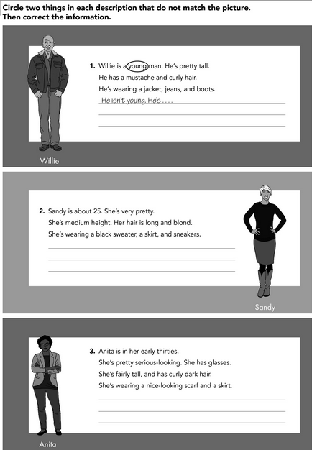

Cuando queremos tener mayor información sobre el aspecto físico de una persona, hacemos preguntas sobre su apariencia general, su estatura (how tall…? / ¿qué tan alt@...?, su cabello (how long…? / qué tan largo…? – What color? / ¿De qué color?), su edad (how old…?),etcétera.

Para responder, utilizamos el verbo BE (am/is/are) y el vocabulario revisado en la actividad anterior. *Ejemplo:* ***How tall*** *is your brother? He is* ***very tall. / ¿Qué tan alto*** *es tu hermano? Él es* ***muy alto****.*

Read and analyze the following examples:

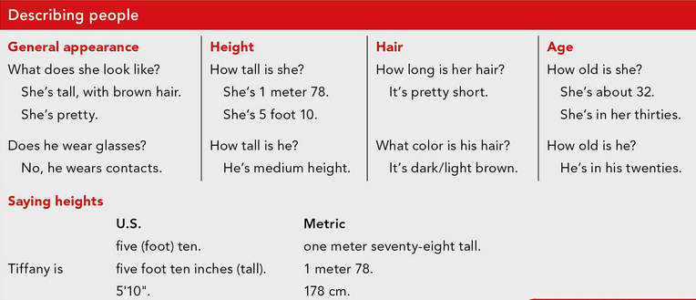

**Answer the following questions about your favorite artist (singer, dancer, actor/actress).**

* What’s his/her name? *His name is…*
* How old is he/she? *He is…*
* Where is he/she from?
* What does he/she look like?
* Does he/she wear glasses?
* How tall is he/she?
* How long is his/her hair?
* What color is his/her hair?

**Answer the following exercises.**

