**NORMAL DE EDUCACIÓN PREESCOLAR**

**ENGLISH A2.2 “sharing information and ideas”**

**UNIT 9 – HOW DOES SHE LOOK LIKE?**

**DEAR STUDENTS,**

**DURING THIS UNIT YOU WILL LEARN VOCABULARY FOR DESCRIBING PEOPLE, AND YOU WILL DESCRIBE PEOPLE’S PHYSICAL APPEREANCE.**

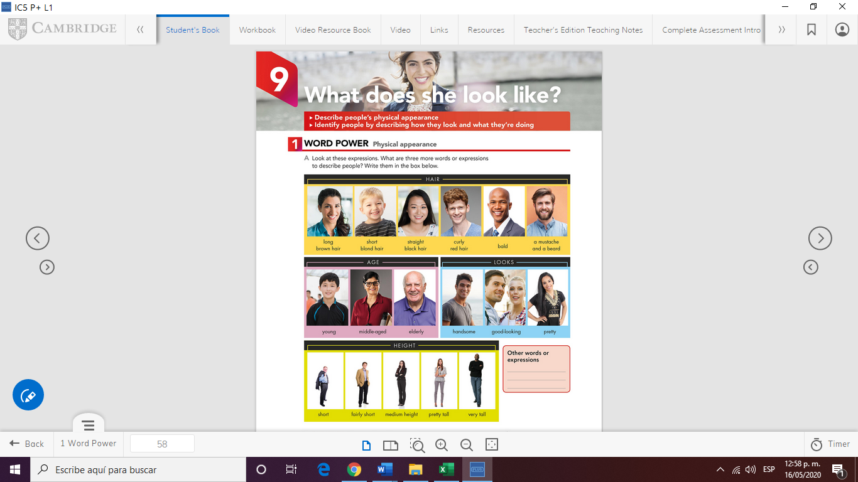

OTHER WORDS AND EXPRESSIONS: ___________________________________________

Click on the following link to practice vocabulary and pronunciation.

<https://learningapps.org/view769850>

listen to the grammar focus (in WhatsApp). Pay attention to the pronunciation and intonation.

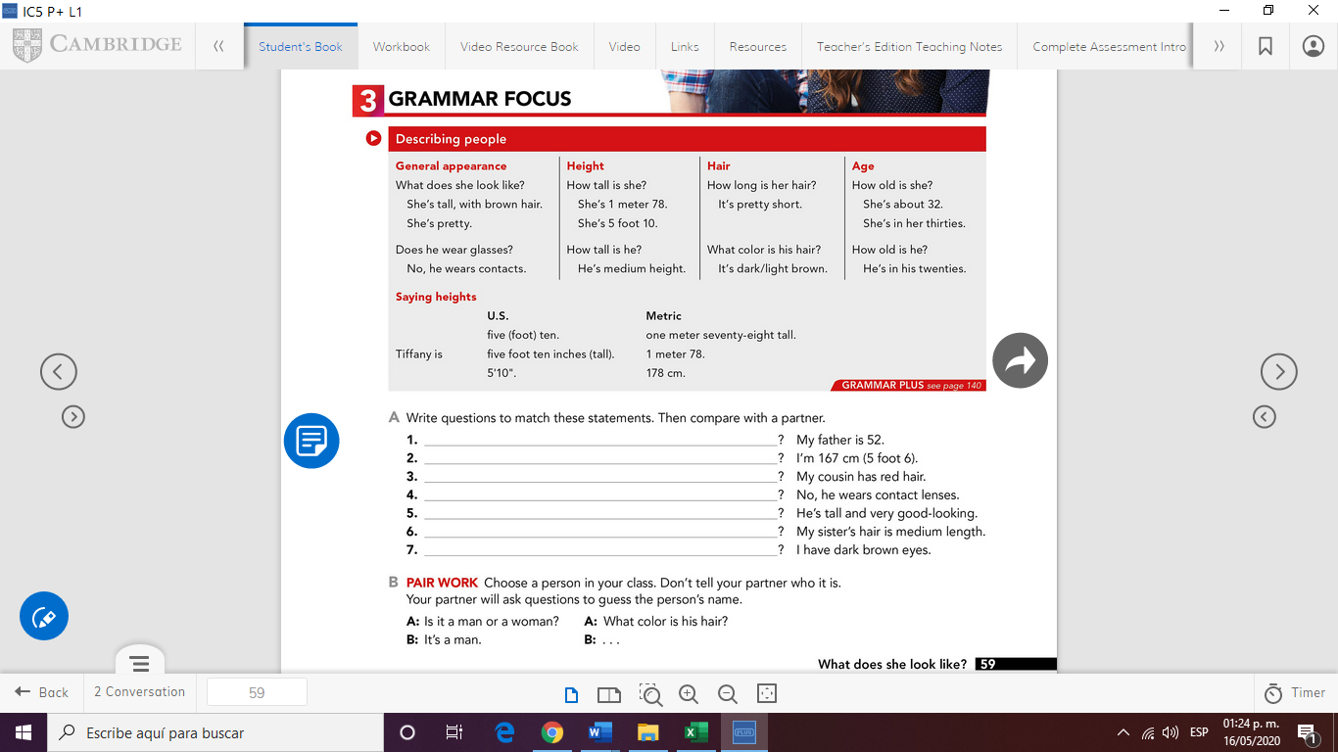

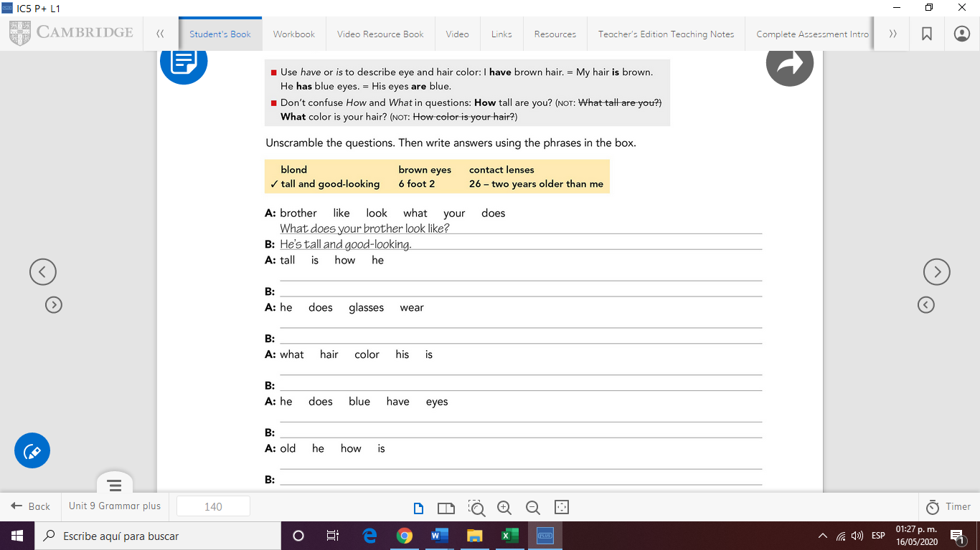



Write your answers here:



Write your questions here: