**ESCUELA NORMAL DE EDUCACIÓN PREESCOLAR**

**ENGLISH A2.2**

**UNIT 7 – WE WENT DANCING – SIMPLE PAST**

**GRAMMAR – QUESTIONS**

Dear students, during the week we will practice the **simple past tense**. You will learn how to make and answer questions about past events.

**ACTIVITY 1 – REMEMBER**

Review the information about when to use the simple past.

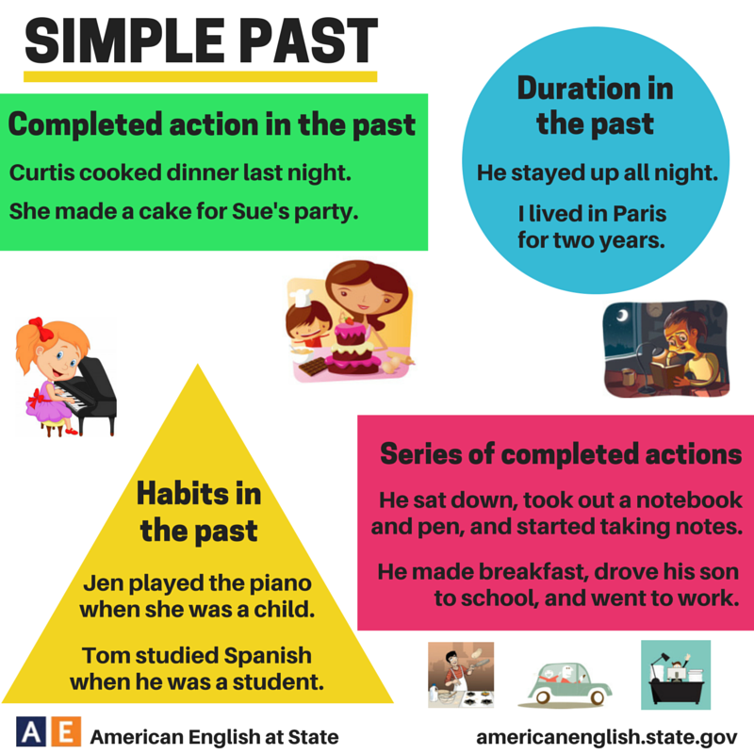

Utilizamos el **pasado simple** para:

* Hablar de una acción o una serie de acciones que ocurrieron en el pasado.
  + *I went to the movies last weekend. / Fui al cine el fin de semana pasado.*
  + *My father took a shower, ate breakfast and went to work. / Mi papa se tomó un baño, comió el desayuno y se fue a trabajar.*
* Hablar de acciones que ocurrieron durante un período de tiempo en el pasado.
  + *I lived in Mérida for two years. / Yo viví en Mérida por dos años.*
* Hablar de cosas que solíamos hacer en el pasado.
  + *She played the piano when she was a child. / Ella tocó el piano cuando era niña.*
  + *Tom studied Spanish when he was a student. / Tom estudió español cuando era estudiante.*

**ACTIVITY 2 – SIMPLE PAST QUESTIONS – 20 PTS.**

Recuerda que hay dos tipos de preguntas, aquellas en las que la respuesta es SI o NO (yes/no questions) y aquellas en las que se pide mayor información sobre un evento (information questions or wh- questions). Es importante mencionar que en preguntas **el verbo se utiliza en su forma simple**, es decir, NO SE CAMBIA AL PASADO puesto que el auxiliar **DID** ya nos indica que se está hablando de algo que ya sucedió.

* **Go to** [**https://www.youtube.com/watch?v=S6_E47aXhwU**](https://www.youtube.com/watch?v=S6_E47aXhwU) **and watch the video. Take notes in your notebook.**
* **Match the questions with the correct answer and write them in your notebook.**

What did you watch on T.V last weekend?

Did you have eggs for breakfast today?

Where did you go on your last vacation?

Did your father work yesterday?

Who did you see at the party?

Did your friends go to the cinema last Sunday?

When did you finish the project?

Did Lisa study for the Math test?

What time did your mother go to bed last night?

Did you and your family do the laundry last week?

I saw my friends Laura and Erick.

No, I didn’t. I had coffee and a toast.

Yes, they did.

We watched horror movies.

No, she didn’t.

At 10:00 p.m.

I finished at midnight, it was really difficult.

Yes, we did. We washed all the clothes.

I went to Puerto Vallarta for a week.

*Example: What did you watch on T.V last weekend? We watched horror movies.*

**ACTIVITY 3 – YES/NO QUESTIONS – 30 PTS.**

Para elaborar preguntas sobre eventos pasados utilizamos el auxiliar DID. En preguntas donde la respuesta es SI o NO utilizamos el auxiliar DID al principio de la siguiente manera:

**DID** + **SUBJECT** + **VERB IN THE SIMPLE FORM** + **COMPLEMENT AND/OR TIME EXPRESSION**?

*Example*. Did you go to school yesterday?

Para responder de forma corta se utilizan las expresiones: Yes, ___ DID. o No, ___ didn’t.

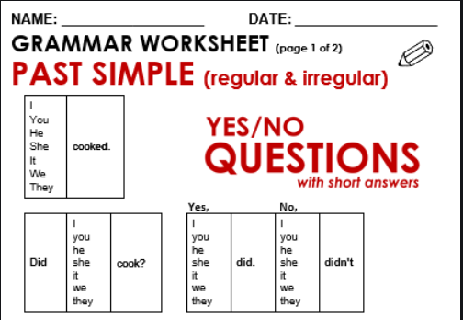

* **Answer the following questions in your notebook with your own information.**

*Ex. Did you have cereal for breakfast? No, I didn’t.*

1. Did you drink coffee this morning?
2. Did your parents work last weekend?
3. Did your best friend call you last week?
4. Did you go to the beach last year?
5. Did you study high school in a public school?
6. Did your mother cook yesterday?
7. Did you visit your grandparents last weekend?
8. Did you go to school two days ago?
9. Did you listen to music yesterday afternoon?
10. Did you and your friends go dancing last weekend?

* **Write five more yes/no questions in your notebook to use them in class next Wednesday.**

**ACTIVITY 3 – INFORMATION QUESTIONS – 30 PTS.**

En preguntas donde pedimos mayor información sobre un suceso (qué, quién, cuándo, donde, etcétera), agregamos la pregunta (WH- word) al principio y seguimos la misma estructura, es decir:

**WH- WORD + DID** + **SUBJECT** + **VERB IN THE SIMPLE FORM** + **COMPLEMENT AND/OR TIME EXPRESSION**?

Para responder se utilizan afirmaciones con la información solicitada (el verbo va en pasado puesto que es una afirmación).

Example. Where did you go last weekend? I went to my grandma’s house.

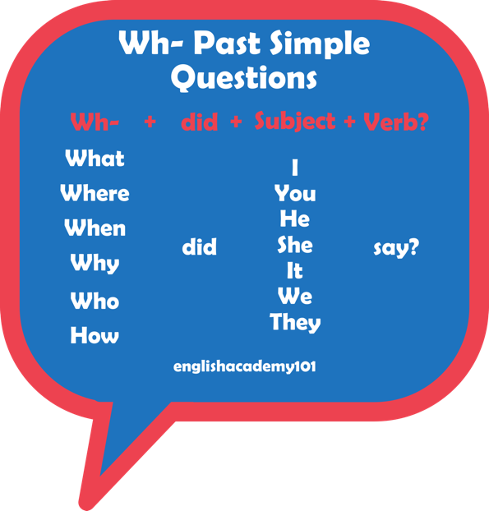

* **Order the words to build information questions about the past and answer them with your own information. Complete this activity in your notebook.**

*Example.*

*did/eat/last Saturday?/What/you*

*What did you eat last Saturday? I ate chicken and noodle soup.*

1. last weekend?/you/do/did/What
2. go/did/Where/your parents/last Saturday?
3. high school?/finish/you/When/did
4. Why/pass/did/your English test?/you
5. get up/today?/did/your best friend/What time

* **Write five more information questions in your notebook to use in class next Wednesday.**

**ACTIVITY 4 – QUESTIONS – 20 PTS.**

* **Complete these conversations in your notebook.**

*stay*

*Did*

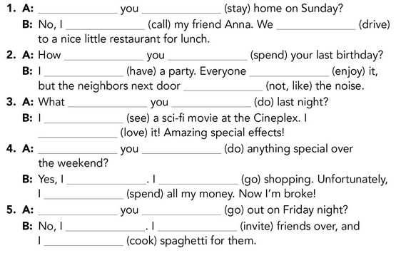

*drove*

*called*