**ESCUELA NORMAL DE EDUCACIÓN PREESCOLAR**

**ENGLISH B1.2**

**UNIT 7 PROJECT**

**USE YOUR VOTE!**



**Aim of the project:**

Give students practice discussing problems and using infinitive clauses and phrases.

This activity will be done in the TEAMS assigned by the teacher.

**Preparation:**

* Visit the following websites and analyze the information about the main problems in Mexico’s educational system.
* <https://www.milenio.com/politica/sep-identifica-seis-problemas-en-sistema-educativo>
* <http://trazandoelrumbo.ibero.mx/la-problematica-persistente-de-la-educacion-en-mexico/#:~:text=El%20acceso%20a%20la%20escuela,han%20concluido%20su%20educaci%C3%B3n%20b%C3%A1sica>.
* <https://merida.anahuac.mx/posgrado/blog/problemas-del-sistema-educativo-en-mexico-y-sus-posibles-soluciones>
* <https://wenr.wes.org/2019/05/education-in-mexico-2>

**Development:**

* Imagine you will elect a Minister of Education for your country. Decide who will be the candidate. Then assign each student a job for the campaign.

Minister of Education (candidate): ____________________________________

Campaign Manager: ______________________________________

Speechwriter: ___________________________________________

* Choose the five most important problems in Mexico’s Educational System and list ways you want to improve education or schools in your country. Then write a speech explaining the improvements and how your candidate will achieve them. **Use the passive voice and prepositions to describe the problem, and infinitive clauses to discuss ways in which these problems can be solved.**

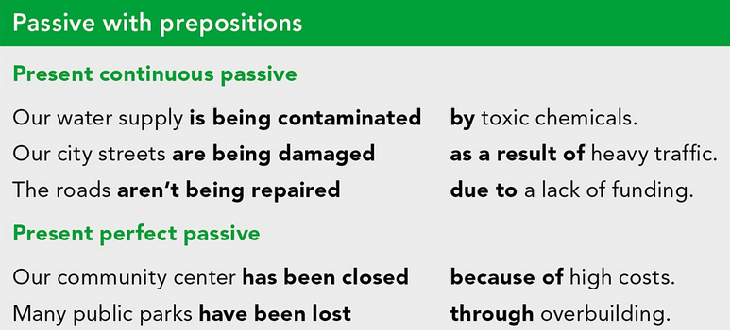

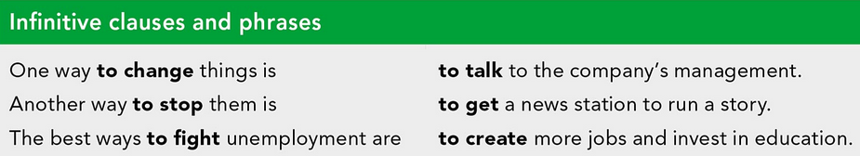

***Example:***

*The most vulnerable groups of our society* ***are not being attended******as a result of*** *the insufficient public expenditure in education and the inequality in its distribution.*

*One way* ***to improve*** *the education in México is* ***to increase*** *the public spending on education and create committees to ensure that these resources are well invested inside schools and communities.*

* Make a presentation with posters, buttons, and signs to help promote your candidate and upload a promotional video to the PADLET. Your classmates will watch your video and use their vote to choose the best Minister of Education for our country.

**Products:**

* Go to <https://padlet.com/alvaradocris87/btrml0zwovpq7dv2> and upload your **video** to the Padlet.

**DEVELOPMENT OF THE PROJECT**

**Imagine you will elect a Minister of Education for your country. Decide who will be the candidate. Then assign each student a job for the campaign.**

Minister of Education (candidate): ____________________________________

Campaign Manager: ______________________________________

Speechwriter: ___________________________________________

**Choose the five most important problems in Mexico’s Educational System and list ways you want to improve education or schools in your country. Then write a speech explaining the improvements and how your candidate will achieve them. Use the passive voice and prepositions to describe the problem, and infinitive clauses to discuss ways in which these problems can be solved.**

**INCLUDE YOUR SPEECH DESCRIBING THE PROBLEMS AND PROVIDING SOLUTIONS HERE:**

**RUBRIC**

