**ESCUELA NORMAL DE EDUCACIÓN PREESCOLAR**

**ENGLISH A2.1**

**UNIT 3 PROJECT**

**CLOTHING AND FASHION**



**Aim:** To practice talking about clothes and discussing preferences.

**PREPARATION**

**Task 1 – Vocabulary practice**

Review the vocabulary you must include in your project. Click on the link and complete the activity: <https://wordwall.net/play/25877/429/125>

**Task 2 – Demonstratives; oneand ones.**

Review demonstratives and the use of one and ones. Click on the link and complete the activity: <https://wordwall.net/play/25878/067/266>

**Task 3 – Preferences; comparing clothes**

Practice building sentences to talk about preferences and compare clothin ítems and accesories.Click on the link and complete the activity: <https://wordwall.net/play/25878/369/568>

Click on the link and practice writing comparatives, send the results to your teacher ([alvaradocris87@gmail.com](mailto:alvaradocris87@gmail.com)): <https://es.liveworksheets.com/ou1452452dl>

**Task 4: Writing (50 words at least)**

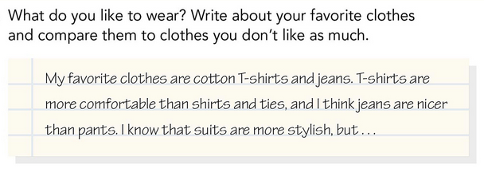

Write your paragraph here:

**DEVELOPMENT**

**Instructions:**

In this Project you must create a video giving your opinion on different clothing ítems and accesories.

1. Prepare 10 pairs of clothing items and/or accesories (2 sweaters, 2 pairs of boots, 2 bracelets, etcetera)
2. Write a script where you compare each pair of items. Describe the items, talk about their price, their color, their material, and tell people which one you prefer and why. Remember to include the vocabulary and grammar structures from the unit.
3. Record a video talking about five sets of items.
4. Upload your video to our Padlet: <https://padlet.com/alvaradocris87/pum2f7miczaia64y>
5. Make comments on your classmates videos.

You can use some of these expressions when giving your opinion:

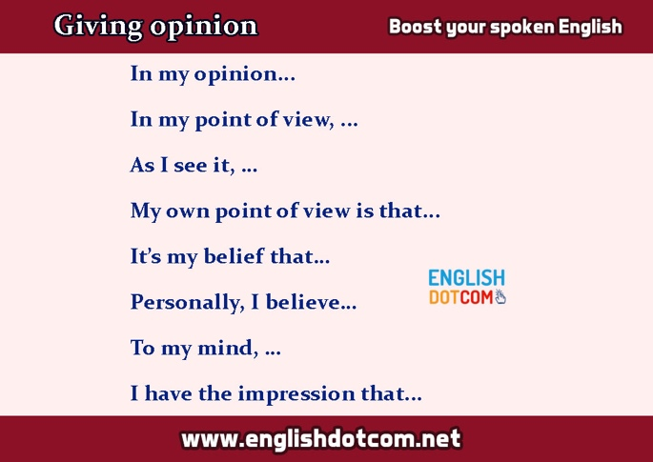

Example:

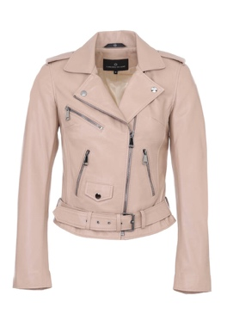 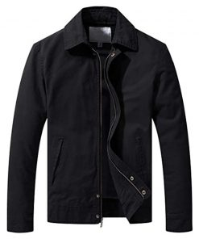

Here I have **two jackets**, this is a beige leather jacket and it’s $40.00, and this is a black cotton jacket and it’s $25.00. The cotton jacket is cheaper tnan the leather jacket.

In my opinion the cotton jacket is warmer than the leather one, but the leather jacket is more beautiful than the cotton one.

Write your script here:

**PRODUCTS**

1. Preparation tasks
   1. Wordwall activities
   2. Paragraph about favorite clothes
2. Final products
   1. Script
   2. Video uploaded to Padlet

**RUBRIC**

|  |  |  |  |
| --- | --- | --- | --- |
| **ACTIVITIES** | **1 POINT** | **3 PTS** | **5 PTS** |
| **PREPARATION ACTIVITIES** | **Links:**  Incomplete tasks in Wordwall and Liveworksheets.  **Paragraph:**  Paragraph of 50 words or less. The content is not relevant to the task. | **Links:**  Complete tasks in Wordwall and Liveworksheets.  **Paragraph:**  Paragraph of less than 50 words written. The content is relevant to the task. | **Links:**  Complete tasks in Wordwall and Liveworksheets.  **Paragraph:**  Paragraph of at least 50 words written. The content is relevant to the task. |
| **FINAL PRODUCTS** | **Script:**  The description and/or comparison of some sets of items is missing.  **Video:**  Less than 5 sets of items are described and compared.  **Poor use of vocabulary and grammar structures from the unit.**  **Poor use of expressions to give an opinion.** | **Script:**  10 sets of items are described and compared.  **Video:**  5 sets of items are described and compared.  **Some vocabulary words and grammar structures from the unit are used.**  **Some expressions to give an opinion are used.** | **Script:**  10 sets of items are described and compared.  **Video:**  5 sets of items are described and compared.  **Use of vocabulary and grammar structures from the unit.**  **Use of expressions to give an opinion.** |
| **SPEAKING PERFORMANCE** | Too much hesitation which interferes with communication.  Pronunciation and intonation error make it difficult to understand the conversation. | The student speaks with some hesitation but it doesn’t interfere with communication.  Pronunciation and intonation are clear and accurate with a few problems. | The student speaks with fluency.  Pronunciation and intonation are clear and accurate. |