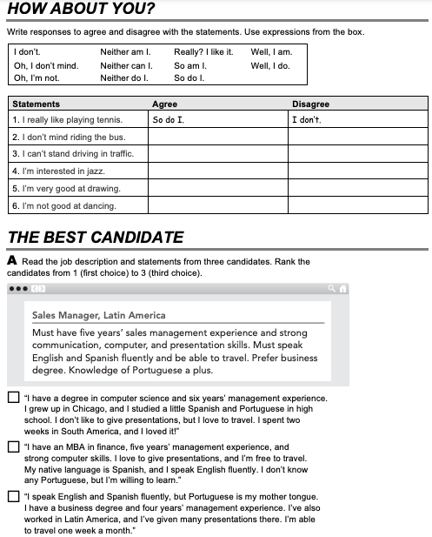

GO TO <https://www.cambridge.org/files/1514/9745/2965/IC5_TSS_L2U10.mp3> . LISTEN AND ANSWER.

