**ESCUELA NORMAL DE EDUCACIÓN PREESCOLAR**

**ENGLISH A2**

**UNIT 6 “HOW OFTEN DO YOU RUN?”**

**VOCABULARY LOG**

**ACTIVITY 1**

**Copy** the vocabulary list in your notebook and **draw pictures** for each word to help you remember its meaning.

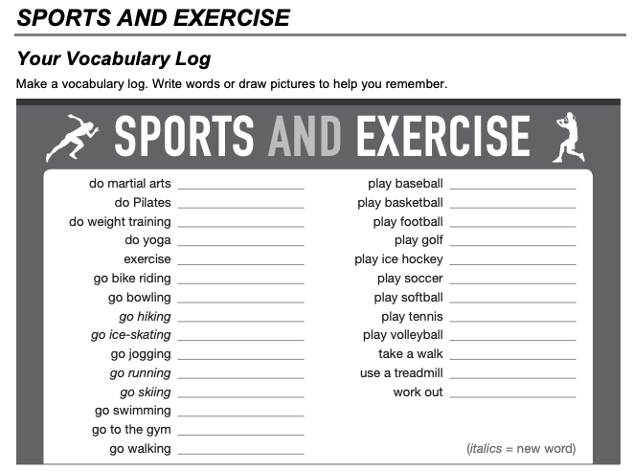

**ACTIVITY 2**

**Watch the video** and analyze the examples. <https://www.youtube.com/watch?v=VAWo65QwP2c>

**Write** sentences telling **HOW OFTEN** you do the activities from the vocabulary log.

**Use** the following frequency adverbs:

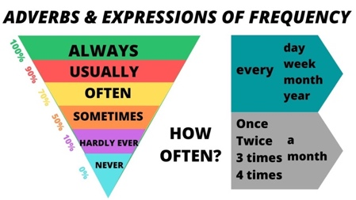

**Example:** *I never do martial arts.* or *I do martial arts twice a week.*