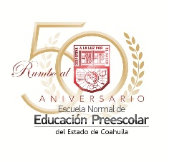

*Escuela Normal De Educación Preescolar*

*English Project: A life in paintings*

*Student´s name:*

*Daisy Carolina Perez Nuncio.*

*Teacher´s name: Guadalupe del Rocío Robledo Corpus.*

*Saltillo, Coahuila. March 2023*

*Project unit 1: A life in paintings*

Competences: Devise learning and teaching proposal using innovative methodologies and applying new technologies to education.

Reflect on one´s own learning process to act consciously in communicative exchanges.

Instructions: Choose a famous painter and research about his/her life.

You have to write his/her biography, childhood, his/her work, then with the information create a collage and use it to explain his/her life to your classmates.

Remember that you have to use the past tense, auxiliar did and the used to.

|  |  |  |  |  |
| --- | --- | --- | --- | --- |
| Category | Unsatisfactory 2 | Satisfactory 3 | Proficient 4 | Excellent 5 |
| On time | Doesn’t deliver the project | Deliver the project out of time. | Deliver the project out of time but show a formal excuse. | Deliver the project on time |
| Creativity | Not creative or original | It is creative and original enough | It is quite creative and original | It is very creative and original |
| Contents | Insufficient or improper contents.  Doesn’t show evidence of knowledge. | Show evidence of knowledge. Enough contents. | Enough contents  Show mastery of knowledge. | Outstanding content  Show excellent knowledge. |
| Presentation | Information and ideas are poorly sequenced (the author jumps around). | Information and ideas are presented in an order that the audience can follow with minimum difficulty. | Information and ideas are presented in a logical sequence which is followed by the reader with little or no difficulty. | Information and ideas are presented in a logical sequence which flows naturally and is engaging to the audience. |

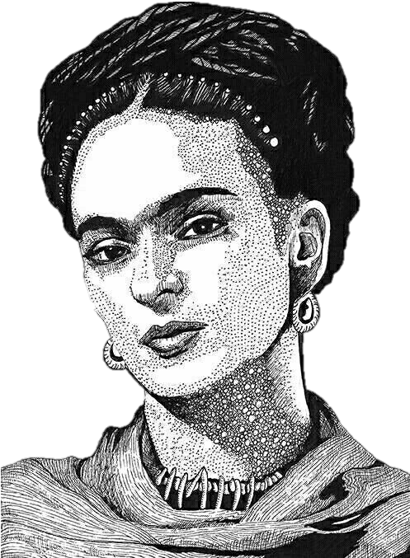

FRIDA KAHLO

**SPANISH**

Magdalena Carmen Frida Kahlo Calderón, ​ conocida como Frida Kahlo, nació el 06 de julio de 1907 en Coyoacán, Ciudad de México.

Ella fue una pintora mexicana. Su obra gira temáticamente en torno a su biografía y a su propio sufrimiento. Fue autora de 150 obras, principalmente autorretratos, en los que proyectó sus dificultades por sobrevivir. Frida Kahlo creó una pintura absolutamente personal, ingenua y profundamente metafórica al mismo tiempo, derivada de su exaltada sensibilidad y de varios acontecimientos que marcaron su vida cuya compleja simbología se conoce por las explicaciones de la propia pintora.

A los dieciocho años Frida Kahlo sufrió un gravísimo accidente que la obligó a una larga convalecencia, durante la cual aprendió a pintar, y que influyó con toda probabilidad en la formación del complejo mundo psicológico que se refleja en sus obras. En 1929 contrajo matrimonio con el muralista Diego Rivera; tres años después sufrió un aborto que afectó en lo más hondo su delicada sensibilidad y creo dos de sus obras más valoradas: Henry Ford Hospital y Frida y el aborto.

También son muy apreciados sus autorretratos, asimismo de compleja interpretación: Autorretrato con monos o Las dos Fridas.

En su búsqueda de las raíces estéticas de México, Frida Kahlo realizó espléndidos retratos de niños y obras inspiradas en la iconografía mexicana anterior a la conquista, pero son las telas que se centran en ella misma y en su difícil vida las que la han convertido en una figura destacada de la pintura mexicana del siglo XX.

Desde los 6 años su vida se vio envuelta en enfermedades como la poliomielitis y en 1925 sufrió un grave accidente de tráfico que le fracturó la columna vertebral y la pelvis. Además de imposibilitarle tener hijos, el accidente fue la causa de una salud siempre precaria.

A través de la pintura, que empezó a practicar en los largos meses de inmovilidad tras el accidente, Frida Kahlo reflejaría de forma soberbia el enfrentamiento entre su ansia de felicidad y la insistente amenaza de su destrucción, a la vez que conjuraba la realidad entre los sueños de amor e hijos y la realidad entre el dolor e impotencia.

Le colocaron un espejo bajo su cama y un carpintero le fabricó una especie de caballete que le permitía pintar estando acostada. Éste fue el inicio de una larga serie de autorretratos, tema que ocupa el retrato de su producción.

Ella en una ocasión afirmó: "Me retrato a mí misma porque paso mucho tiempo sola y porque soy el motivo que mejor conozco." En poco tiempo Frida desarrolló un vocabulario simbólico propio; con él acompañaba sus retratos para representar metafóricamente sus experiencias y sus pensamientos.

A principios de 1954, tuvieron que amputarle la pierna por una infección de gangrena, esto la sumió en una gran depresión, escribiendo una de tantas frases profundas que le caracterizaba, “pies para que los quiero sí tengo alas para volar”.

Su diario se cerró para siempre con esta declaración: “Espero alegre la salida y espero no volver jamás”.

El 13 de julio de 1954, el Palacio de Bellas Artes en la Ciudad de México, se vistió de flores para recibir el cuerpo sin vida de la pintora mexicana Frida Kahlo, de tan solo 47 años, quien amaneció en su cama como si estuviera dormida, había muerto sin darse cuenta.

**ENGLISH**

Magdalena Carmen Frida Kahlo Calderón, known as Frida Kahlo, was born on July 6, 1907, in Coyoacán, Mexico City.

She was a Mexican painter. His work thematically revolves around his biography and his own suffering. She was the author of 150 works, mainly self-portraits, in which she projected her difficulties to survive. Frida Kahlo created a personal painting, naive and deeply metaphorical at the same time, derived from her exalted sensitivity and various events that marked her life whose complex symbology is known from the painter's own explanations.

At the age of eighteen, Frida Kahlo suffered a very serious accident that forced her to undergo a long convalescence, during which she learned to paint, and which most likely influenced the formation of the complex psychological world that is reflected in her works. In 1929 she married the muralist, Diego Rivera; three years later she suffered an abortion that deeply affected her delicate sensibility and I create two of his most valued works: ***Henry Ford Hospital ( La cama volando) y Frida y el aborto.***

His self-portraits, of complex interpretation, are also highly appreciated: ***Autorretrato con monos o Las dos Fridas.***

In her search for the aesthetic roots of Mexico, Frida Kahlo made splendid portraits of children and works inspired by pre-conquest Mexican iconography, but it is the canvases that focus on herself and her difficult life that have made her an outstanding figure of 20th century Mexican painting.

From the age of 6 his life was involved in diseases such as poliomyelitis and in 1925 he suffered a serious traffic accident that fractured his spine and pelvis. In addition to making, it impossible for her to have children, the accident was the cause of her always precarious health.

Through painting, which she began to practice in the long months of immobility after the accident, Frida Kahlo would superbly reflect the confrontation between her desire for happiness and the insistent threat of her destruction, at the same time that she conjured up reality among the dreams of love and children and reality between pain and impotence.

They placed a mirror under her bed and a carpenter made her a kind of easel that allowed her to paint while lying down. This was the beginning of a long series of self-portraits, a subject that occupies the portrait of his production.

She once stated: "I portray myself because I spend a lot of time alone and because I am the reason I know best." In a short time, Frida developed her own symbolic vocabulary; with it he accompanied his portraits to metaphorically represent his experiences and his thoughts.

At the beginning of 1954, her leg had to be amputated due to a gangrene infection, this plunged her into a great depression, writing one of the many profound phrases that characterized her, “what do I want feet for if I have wings to fly”.

His diary closed forever with this declaration: "I look forward to leaving and I hope never to return."

On July 13, 1954, the Palace of Fine Arts in Mexico City, dressed in flowers to receive the lifeless body of the Mexican painter Frida Kahlo, only 47 years old, who woke up in her bed as if she were asleep, had died without realizing it.

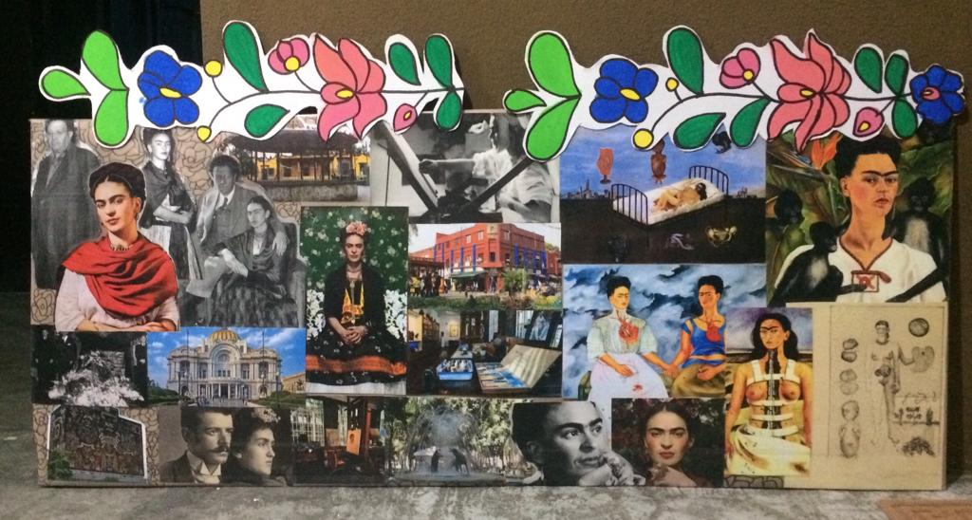**COLLAGE.**

**Link of the video:**

[**https://youtu.be/TspUWitK7S8**](https://youtu.be/TspUWitK7S8)