**

*Escuela Normal De Educación Preescolar*

*English Project: Sports star*

*Student´s name: Tania Melisa Gutierrez Fonseca*

*Eva Carolina Moron Perez*

*Teacher´s name: Guadalupe del Rocío Robledo Corpus.*

*Saltillo, Coahuila. May 2023*

**Project unit 2 Sports star**

**interviewer**: Hello, good morning today in sports section we have the fabulous swimmer Eva. Wichi has participated in the Olympics and toor 3 gold medals and 1 silver. But tell us, how old did you started in this sport?

**Swimmer**: Hello, it’s a great pleasure for me to be here, well look, I started very young, my mother has a always loved the water, so she took me to swimming courses since I was 2 years old

**interviewer**: Wow you started very young, so your mom was a big influence on you in this sport

**Swimmer**: if so, in fact I dedicate all my medals to her

**Interviewer:** something that to our viewers is what do you do every day, so please share your training routine with us

**Swimmer:** sure, every day I get up at 6 am, I go running for a 1 hour, and them nearly all prepared brands with eggs in omelet. At 10 I arrive at the pool in the city center, and I’m practice about 1 hour in the afternoon. I often eat something heavier when the dessert is already coming down. I do breathing exercises in the pool and I return home at 6, I have something lighter for dinner and I sleep at 9 o’clock at night. This is my routine from Monday to Friday, and twice a week I rest, I go out with my family or my friends.

**Interviewer:** wow, is genius but tell us how feels to be the one to represent Mexico in the Canadian championships 2023

**Swimmer:** it is very exciting and great responsibility

**Interviewer**: than you very much for sharing a bit of your life with us, the truth is that we are very proud of everything you have archived and that you are our representative, we hope you do well and I hope to be able to interview you in Canada

**Swimmer:** of course, see you there

**Interviewer:** see you

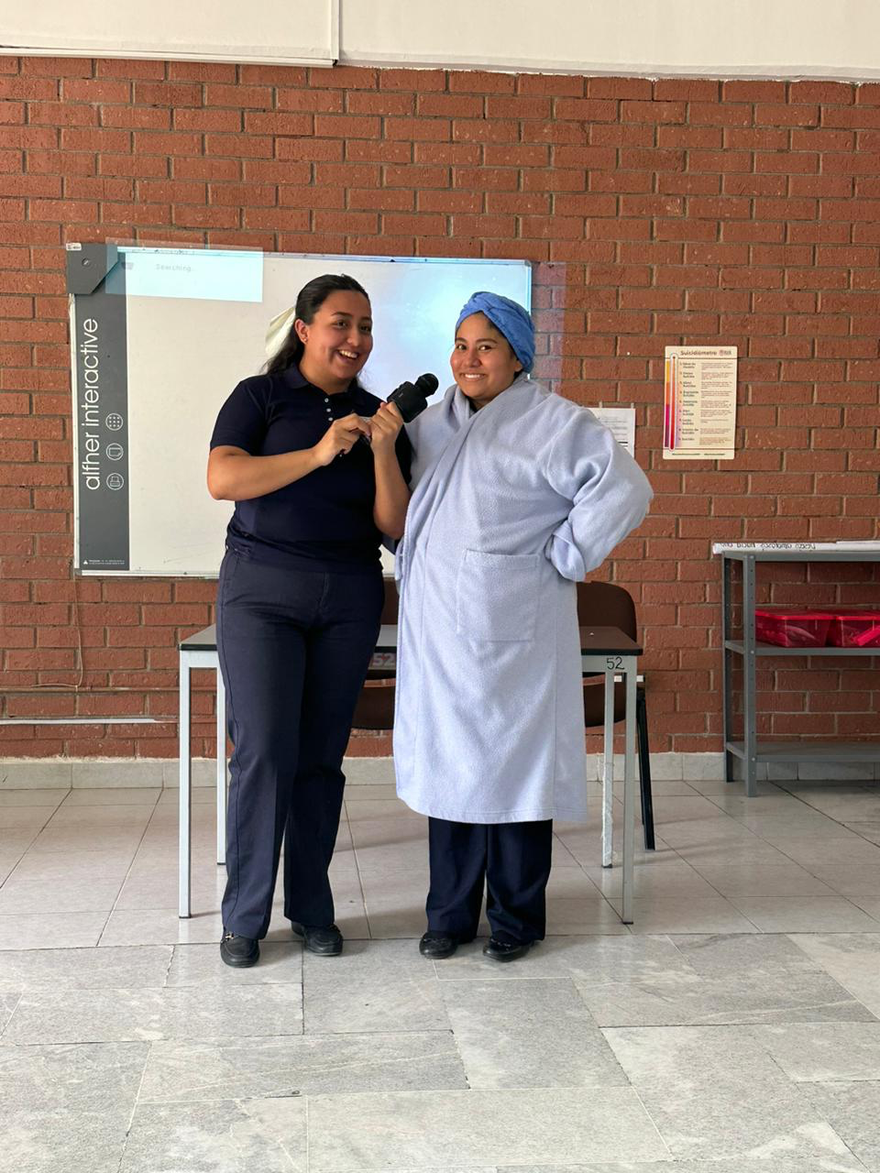

|  |  |  |  |  |
| --- | --- | --- | --- | --- |
| Category | Unsatisfactory 2 | Satisfactory 3 | Proficient 4 | Excellent 5 |
| On time | Doesn’t deliver the project | Deliver the project out of time. | Deliver the project out of time but show a formal excuse. | Deliver the project on time |
| Creativity | Not creative or original | It is creative and original enough | It is quite creative and original | It is very creative and original |
| Contents | Insufficient or improper contents.  Doesn’t show evidence of knowledge. | Show evidence of knowledge. Enough contents. | Enough contents  Show mastery of knowledge. | Outstanding content  Show excellent knowledge. |
| Presentation | Information and ideas are poorly sequenced (the author jumps around).  If you read your grade is going be less | Information and ideas are presented in an order that the audience can follow with minimum difficulty. | Information and ideas are presented in a logical sequence which is followed by the reader with little or no difficulty. | Information and ideas are presented in a logical sequence which flows naturally and is engaging to the audience. |