**

*Escuela Normal De Educación Preescolar*

*English Project: Sports star*

*Student´s name:*

*Mayra Ruby Ontiveros*

*Ana Paula Saucedo Muñiz*

*Patricia Abigail Sanchez Cardenas*

*Teacher´s name: Guadalupe del Rocío Robledo Corpus.*

*Saltillo, Coahuila. Monday 8 May 2023*

Project unit 2 Sports star

Pair work: In pairs you will participate in a role play in where one of you is going to be a famous sport star, and the other will be a reporter, you must create an interview and present it to the group.

Write the interview script in this document and add a cover.

Remember use the adverbs of frequency and questions like how often do you…? How long do you…?

Date to deliver: Monday, May 8

**INTERVIEW 1**

Reporter: Good morning today we are in a high-performance sports center.

Reporter: What's your name?

Interviewee: Good morning My name is Ana Gabriela Guevara

Reporter: What sport do you practice?

Interviewee: Athletics practices, a great discipline

Reporter: How long have you been playing this sport?

Interviewee: I have been in this discipline for Twelve years

Reporter: How much time do you spend training each day?

Interviewee: I always train with a duration of three hours a day, although many times the training time is extended

Reporter: How often do you attend an athletics meeting?

Interviewee: I attend regularly, one or two a week even though sometimes they are improvised

Reporter: How well do you practice?

Interviewee: Very practical, I am a specialist in the four hundred and eight hundred meters with the shortest time in the world,

Reporter: That would be all thank you very much.

Interviewee: don't forget to play a sport

**INTERVIEW 2**

eporter: What's your name?

Interviewee: HI my name is Paola Longoria

Reporter: What sport do you practice?

Interviewee: i'm practices tennis

Reporter: How long have you been playing this sport?

Interviewee:I have been in this practice for ten years

Reporter: How much time do you spend training each day?

Interviewee: I always train with two or three hours a day.

Reporter: How often do you attend an athletics meeting?

Interviewee:I I attend regularly, once or twice a week.

Reporter: How well do you practice?

Interviewee: I'm very good at sports this is due to practices and training

Reporter: That would be all thank you very much.

Interview you're welcom bye

X

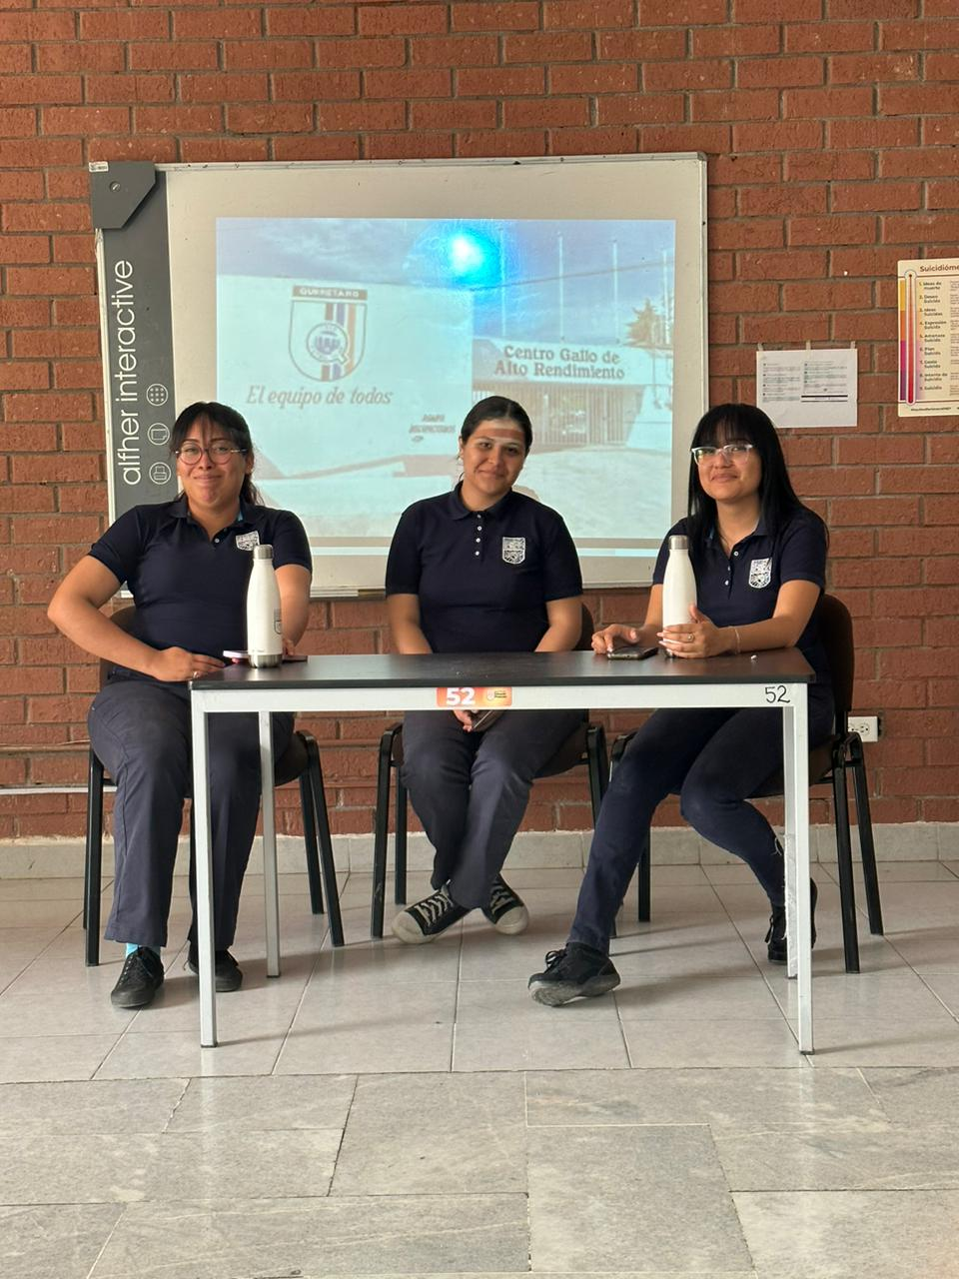

|  |  |  |  |  |
| --- | --- | --- | --- | --- |
| Category | Unsatisfactory 2 | Satisfactory 3 | Proficient 4 | Excellent 5 |
| On time | Doesn’t deliver the project | Deliver the project out of time. | Deliver the project out of time but show a formal excuse. | Deliver the project on time |
| Creativity | Not creative or original | It is creative and original enough | It is quite creative and original | It is very creative and original |
| Contents | Insufficient or improper contents.  Doesn’t show evidence of knowledge. | Show evidence of knowledge. Enough contents. | Enough contents  Show mastery of knowledge. | Outstanding content  Show excellent knowledge. |
| Presentation | Information and ideas are poorly sequenced (the author jumps around).  If you read your grade is going be less | Information and ideas are presented in an order that the audience can follow with minimum difficulty. | Information and ideas are presented in a logical sequence which is followed by the reader with little or no difficulty. | Information and ideas are presented in a logical sequence which flows naturally and is engaging to the audience. |