**

**

*Escuela Normal De Educación Preescolar*

*English Project: Sports star*

*Student´s name:*

*Fatima Lizbeth Anguiano Calderón. #1*

*Perla Abigail Cepeda Garcia. #2*

*Teacher´s name: Guadalupe del Rocío Robledo Corpus.*

*Saltillo, Coahuila. May 2023*

F: Hello my name is Mariazel, what your name?

P: Hi, my name is Guillermo Ochoa. You can call me “Memo”

F: Nice to meet you memo. How old are you?

P: I am 37 years old

F: Do you practice and sport?

P: Yes, I play soccer

F:It´s interesting, How long have you been practicing it?

P: 19 years ago I started playing with the American team

F: how good are you playing?

P: I am pretty good

F: How often do you train?

P: Two awards, every day

F: Wow.. That’s more time. Tanks you fir you time. See you leter

P: Good bye!, have a good day.

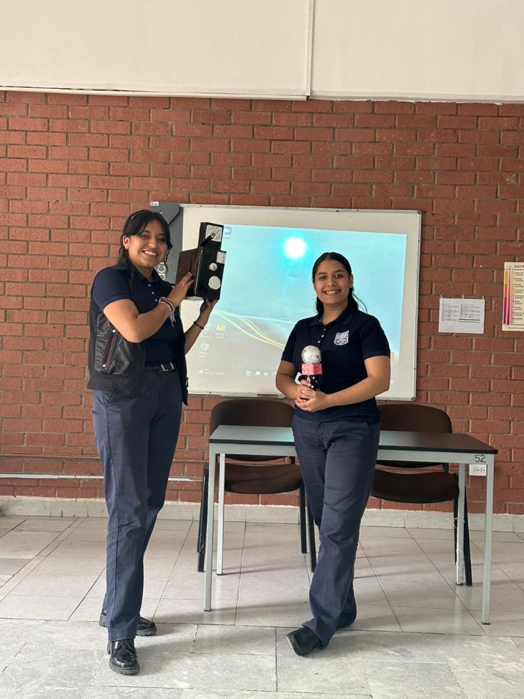

Project unit 2 Sports star

Pair work: In pairs you will participate in a role play in where one of you is going to be a famous sport star, and the other will be a reporter, you must create an interview and present it to the group.

Write the interview script in this document and add a cover.

Remember use the adverbs of frequency and questions like how often do you…? How long do you…?

Date to deliver: Monday, May 8

|  |  |  |  |  |
| --- | --- | --- | --- | --- |
| Category | Unsatisfactory 2 | Satisfactory 3 | Proficient 4 | Excellent 5 |
| On time | Doesn’t deliver the project | Deliver the project out of time. | Deliver the project out of time but show a formal excuse. | Deliver the project on time |
| Creativity | Not creative or original | It is creative and original enough | It is quite creative and original | It is very creative and original |
| Contents | Insufficient or improper contents.  Doesn’t show evidence of knowledge. | Show evidence of knowledge. Enough contents. | Enough contents  Show mastery of knowledge. | Outstanding content  Show excellent knowledge. |
| Presentation | Information and ideas are poorly sequenced (the author jumps around).  If you read your grade is going be less | Information and ideas are presented in an order that the audience can follow with minimum difficulty. | Information and ideas are presented in a logical sequence which is followed by the reader with little or no difficulty. | Information and ideas are presented in a logical sequence which flows naturally and is engaging to the audience. |