**

*Escuela Normal De Educación Preescolar*

*English Project: Sports star*

*Student´s name: Estrella Janeth Sanchez Moncada*

*Jenifer Janeth Garcia Escobedo*

*Monserrath Valdez Rios*

*Teacher´s name: Guadalupe del Rocío Robledo Corpus.*

*Saltillo, Coahuila. May 2023*

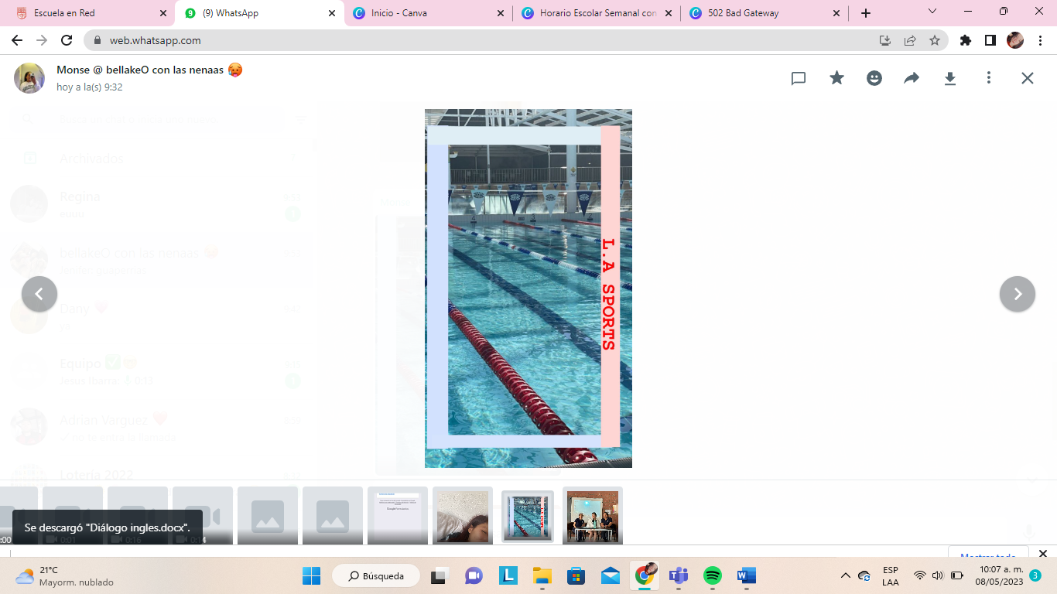**PROJECT UNIT 2 SPORTS STAR**

L.A. SPORTS

Good morning, everyone, welcome to L.A. Sports with Jenni and Monse

Today we are pleased to welcome Estrella Janeth, a professional swimmer, with us.

(Aplausos)

Estrella: Thanks for inviting me, it is a pleasure for me to be in your program.

Monse: Can we ask you a few questions about your career?

Estrella: Sure!

Jenni: At what age did you start swimming?

Estrella: I started since I was three years old.

Monse: Wow! You were so little. How has been the process of becoming a swimmer been?

Estrella: Oh! It has been so difficult, but all these years of work have been worth it.

Jenni: Have you always liked swimming or did you choose it for another reason.

Estrella: Yes, since I was a child, I adored to be in the water all the time.

Monse: Who are the people who are supported you in this process?

Estrella: My parents and my brothers all the time. From taking me to the training, supporting me with my diet and attending every competition.

Jenni: That’s so cool to have the support of your family. Well, how long do you train daily?

Estrella: Usually I train two hours a day, but I rest on Sundays because the rest is important for our muscles.

Monse: How do you prepare for a competition?

Estrella: The training before a competition is very heavy. I must be in the pool about three or four hours a day.

Jenni: What type of swimming do you consider to be your specialty?

Estrella: Crawl technique and butterfly swim.

Jenni: How do you eat a balanced diet?

Estrella: Well, I eat about four or five times a day to have a lot of energy. On breakfast I usually eat two eggs with avocado toast, some fruit, and the green juice. For snack I drink a protein shake; for lunch I eat chicken or fish with salad and rice. And finally for dinner I usually eat tuna with vegetables.

Monse: Do you eat some junk food?

Estrella: Sure! All of us need some junk food, but I just eat it twice a month.

Jenni: Perfect! That’s all. Thanks for coming.

Estrella: Thanks for inviting me, it has been a pleasure.

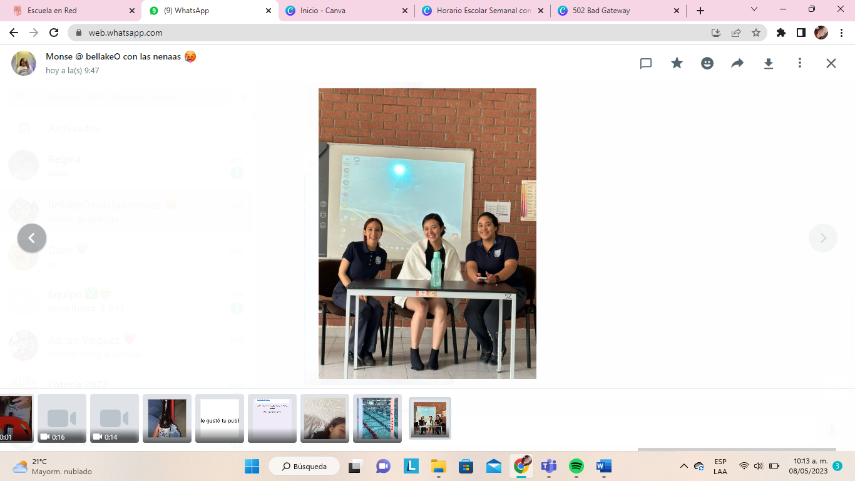

|  |  |  |  |  |
| --- | --- | --- | --- | --- |
| Category | Unsatisfactory 2 | Satisfactory 3 | Proficient 4 | Excellent 5 |
| On time | Doesn’t deliver the project | Deliver the project out of time. | Deliver the project out of time but show a formal excuse. | Deliver the project on time |
| Creativity | Not creative or original | It is creative and original enough | It is quite creative and original | It is very creative and original |
| Contents | Insufficient or improper contents.  Doesn’t show evidence of knowledge. | Show evidence of knowledge. Enough contents. | Enough contents  Show mastery of knowledge. | Outstanding content  Show excellent knowledge. |
| Presentation | Information and ideas are poorly sequenced (the author jumps around).  If you read your grade is going be less | Information and ideas are presented in an order that the audience can follow with minimum difficulty. | Information and ideas are presented in a logical sequence which is followed by the reader with little or no difficulty. | Information and ideas are presented in a logical sequence which flows naturally and is engaging to the audience. |