**

*Escuela Normal De Educación Preescolar*

*English Project: Sports star*

*Student´s name: Arely Hernández Serrano and Julia Yessenia Montoya Silva*

*Teacher´s name: Guadalupe del Rocío Robledo Corpus.*

*Saltillo, Coahuila. Monday, May 8 2023*

**Project unit 2 Sports star**

**Famous Star: LeBron James**

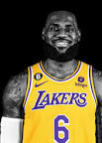

* *Hello, my name is Yesenia from Tv Sport, we are here with the basketball star and Lakers player, LeBron James. how are you today?*
* **Hi Yesenia, great thanks, excited for tomorrow's game**
* *LeBron, can we ask you a few questions?*
* **Of course**
* *How often do you exercise?*
* **I exercise every day**
* *That's great, what kind of exercises do you practice?*
* **I jump rope, weights, run in the park and practice basketball**
* *How long do you spend at the gym?*
* **4 hours a day or sometimes 3 hours**
* *How good are you swimming?*
* **Pretty good I like it a lot, it's part of my exercises**

*How often do you play basketball?*

* **Mm, twice a week**
* *Wow, that's incredible, now we see why you're such a good player, finally, what can you tell us about tomorrow's game?*
* **I'll wait for you tomorrow, to support the Lakers a lot. And nothing that we are going to win.**
* *As you heard, let's support from the stands tomorrow, thank you very much LeBron James, success.*

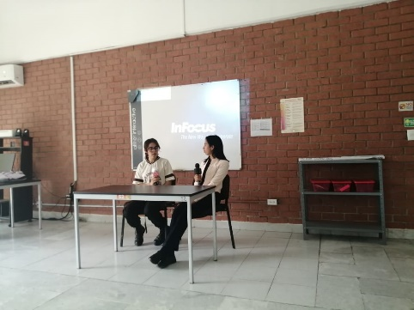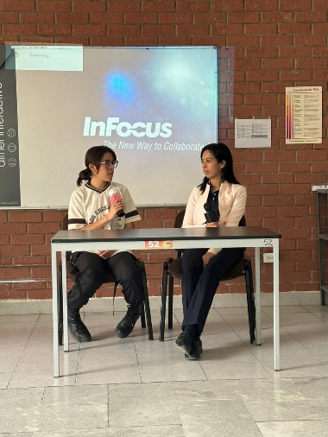

**Rubric**

Pair work: In pairs you will participate in a role play in where one of you is going to be a famous sport star, and the other will be a reporter, you must create an interview and present it to the group.

Write the interview script in this document and add a cover.

Remember use the adverbs of frequency and questions like how often do you…? How long do you…?

Date to deliver: Monday, May 8

|  |  |  |  |  |
| --- | --- | --- | --- | --- |
| Category | Unsatisfactory 2 | Satisfactory 3 | Proficient 4 | Excellent 5 |
| On time | Doesn’t deliver the project | Deliver the project out of time. | Deliver the project out of time but show a formal excuse. | Deliver the project on time |
| Creativity | Not creative or original | It is creative and original enough | It is quite creative and original | It is very creative and original |
| Contents | Insufficient or improper contents.  Doesn’t show evidence of knowledge. | Show evidence of knowledge. Enough contents. | Enough contents  Show mastery of knowledge. | Outstanding content  Show excellent knowledge. |
| Presentation | Information and ideas are poorly sequenced (the author jumps around).  If you read your grade is going be less | Information and ideas are presented in an order that the audience can follow with minimum difficulty. | Information and ideas are presented in a logical sequence which is followed by the reader with little or no difficulty. | Information and ideas are presented in a logical sequence which flows naturally and is engaging to the audience. |