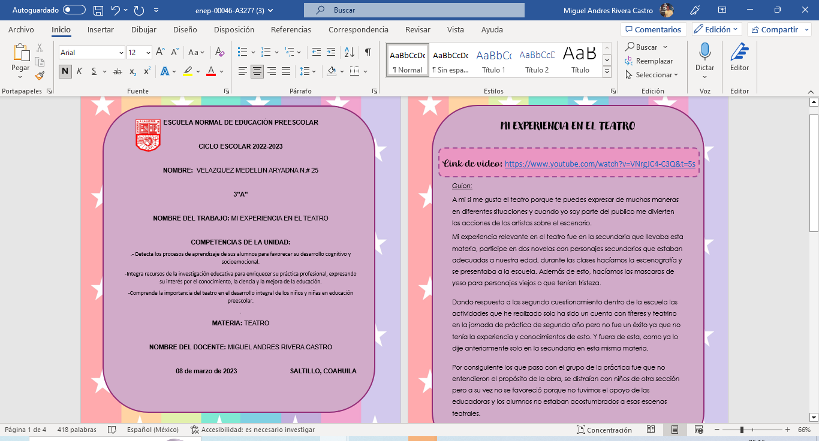
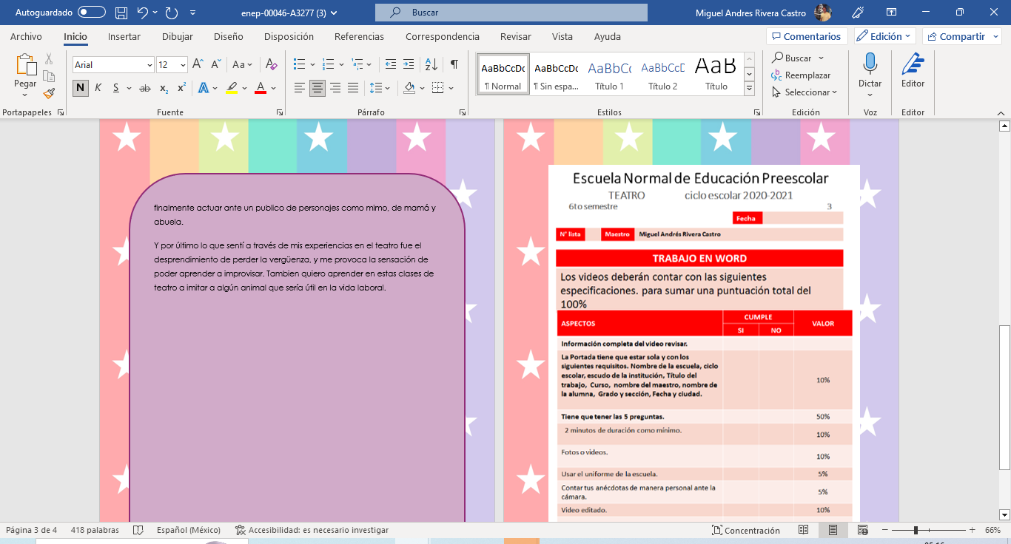
Link de video: https://www.youtube.com/watch?v=VNrgJC4-C3Q&t=5s

