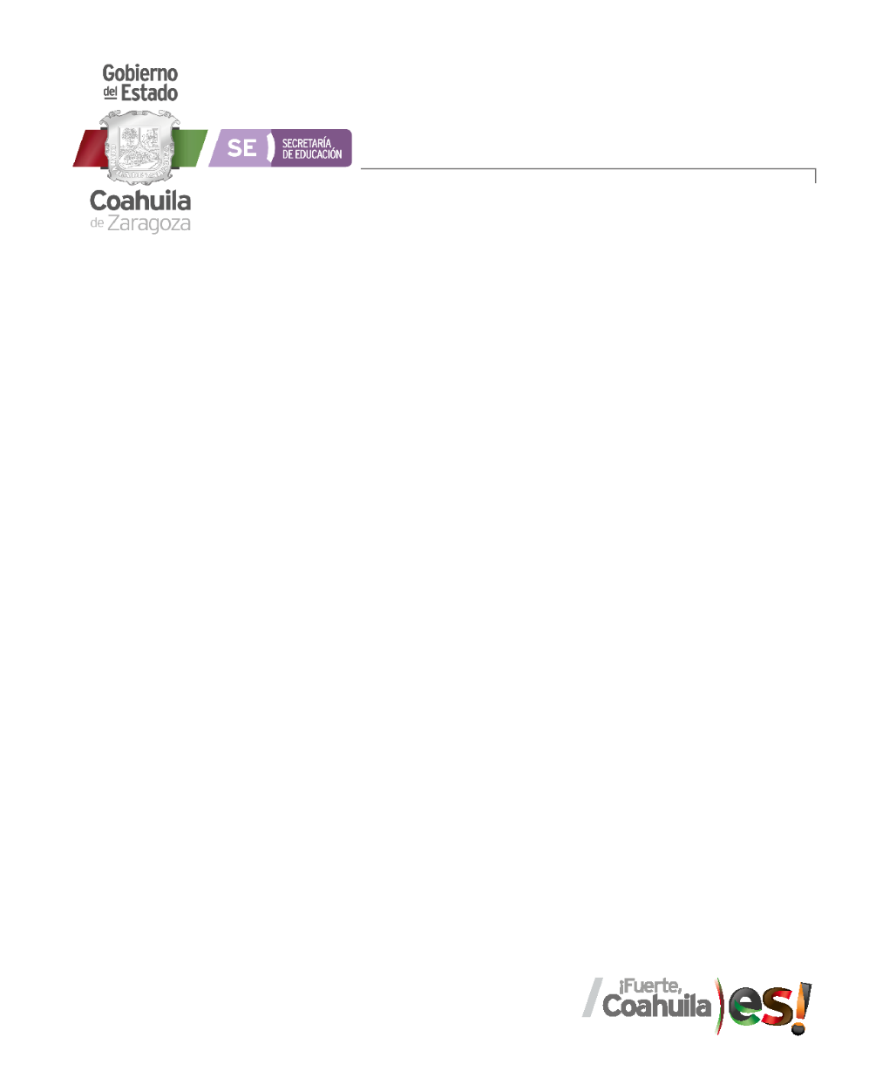

Rubric to evaluate participation

|  |  |  |  |  |
| --- | --- | --- | --- | --- |
| Category | Unsatisfactory 2 | Satisfactory 3 | Proficient 4 | Excellent 5 |
| Attitude | Negative and improper attitude. | Proper attitude. | Positive and respectful attitude | Positive, assertive and respectful attitude. |
| Classmates interaction | Disrespect your classmates. | Respect your classmates. | Respect your classmates, promotes a positive environment. | Respect your classmates, promotes a positive enviroment and encourage them to participate. |
| Preparedness | Doesn’t show evidence of knowledge. | Show evidence of knowledge. | Show mastery of knowledge. | Show excellent knowledge. |
| Behavior during the class | Bad behaviour, disrespectful, rude. | Proper behavior | Positive and respectful behavior during the class | Positive, assertive and respectful behavior during the class. |

Rubric to evaluate classwork

|  |  |  |  |  |
| --- | --- | --- | --- | --- |
| Category | Unsatisfactory 4 | Satisfactory 6 | Proficient 8 | Excellent 10 |
| On time | Doesn’t deliver all the activities and work. | Deliver the activities out of time. | Deliver the activities out of time but show a formal excuse. | Deliver all the activities and work on time |
| Clarity/ Grammar | The purpose of the student work is not well-defined.  More than 5 grammar errors. | The central purpose of the student work is identified.  3-5 grammar errors | The central purpose of the student work is clear and ideas are almost always focused in a way that supports the main idea.  1-2 grammar error | The central purpose of the student work is clear and supporting ideas always are always well-focused.  Without grammar errors. |
| Contents | Insufficient or improper contents.  Doesn’t show evidence of knowledge. | Show evidence of knowledge. Enough contents. | Enough contents  Show mastery of knowledge. | Outstanding content  Show excellent knowledge. |
| Organization | Information and ideas are poorly sequenced (the author jumps around). | Information and ideas are presented in an order that the audience can follow with minimum difficulty. | Information and ideas are presented in a logical sequence which is followed by the reader with little or no difficulty. | Information and ideas are presented in a logical sequence which flows naturally and is engaging to the audience. |