DELAYED ERROR CORRECTION

**Instructions:**

1. **Study the following statements taken from your written tasks and forum participation.**
2. **Use the correction code below to identify the meaning of the correction symbols next to the statements.**
3. **Spot the kinds of errors/mistakes in each statement or phrase and correct them**



Grammar and spelling!!

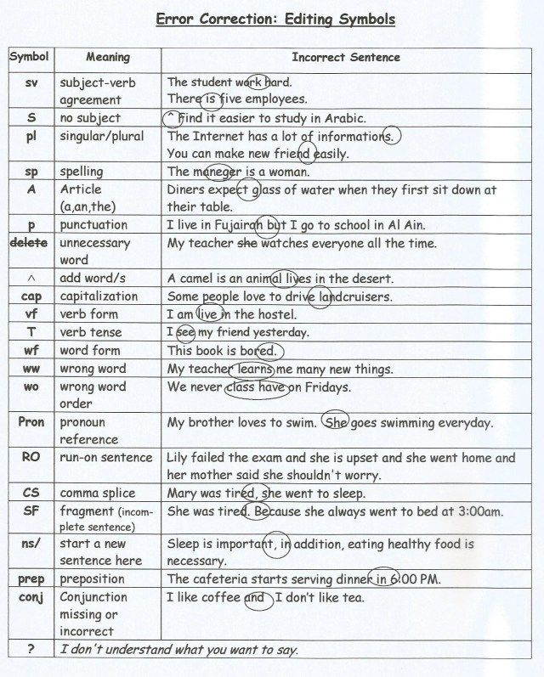

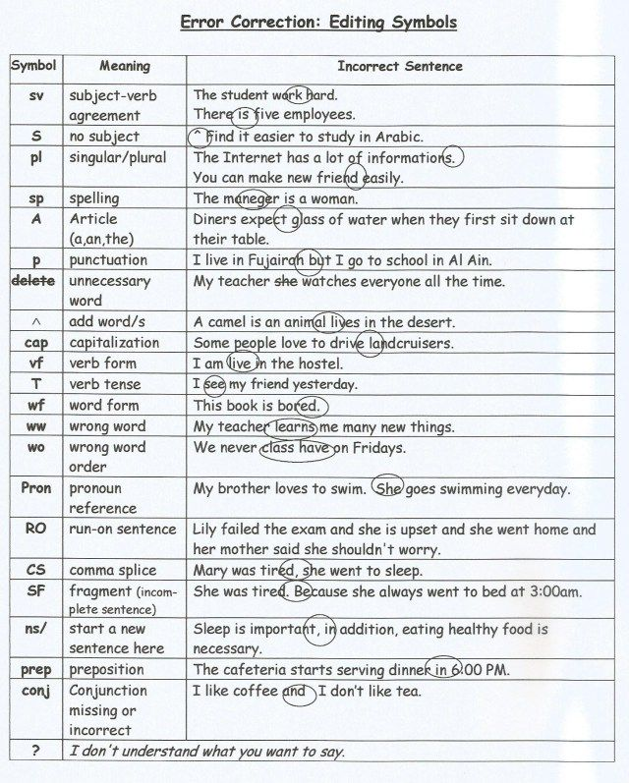

At first, must of us were scared of being lockdown in our own houses for an indeterminated period of time (sp/ww)

it would be so nice that when this thing end see all the human beings giving love (sv)

The sky in large cities were clearing up, (sv)

The different shades of green had return to our lands, (vf)

The familys played together again, (wf)

But to listened to all the brave ones who fought in hospitals (vf)

it is one of my duty to take care of it. (wf)

when all this feelings and thought come (ww)

Maybe they are acting in this way not because of fear but because of ignorancy. (ww)

the same idea about the autor that ~~it~~'s really important (sp/unnecessary pron)

not everyone are apporting  effort (sva/ww)

the others that share you comunity, you city, you world, (pron/sp)

she does not tell ~~to~~ anyone (~~delete~~)