**ESCUELA NORMAL DE EDUCACIÓN PREESCOLAR**

**ENGLISH A1.2 DEVELOPING ELEMENTARY CONVERSATIONS**

**UNIT 9 PROJECT “THE COOKING SHOW”**

**Aim:** Give Ss practice talking about food.

**Prepare:**

1. Look at the vocabulary and practice their pronunciation.
2. Go to <https://www.youtube.com/watch?v=PN_4IpCgVIQ> , watch the video and practice.
3. Complete the chart.

|  |
| --- |
| **How to make:** |
| **You will need (ingredients):** |
| **What to do (steps):**  *First…*  *Then…*  *Finally…* |

1. Think of a healthy and easy recipe that you can prepare at home (fruit salad, sandwich, hot dogs, soup, etcetera).
2. Think about your presentation, ***the ingredients you need to prepare your dish (use vocabulary from the unit and measure words), and the steps to prepare it (use sequence words and cooking verbs).***
3. Write your recipe in this document.

**Present:**

* Make a **video** where you show the recipe as in the example (<https://www.youtube.com/watch?v=PN_4IpCgVIQ>). ***Try not to read.***
* Upload your video to **Youtube or Google Drive** and upload  ***the link*** in this word document to Escuela en Red.

**USEFUL VOCABULARY FOR YOUR PROJECT**

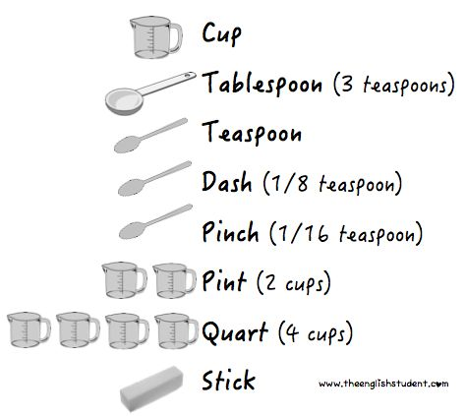 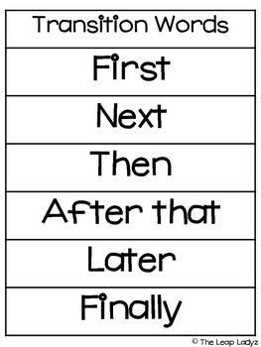

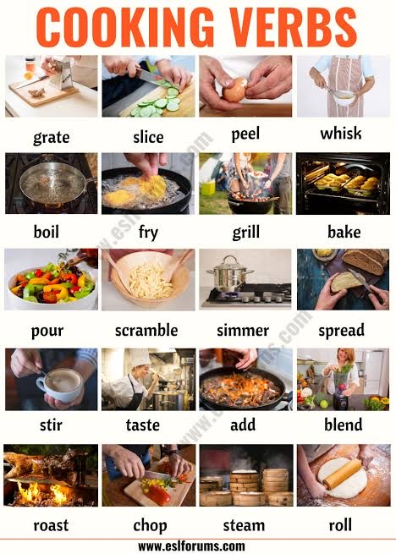

**READ MORE EXAMPLES.**

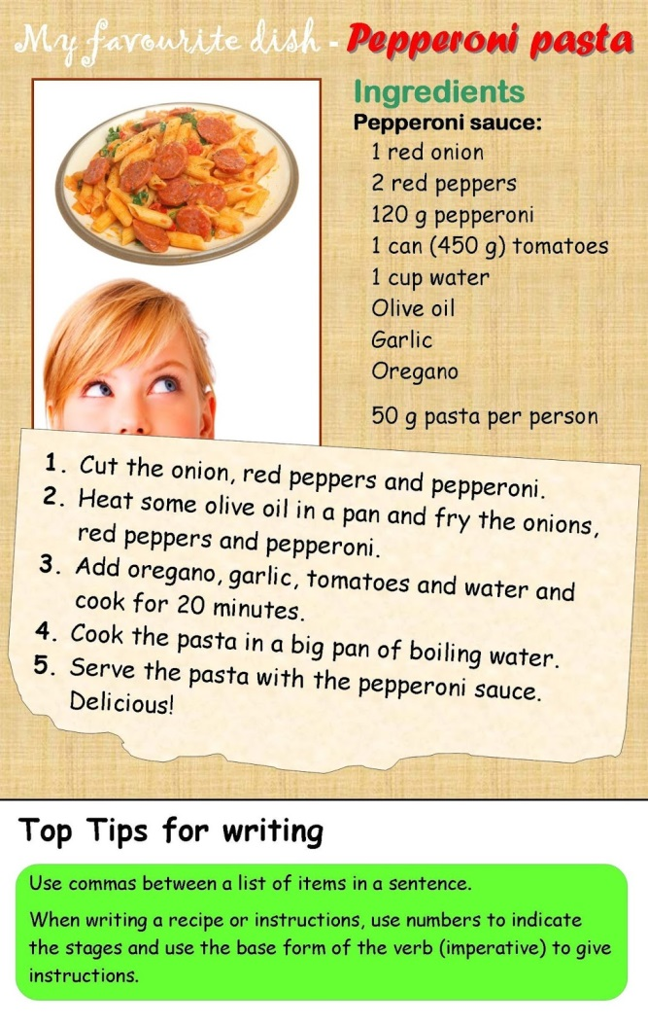

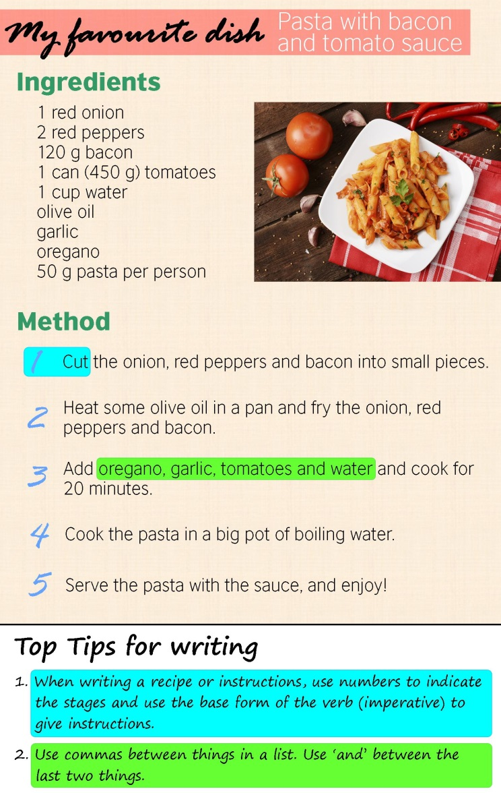

**WRITE YOUR RECIPE.**

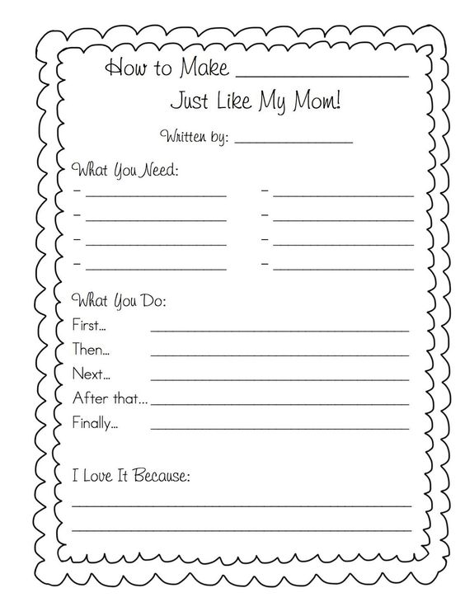

**RUBRIC**

|  |  |  |  |
| --- | --- | --- | --- |
| **EVALUATION CRITERIA** | **NEEDS IMPROVEMENT** | **GOOD** | **EXCELLENT** |
| **PRODUCTS** | The preparation activities or the video are missing or they don’t meet the requirements.  **1 point** | A Word document with some missing activities and a link to a video on YouTube.  The video doesn’t include a cover or introduction, has some missing elements or it has a poor quality.    **2 pts.** | A Word document with the preparation activities completed and a link to a video on YouTube or Google Drive.  The video shows the student describing the steps to prepare an easy and healthy dish.  The video includes a cover or introduction and it has good quality.  **3 pts.** |
| **CONTENT** | The presentation does not meet the requirements in the guideline.  **1 pts.** | The presentation does not meet the requirements in the guideline (vocabulary from the unit is not used or it has missing elements).  **2 pts.** | The task meets the requirements in the guideline.  The video includes a presentation, the name of the dish, the ingredients and the procedure.  **3 pts.** |
| **SPEAKING TASK** | Expresses him/her ideas with many hesitations and poor intonation.  Uses incomplete sentences.  Mispronounces several words.  Rarely uses appropriate vocabulary and grammar structures.  **1 point.** | Is able to express his/her ideas with some hesitation but managed to maintain flow and adequate intonation.  Uses correct vocabulary and grammar structures appropriately most of the time  **3 pts.** | Is able to express his/her ideas fluently with correct intonation using complete sentences and with no major production errors.  Uses vocabulary and grammar structures appropriately.  **4 pts.** |

**PASTE THE LINK TO YOUR VIDEO HERE!**

**AND**

