ZOOM PRACTICE!!!

**IMAGINE YOU ARE A FAMOUS ACTIVIST. WRITE YOUR INFORMATION IN THE SCREEN. (COPIA LA TARJETA DE CONTACTO EN TU CUADERNO)**

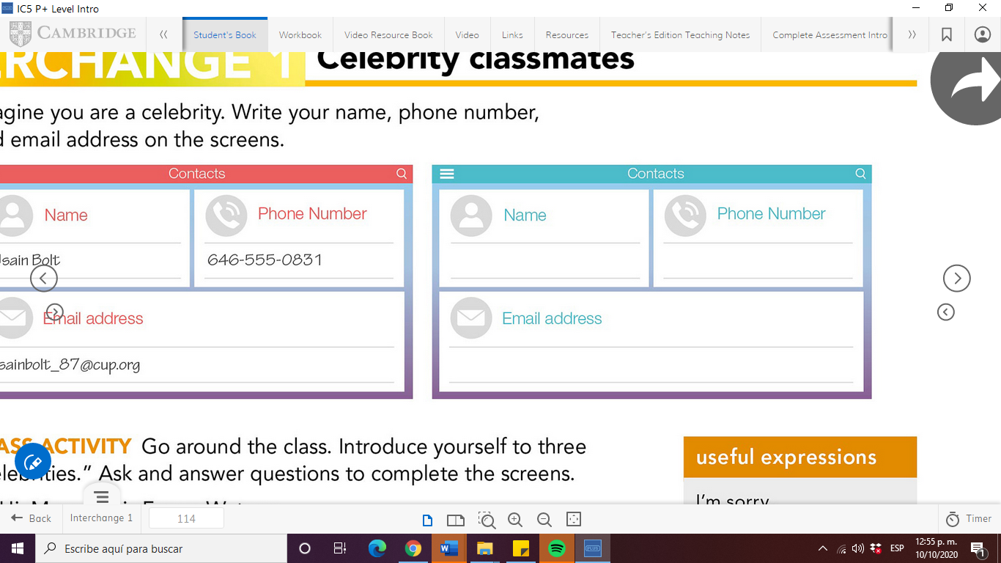

DEAR STUDENT FROM ENEP YOU ARE INVITED TO THE WORLD ANNUAL REUNION OF THE GREATES WOMEN’S, CHILDREN’S and ANIMALS’ RIGHTS ACTIVISTS.

LONDON, ENGLAND OCTOBER 16th, 2020

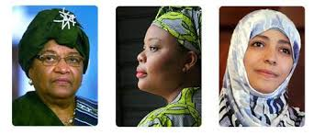

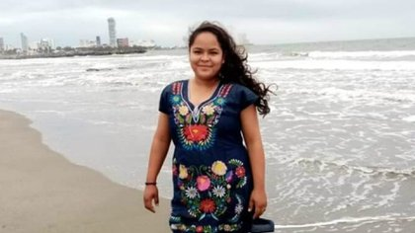

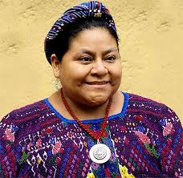INTRODUCE YOURSELF AND ASK INFORMATION TO THE OTHER ACTIVISTS. COMPLETE THE INFORMATIONS IN YOUR SCREENS.

**HI, my name is Malala Yousafzai. I’m a Pakistani activist for the girls’ rights to education**

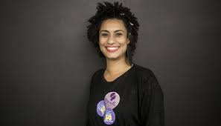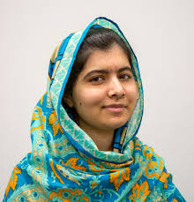

**It’s Malala dash Yousafzai at girlseducation dot org.**

**I’m Marielle Franco. I’m a Brazilian activist for the women’s and LGBT community rights. Nice to meet you, Malala**

**Nice to meet you too. Marielle, what’s your E-mail address?**

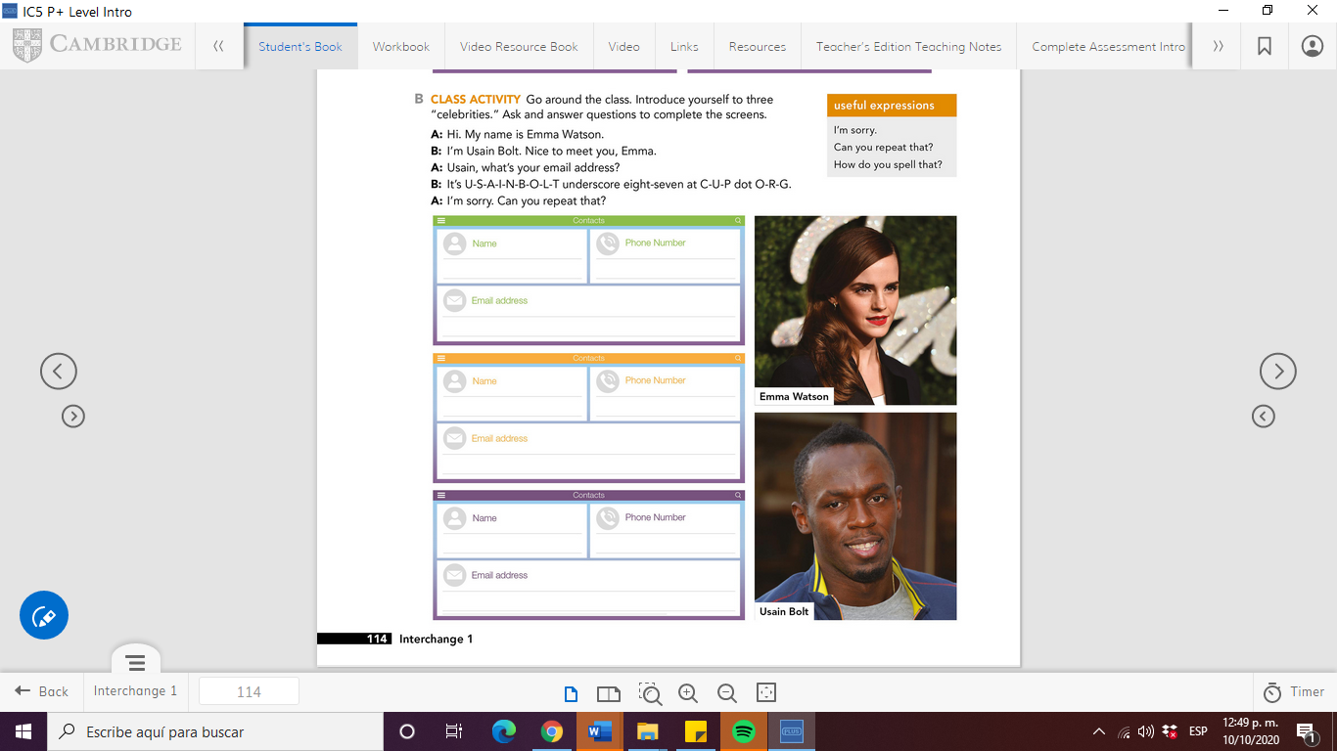

**I’m sorry. Can you repeat…?**

**It’s F-R-A-N-C-O underscore M at human rights dot org. And what’s your E-mail Malala?**

|  |
| --- |
| GROUP 1 7:30-8:30 AM |
|  |
| ANGUIANO PEREZ NATALIA GUADALUPE |
| ARIZPE ALVAREZ ADAMARY SARAHI |
| AVILA CASTILLO PAMELA YUDITH |
| CARDENAS TOVAR MONICA GUADALUPE |
| CARRANZA SAUCEDO ILSE IRASEMA |
| CORTES ALBIZO ALONDRA ESMERALDA |
| COVARRUBIAS TAVITAS NANCY GUADALUPE |
| DE LA CRUZ SAUCEDO DIANA CRISTELA |
| FLORES RODRIGUEZ SANDRA LUZ |
| GAONA NAVEJAR MAYRA ALEJANDRA |
| GARCIA FLORES MARIANA |
| GARCIA GARCIA ANDREA ELIZABETH |
| GAYTAN ESPINOZA JIMENA SARAHI |
| GIL RODRIGUEZ VANESSA MERITXELL |
| GOMEZ HERNANDEZ SARA YAMILET |

brenda bollain y Goytia le está invitando a una reunión de Zoom programada.

Tema: WHAT'S YOUR INFORMATION?

Hora: 16 oct 2020 07:30 AM Ciudad de México

Unirse a la reunión Zoom

https://us04web.zoom.us/j/74116462168?pwd=UjdMQ01VZCtzRlphTFhaQitaT3psdz09

ID de reunión: 741 1646 2168

Código de acceso: attitude

brenda bollain y Goytia le está invitando a una reunión de Zoom programada.

Tema: WHAT'S YOUR INFORMATION?

Hora: 16 oct 2020 08:30 AM Ciudad de México

Unirse a la reunión Zoom

https://us04web.zoom.us/j/73747413348?pwd=ZktmUjhnR0FPNENscEVCZ29NRy9mZz09

ID de reunión: 737 4741 3348

Código de acceso: ATTITUDE

|  |
| --- |
| GROUP 2 8:30-9:30 AM |
|  |
| GUERRERO VIGIL ANDREA ABIGAIL |
| HERNANDEZ HERRERA VICTORIA |
| HERNANDEZ VEGA ALISON LILY |
| HUERTA PALACIOS ALONDRA |
| MARTINEZ ALDACO MELISSA |
| MARTIÑON TOMATSU ANGELA |
| MASCORRO ARELLANO SOFIA ABIGAIL |
| MONCADA SANCHEZ CAMILA MONTSERRAT |
| MONRREAL CAMACHO VICTORIA BERENICE |
| MONTOYA SILVA JULIA YESSENIA |
| PEREZ NUNCIO DAISY CAROLINA |
| REYES LEZA AMERICA MICHELLE |
| SERNA REYES JULISA |
| SOSA DOMINGUEZ VERENA CONCEPCION |
| TORRES RUBIO JANETH GUADALUPE |
| VALDES JIMENEZ MARIANA GUADALUPE |