**ESCUELA NORMAL DE EDUCACIÓN PREESCOLAR**

**ENGLISH A1.1 STARTING BASIC COMMUNICATION**

**ENGLISH PROJECT “FASHION SHOW”**

**UNIT 4: IS THIS COAT YOURS?**

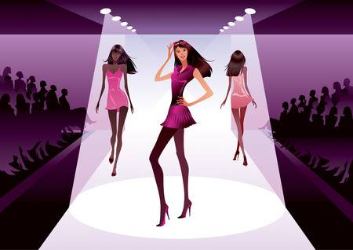

**AIM:**

Give Ss practice describing clothing using the present continuous.

**PREPARATION:**

Complete tasks A, B and C (possessive adjectives and pronouns, describing clothing and script).

Plan a fashion show:

* Choose a season and a type of clothing to prepare a fun and interesting outfit for the day of the runway.
* During the fashion show you will play the role of the presenter and the role of the model.
* As the presenter, you will make descriptions of the clothes the models will wear using as much detail as possible (clothes, colors, nationalities, adjectives). You will also interview the models so they can describe some of the clothes they will be wearing.

**PRESENTATION:**

The day of the show you must be ON TIME at the auditorium wearing the outfit you prepared for the runway.

For your oral presentation you will “role play” the presenter and the model. You will practice describing clothing and asking wh- questions and yes/no questions about it. The more vocabulary and grammar structures you use on your presentation, the more points you will get.

**PRODUCTS:**

* You must bring your tasks A, B and C printed for the next session (November 28th)
* You must upload a **word document** to Escuela en Red with tasks A, B and C completed.
* You must **wear the outfit you prepared** for your presentation.

**DUE DATE TO UPLOAD PRODUCTS TO THE PLATFORM:** Wednesday November 28th, 2018

**SPEAKING ACTIVITY:** Thursday Nov. 29th, 2018

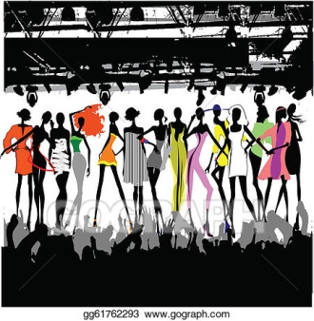

**RUBRIC**

|  |  |  |  |
| --- | --- | --- | --- |
| EVALUATION CRITERIA | NEEDS IMPROVEMENT | GOOD | EXCELLENT |
| PRODUCTS | The previous tasks are incomplete and have several mistakes.  **1 point** | The previous tasks are complete but they have some mistakes.  **2 pts.** | The previous tasks are complete and they have few or no mistakes.  **3 pts.** |
| PRESENTATION | The student didn´t prepare an outfit for the show.  **0 pts.** | The student prepared an outfit but it is very simple and it doesn´t have varied items.  **1 point** | The student prepared a complete and interesting outfit for the presentation.  **2 pts.** |
| SPEAKING TASK | Expresses him/her ideas with many hesitations and poor intonation.  Uses incomplete sentences.  Mispronounces several words.  Rarely uses appropriate vocabulary and grammar structures.  **2 pts.** | Is able to express his/her ideas with some hesitation but managed to maintain flow and adequate intonation.  Uses correct vocabulary and grammar structures appropriately most of the time.  **4 pts.** | Is able to express his/her ideas fluently with correct intonation using complete sentences and with no major production errors.  Uses vocabulary and grammar structures appropriately.  **5 pts.** |

**PREVIOUS TASKS**

**TASK A**. Complete the sentences using possessive adjectives or possessive pronouns.

1. These aren´t _______ (my/mine) sneakers. ________ (my/mine) are blue.
2. This is Emma’s sweater, this scarf is _______ ( her/hers) too.
3. These gloves are ________ (your/yours), ________ (my/mine) gloves are light brown.
4. ________ (our/ours) shoes are under the bed.
5. Luis is wearing a beautiful black jacket, ________ (his, his) shirt is nice too.
6. ________ (their/theirs) jackets are from Italy.

**TASK B.** Complete the sentences using *is, are, isn’t or aren’t.*

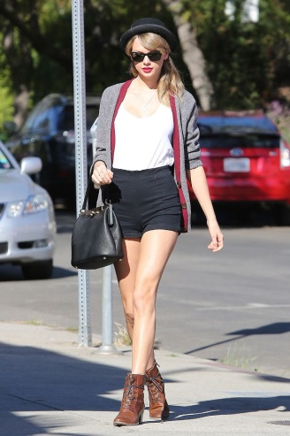 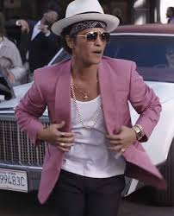

1. Taylor _______ wearing brown boots and a black purse.
2. Bruno ________ wearing a beautiful pink jacket.
3. Taylor and Bruno ________ wearing hats.
4. Taylor ________ wearing a scarf.
5. Bruno ________ wearing gloves.
6. Taylor and Bruno ________ wearing pajamas.

**TASK C.** Read the script and then create a different one describing the outfits on the pictures, remember to describe details such as **colors, nationalities and adjectives**.

*Welcome to Fashion Week Fashion. Let's see some cool fashion! Number one is in a beautiful black blouse. Her skirt is blue and her black high heels are from Italy.*

*Thank you, number one.*

*And here's number two, her skirt is black, her blouse is blue, and her blue high heels are Japanese. Looking good!*

*Say hello to number three. His suit is light gray, his tie is dark green, and his shoes are brown.*

*Now for number four, handsome in a dark gray suit. He has a light green tie, and his shoes are black. Well done!*

*Let's welcome number five. Her cap is green, and she has a beige jacket. Her jeans are blue, and her sneakers are purple. Very nice!*

*Last up is pretty number six with purple sneakers and blue jeans. Her jacket is dark brown, and her cap is red. Wonderful, number six!*

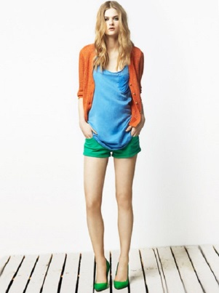 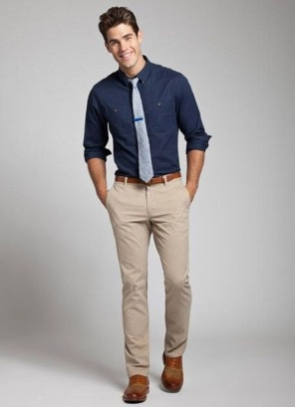  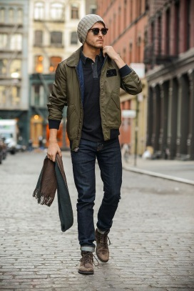 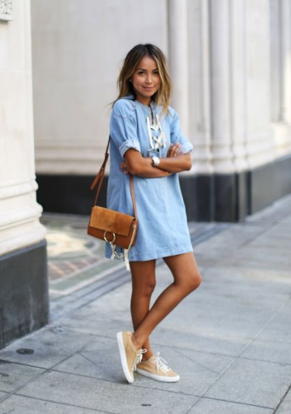

**MY SCRIPT:**