**ESCUELA NORMAL DE EDUCACIÓN PREESCOLAR**

**CICLO ESCOLAR 2022-2023**

***INGLES***

**Docente:**

GUADALUPE DEL ROCIO ROBLEDO CORPUSA

**Alumna:**

**Regina Estefanía Durán Avilés #7**

**Semestre y sección:** 5° B

**Project unit 1 It´s a really great place!**

Saltillo, Coahuila Septiembre 2023

XALAPA-ENRIQUEZ VERACRUZ

**What is it like?**

It's a beautiful and relaxing place. With beautiful views, the streets are colorful and the people are friendly.

**What can you do there?**

You can visit the different museums that the place has, plus the parks, walk around the streets and it is close to the port of Veracruz.

**What is there to see?**

You can't miss the anthropology museum.

**What is the weather like?**

The weather is warm most of the time.

**What is the best time of year to visit the place?**

The best time of the year to visit is August and September.

**What can you buy?**

You can buy seafood, handicrafts and souvenirs.

**What is it like?**

It's a beautiful and relaxing place. With beautiful views, the streets are colorful and the people are friendly.

**What can you do there?**

You can visit the different museums that the place has, plus the parks, walk around the streets and it is close to the port of Veracruz.

**What is there to see?**

You can't miss the anthropology museum.

**What is the weather like?**

The weather is warm most of the time.

**What is the best time of year to visit the place?**

The best time of the year to visit is August and September.

**What can you buy?**

You can buy seafood, handicrafts and souvenirs.

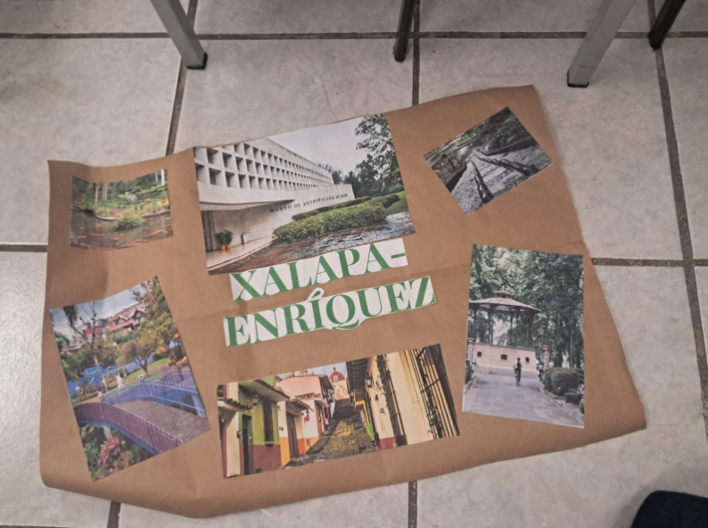

|  |  |  |  |  |
| --- | --- | --- | --- | --- |
| Category | Unsatisfactory 2 | Satisfactory 3 | Proficient 4 | Excellent 5 |
| On time | Doesn’t deliver the project | Deliver the project out of time. | Deliver the project out of time but show a formal excuse. | Deliver the project on time |
| Creativity | Not creative or original | It is creative and original enough | It is quite creative and original | It is very creative and original |
| Contents | Insufficient or improper contents.  Doesn’t show evidence of knowledge. | Show evidence of knowledge. Enough contents. | Enough contents  Show mastery of knowledge. | Outstanding content  Show excellent knowledge. |
| Presentation | Information and ideas are poorly sequenced (the author jumps around). | Information and ideas are presented in an order that the audience can follow with minimum difficulty. | Information and ideas are presented in a logical sequence which is followed by the reader with little or no difficulty. | Information and ideas are presented in a logical sequence which flows naturally and is engaging to the audience. |