

**Escuela Normal de Educación Preescolar**

**Licenciatura en Educación Preescolar**

Ciclo Escolar 2023-2024

Curso: Ingles Hacia Nuevas Perspectivas Globales

Mtra.: Guadalupe del Rocío Robledo Corpus

**Project Unit I:**

**It´s a really great place!**

Alumna: Angela Lecely Cortés Villarreal

3° “B”

Quinto Semestre

28 de septiembre del 2023

**Project unit 1** **It´s a really great place!**

Instructions: Choose one place you want to go on vacation. Then answer   
these questions about that place.

**What’s it like?**

It is a very touristy place, full of beaches, desert landscapes and impressive canyons and mountains.

**What can you do there?**

You can visit the Cabo San Lucas Marina, a marina surrounded by restaurants, bars and shops. Cabo Pulmo National Park, where you can dive or snorkel and see a wide variety of marine species. You can also visit the Estero de San José del Cabo, a natural estuary with a wide variety of flora and fauna.

**What should you see there?**

You shouldn’t miss El Arco, an impressive rock formation that is at the tip of the Baja California peninsula, and Playa del Amor, quiet and perfect for enjoying the sun and the sea.

**What’s the weather like?**

It is hot in summer and warm in winter.

**What’s the best time of the year to visit the place?**

The best time to visit Los Cabos San Lucas is from December to March.

**What things can you buy?**

You can buy beautiful handcrafted pieces such as key chains, hand-painted t-shirts, sarapes, sandals, masks, tapestries, talavera, engravings and figures with marine motifs.

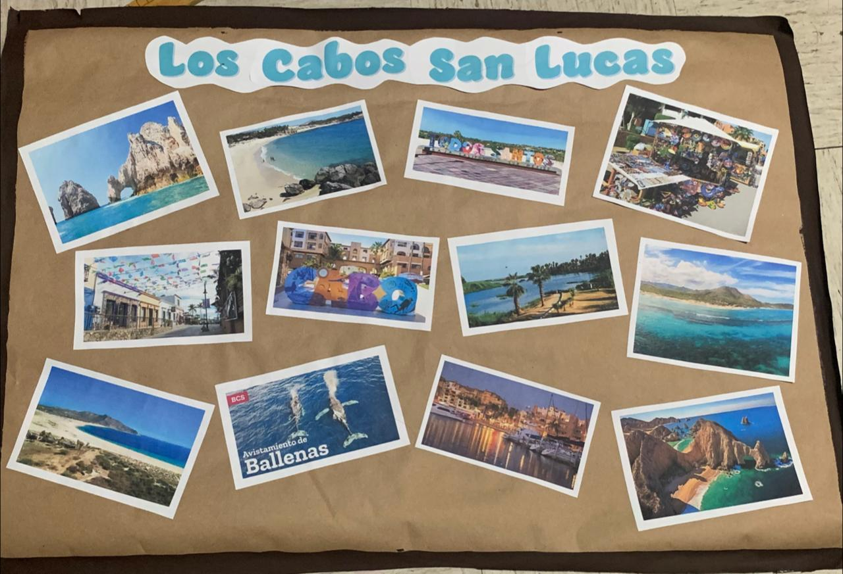

**Rubric**

|  |  |  |  |  |
| --- | --- | --- | --- | --- |
| **Category** | **Unsatisfactory 2** | **Satisfactory 3** | **Proficient 4** | **Excellent 5** |
| **On time** | Doesn’t deliver the project | Deliver the project out of time. | Deliver the project out of time but show a formal excuse. | Deliver the project on time |
| **Creativity** | Not creative or original | It is creative and original enough | It is quite creative and original | It is very creative and original |
| **Contents** | Insufficient or improper contents.  Doesn’t show evidence of knowledge. | Show evidence of knowledge. Enough contents. | Enough contents  Show mastery of knowledge. | Outstanding content  Show excellent knowledge. |
| **Presentation** | Information and ideas are poorly sequenced (the author jumps around). | Information and ideas are presented in an order that the audience can follow with minimum difficulty. | Information and ideas are presented in a logical sequence which is followed by the reader with little or no difficulty. | Information and ideas are presented in a logical sequence which flows naturally and is engaging to the audience. |