**ESCUELA NORMAL DE EDUCACION PREESCOLAR**

**Licenciatura en educación preescolar**



Quinto semestre Sección: B

Ciclo escolar

2022-2023

Curso: Ingles

**Proyect**

Docente: Guadalupe Del Roció Robledo Corpus

Presentado por:

Fátima Alejandra Rodríguez Galván #25

Saltillo Coahuila de Zaragoza 28 de septiembre de 2023

**Project unit 1 It´s a really great place!**

Instructions: Choose one place you want to go on vacation. Then answer   
these questions about that place.

Instructions: Choose a place you want to go on vacation. Then answer these questions about that place.

* How is? It is beautiful, cheerful and its beach is large.
* What can you do there? You can swim and walk on the beach.
* What should you see there? You should walk along the boardwalk and visit the aquarium.
* What's the weather like? It's really hot
* What is the best time of year to visit the place? The best time to visit is in October.
* What things can you buy? You can buy food and cocktails

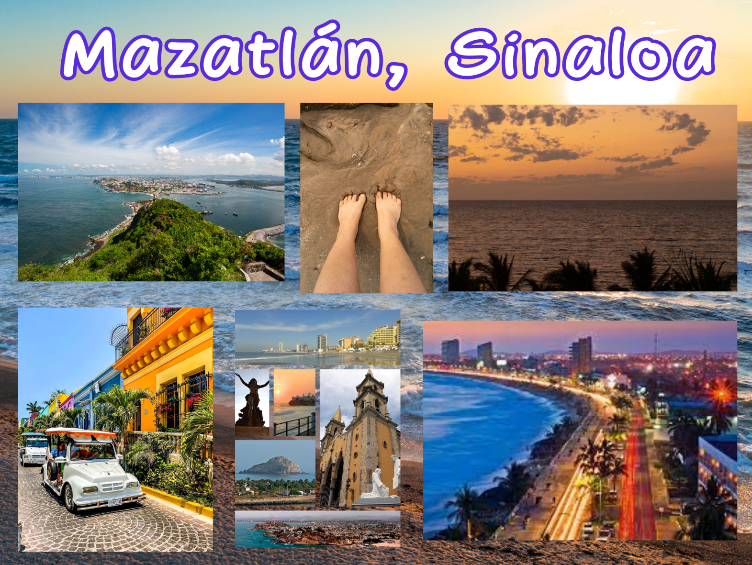

***Review the next rubric***

|  |  |  |  |  |
| --- | --- | --- | --- | --- |
| Category | **Unsatisfactory 2** | **Satisfactory 3** | **Proficient 4** | **Excellent 5** |
| **On time** | Doesn’t deliver the project | Deliver the project out of time. | Deliver the project out of time but show a formal excuse. | Deliver the project on time |
| **Creativity** | Not creative or original | It is creative and original enough | It is quite creative and original | It is very creative and original |
| **Contents** | Insufficient or improper contents.  Doesn’t show evidence of knowledge. | Show evidence of knowledge. Enough contents. | Enough contents  Show mastery of knowledge. | Outstanding content  Show excellent knowledge. |
| **Presentation** | Information and ideas are poorly sequenced (the author jumps around). | Information and ideas are presented in an order that the audience can follow with minimum difficulty. | Information and ideas are presented in a logical sequence which is followed by the reader with little or no difficulty. | Information and ideas are presented in a logical sequence which flows naturally and is engaging to the audience. |