

**​Ingles**

**Ciclo Escolar** 2022 – 2023

**Docente:** Guadalupe Del Rocío Robledo Corpus

**Alumna:** Pérez López Marisol **NL:** 22

**Unidad I:** Events, devices and advice

**Competencias de la unidad:**

-Describe people's looks and physical appearance

-Give instructions to prepare dishes

-Order food and give opinions on dishes

**Saltillo, Coahuila a 27 de septiembre de 2022.**

**Project unit 1 It´s a really great place!**

**Instructions: Choose one place you want to go on vacation. Then answer   
these questions about that place.**

What’s it like? The water is very clean, it is a place where people travel by bicycle, the bicycles are highly decorated to avoid theft, they speak many languages ​​and the buildings are narrow to save money.

What can you do there? You can walk over the bridges and ride a bicycle.

What should you see there? You should visit the Anne Frank and Van Gogh museums.

What’s the weather like? With mild summers and cold winters. Wind and rain are common for most of the year, with July and August being the rainiest months and March being the driest of the year.

What’s the best time of the year to visit the place? Between the end of April and the beginning of October.

What things can you buy? You can buy cheese, ceramics, tulips and gin

**Make a poster to advertise the place. Use photos or draw pictures to explain what you can do there. Double sheet size, you can use sheet of paper, cardboard, magazines or and others materials. You can make it using the computer and then printed, or it can be handmade.**

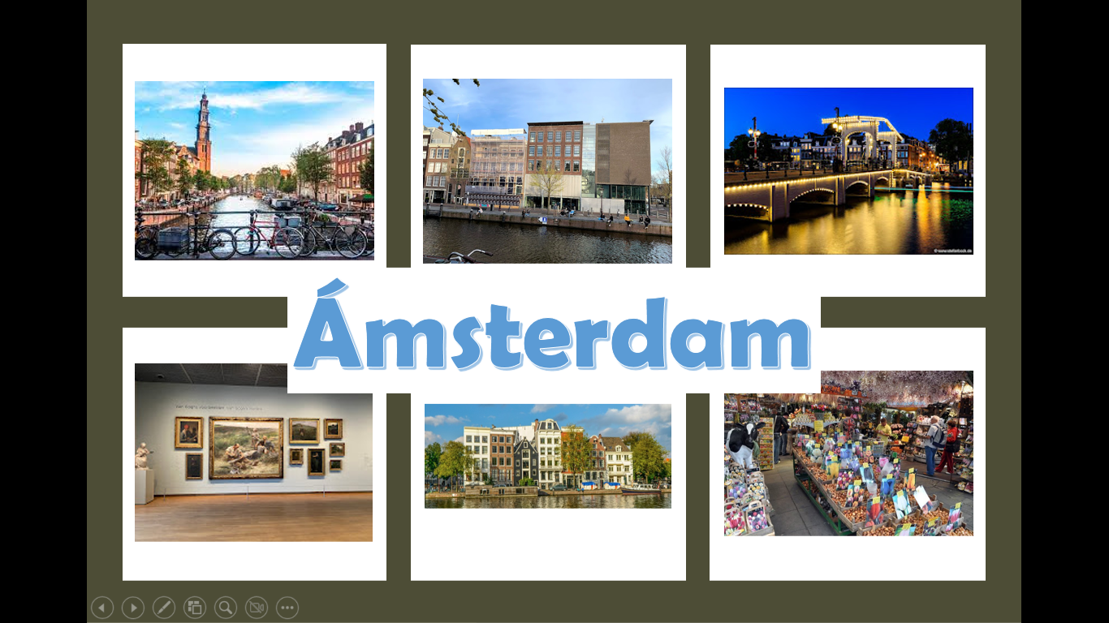

**Review the next rubric**

|  |  |  |  |  |
| --- | --- | --- | --- | --- |
| Category | Unsatisfactory 2 | Satisfactory 3 | Proficient 4 | Excellent 5 |
| On time | Doesn’t deliver the project | Deliver the project out of time. | Deliver the project out of time but show a formal excuse. | Deliver the project on time |
| Creativity | Not creative or original | It is creative and original enough | It is quite creative and original | It is very creative and original |
| Contents | Insufficient or improper contents.  Doesn’t show evidence of knowledge. | Show evidence of knowledge. Enough contents. | Enough contents  Show mastery of knowledge. | Outstanding content  Show excellent knowledge. |
| Presentation | Information and ideas are poorly sequenced (the author jumps around). | Information and ideas are presented in an order that the audience can follow with minimum difficulty. | Information and ideas are presented in a logical sequence which is followed by the reader with little or no difficulty. | Information and ideas are presented in a logical sequence which flows naturally and is engaging to the audience. |