
ESCUELA NORMAL DE EDUCACION PREESCOLAR
Curso:
Inglés: Hacia nuevas perspectivas globales
Docente:
Guadalupe del Rocío Robledo Corpus
Alumna:
Luisa Fernanda Oropeza Valdés
No. 21
Project Unit 1

Saltillo, Coahuila. 28 de septiembre de 2023
Palermo
Palermo is the capital of the Italian island in Sicily. It is considered a dirty and a bit dangerous place, but in reality it is a beautiful, old and crowded city. It is a city with a small population, and some famous Italians live there.
You should definitely go to the Fonte Pretoria and relax in the Garibaldi Garden. You can visit the big market in Piazza marina and buy some souvenirs. It has impressive churches, palaces, bars and markets.
You shouldn’t miss the tour of the Massimo Vittorio Emanuele II theater. And of course, you should visit the Catacombe dei Cappuccini, catacombs that are sold as unique cultural heritage.
The best time to visit Plermo is between November and December as it is low season. You can walk freely, although winter comes in December and it is really cold, if you enjoy summer you should go between the months of April and September although the season is higher as are the deaths.
And finally, you should try Aranchi, they are rice balls filled with different ingredients and of course, you should try a typical pizza

My poster
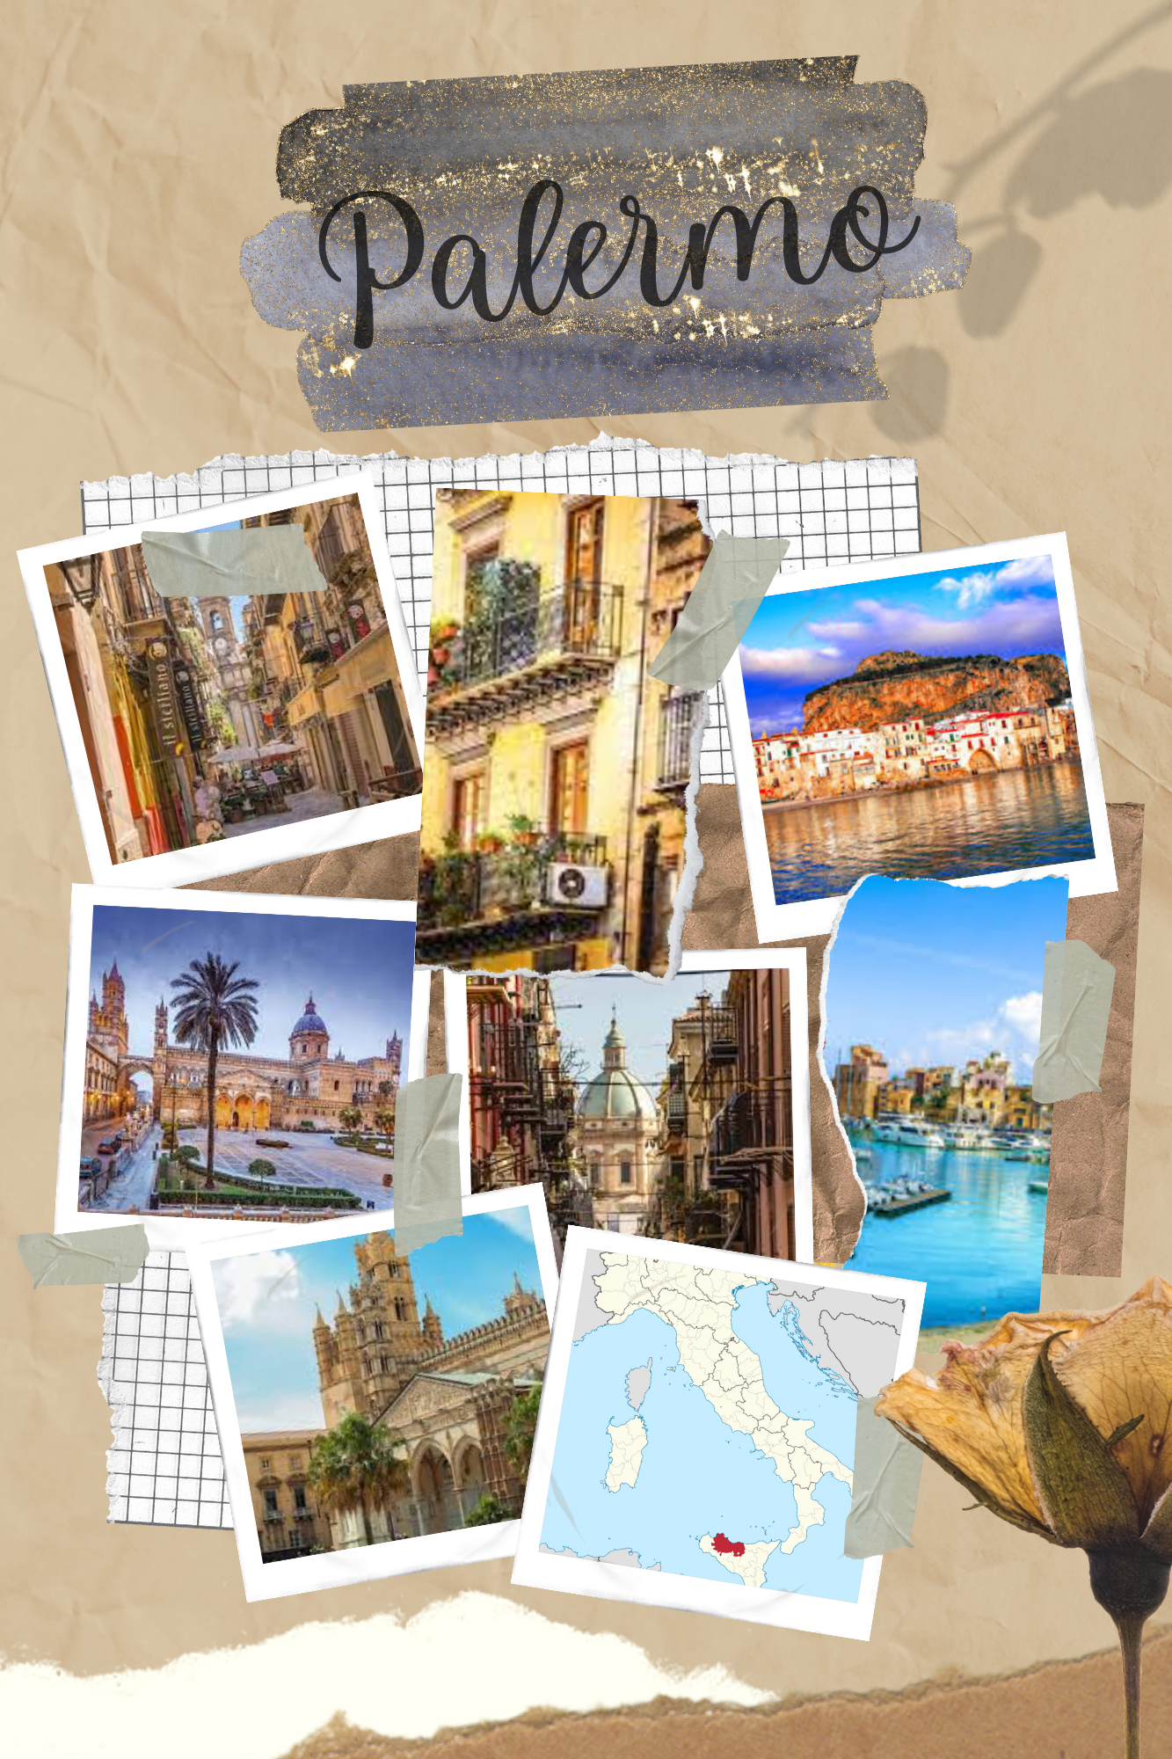

Category | Unsatisfactory 2 | Satisfactory 3 | Proficient 4 | Excellent 5
On time | Doesn’t deliver the project | Deliver the project out of time. | Deliver the project out of time but show a formal excuse. | Deliver the project on time
Creativity | Not creative or original | It is creative and original enough | It is quite creative and original | It is very creative and original
Contents | Insufficient or improper contents.  Doesn’t show evidence of knowledge. | Show evidence of knowledge. Enough contents. | Enough contents  Show mastery of knowledge. | Outstanding content  Show excellent knowledge.
Presentation | Information and ideas are poorly sequenced (the author jumps around). | Information and ideas are presented in an order that the audience can follow with minimum difficulty. | Information and ideas are presented in a logical sequence which is followed by the reader with little or no difficulty. | Information and ideas are presented in a logical sequence which flows naturally and is engaging to the audience.
Rubric

