**

*Escuela Normal De Educación Preescolar*

*English Project:*

*Student´s name: Estrella Janeth Sanchez Moncada*

*Teacher´s name: Guadalupe del Rocío Robledo Corpus.*

*Saltillo, Coahuila. Sep 2023*

**PROJECT UNIT 1 IT´S A REALLY GREAT PLACE!**

Instructions: Choose one place you want to go on vacation. Then answer   
these questions about that place.

What’s it like?

*Cancun is very big, beautiful, and very touristic.*

What can you do there?

*You can relax whit family or friends, you can visit the little beaches around there, go to the market and buy souvenirs, do snorkelilng, surfing, swimming and do some extremes activities.*

What should you see there?

*The sunset, the sea animals and the coral reefs*.

What’s the weather like?

*The weather is sunny and hot.*

What’s the best time of the year to visit the place?

*Summer*

What things can you buy?

*Clothes, friendship bracelets, sea shells, souvenirs and food.*

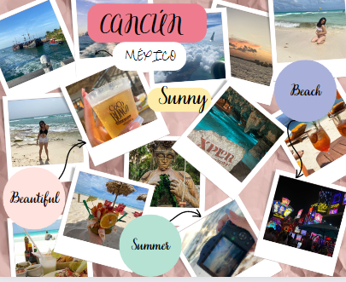

* Make a poster to advertise the place. Use photos or draw pictures to explain what you can do there.
* Double sheet size, you can use sheet of paper, cardboard, magazines or and others materials.
* You can make it using the computer and then printed, or it can be handmade.
* You have to send the activity by school online, create a document, with the cover, the rubric, and the picture of your poster. Then present the poster the next Thursday September 28th

Review the next rubric

|  |  |  |  |  |
| --- | --- | --- | --- | --- |
| Category | Unsatisfactory 2 | Satisfactory 3 | Proficient 4 | Excellent 5 |
| On time | Doesn’t deliver the project | Deliver the project out of time. | Deliver the project out of time but show a formal excuse. | Deliver the project on time |
| Creativity | Not creative or original | It is creative and original enough | It is quite creative and original | It is very creative and original |
| Contents | Insufficient or improper contents.  Doesn’t show evidence of knowledge. | Show evidence of knowledge. Enough contents. | Enough contents  Show mastery of knowledge. | Outstanding content  Show excellent knowledge. |
| Presentation | Information and ideas are poorly sequenced (the author jumps around). | Information and ideas are presented in an order that the audience can follow with minimum difficulty. | Information and ideas are presented in a logical sequence which is followed by the reader with little or no difficulty. | Information and ideas are presented in a logical sequence which flows naturally and is engaging to the audience. |