**

*Escuela Normal De Educación Preescolar*

*English Project: It´s a really great place!*

*Student´s name: Arely Hernández Serrano*

*Teacher´s name: Guadalupe del Rocío Robledo Corpus.*

*Saltillo, Coahuila. 28th September 2023*

**Project unit 1 It´s a really great place!**

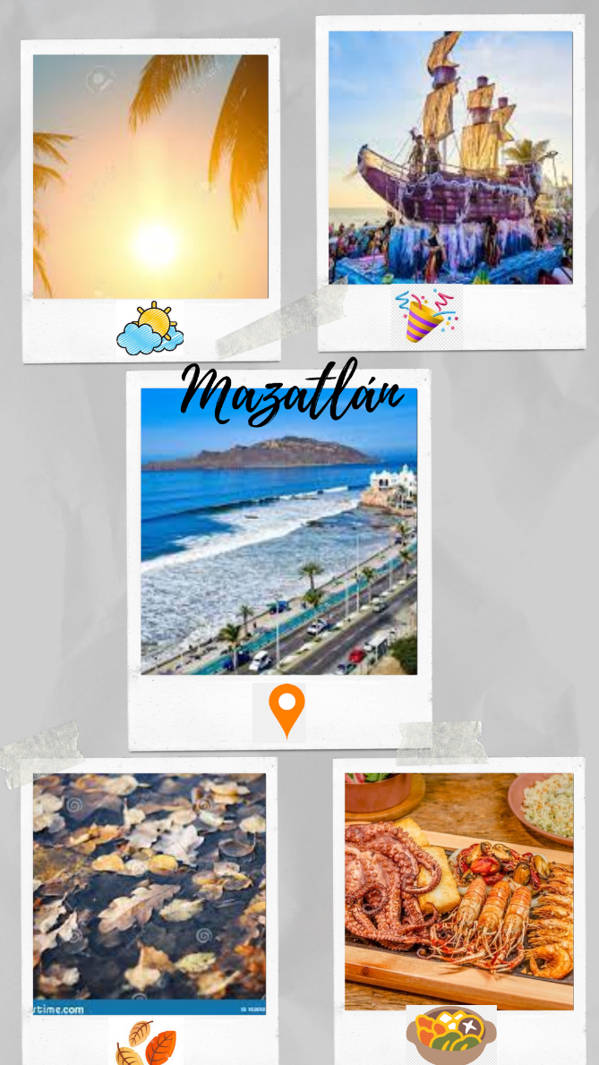

Instructions: Choose one place you want to go on vacation. Then answer   
these questions about that place.

1. **What’s it like?** It is beautiful and relaxing.
2. **What can you do there?** You can visit the aquarium.
3. **What should you see there?** You should see the carnival and visit the island.
4. **What’s the weather like?** The weather is warm in the mornings and hot in the afternoons.
5. **What’s the best time of the year to visit the place?** The best time to visit is in autumn, between October and November.
6. **What things can you buy?** You can buy their typical food, seafood.

Make a poster to advertise the place. Use photos or draw pictures to explain what you can do there.

Double sheet size, you can use sheet of paper, cardboard, magazines or and others materials.

You can make it using the computer and then printed, or it can be handmade.

You have to send the activity by school online, create a document, with the cover, the rubric, and the picture of your poster. Then present the poster the next Thursday September 28th

Review the next rubric

|  |  |  |  |  |
| --- | --- | --- | --- | --- |
| Category | Unsatisfactory 2 | Satisfactory 3 | Proficient 4 | Excellent 5 |
| On time | Doesn’t deliver the project | Deliver the project out of time. | Deliver the project out of time but show a formal excuse. | Deliver the project on time |
| Creativity | Not creative or original | It is creative and original enough | It is quite creative and original | It is very creative and original |
| Contents | Insufficient or improper contents.  Doesn’t show evidence of knowledge. | Show evidence of knowledge. Enough contents. | Enough contents  Show mastery of knowledge. | Outstanding content  Show excellent knowledge. |
| Presentation | Information and ideas are poorly sequenced (the author jumps around). | Information and ideas are presented in an order that the audience can follow with minimum difficulty. | Information and ideas are presented in a logical sequence which is followed by the reader with little or no difficulty. | Information and ideas are presented in a logical sequence which flows naturally and is engaging to the audience. |