**ESCUELA NORMAL DE EDUCACIÓN PREESCOLAR DEL ESTADO DE COAHUILA**

Licenciatura en Educación Preescolar

Ciclo escolar 2023-2024

Quinto semestre Sección “B”



**Curso:**

Inglés hacia nuevas perspectivas globales

**Docente:**

Guadalupe del Rocío Robledo Corpus

**Tema:**

Project unit 1 It´s a really great place!

**Alumna:**

Kenia Marily Monsiváis Rodríguez #17

**Saltillo, Coahuila de Zaragoza Septiembre/2023**

**Project unit 1 It´s a really great place!**

Instructions: Choose one place you want to go on vacation. Then answer   
these questions about that place.

**What's it like?**

A very populated, illuminated, beautiful, large, clean city.

**What can you do there?**

Visit the Louvre Museum, enjoy a tour, visit the Versailles palace.

**What should you see there?**

The Eiffel Tower, visiting Disneyland, the Arc de Triomphe, Galleries Lafayette, among others.

**What's the weather like?**

The climate is hot and sweltering summers and very cold winters. Rains are frequent.

**What is the best time of year to visit the place?**

Spring, mild temperatures. April June

**What things can you buy?**

Cupcakes, painted portraits, antiques, postcards, macaroons, among others.

**“Poster”**

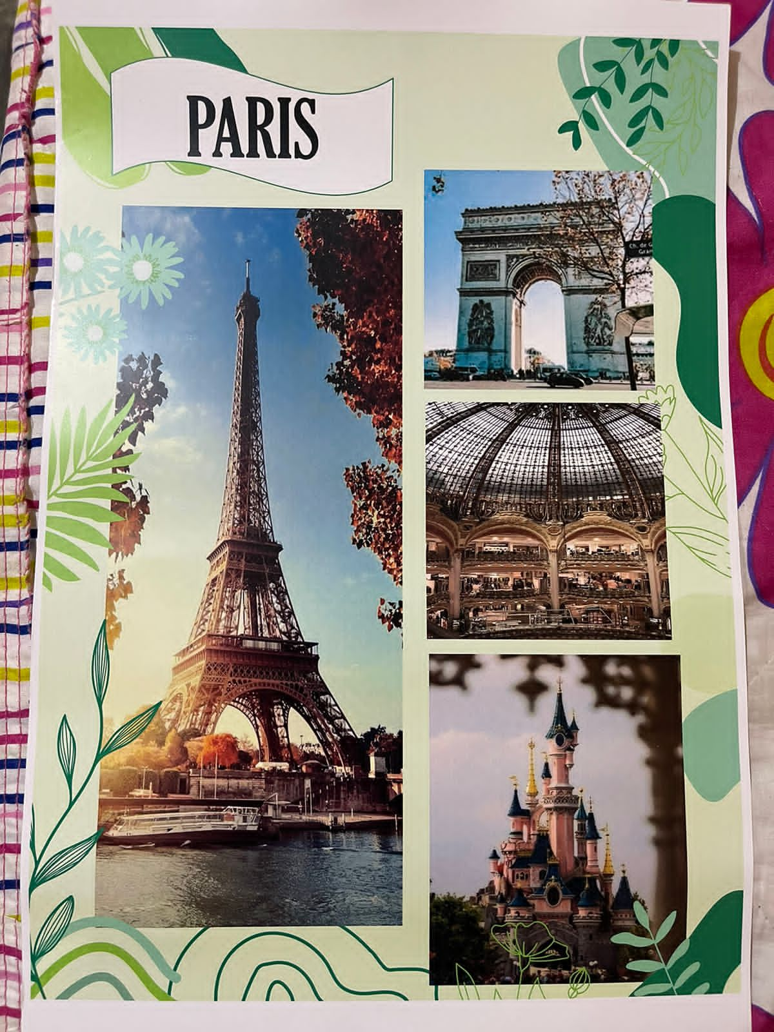

**“Review the next rubric”**

|  |  |  |  |  |
| --- | --- | --- | --- | --- |
| Category | Unsatisfactory 2 | Satisfactory 3 | Proficient 4 | Excellent 5 |
| On time | Doesn’t deliver the project | Deliver the project out of time. | Deliver the project out of time but show a formal excuse. | Deliver the project on time |
| Creativity | Not creative or original | It is creative and original enough | It is quite creative and original | It is very creative and original |
| Contents | Insufficient or improper contents.  Doesn’t show evidence of knowledge. | Show evidence of knowledge. Enough contents. | Enough contents  Show mastery of knowledge. | Outstanding content  Show excellent knowledge. |
| Presentation | Information and ideas are poorly sequenced (the author jumps around). | Information and ideas are presented in an order that the audience can follow with minimum difficulty. | Information and ideas are presented in a logical sequence which is followed by the reader with little or no difficulty. | Information and ideas are presented in a logical sequence which flows naturally and is engaging to the audience. |