**Escuela Normal de Educación Preescolar**

Lic. En educación Preescolar

**Curso.** Inglés

**Actividad.**

Proyecto

**Profesora. Guadalupe Del Rocío Robledo Corpus**

**Alumna.** Hernández García Regina Neidelyn #9

Ciclo 2023-2024 Saltillo, Coahuila

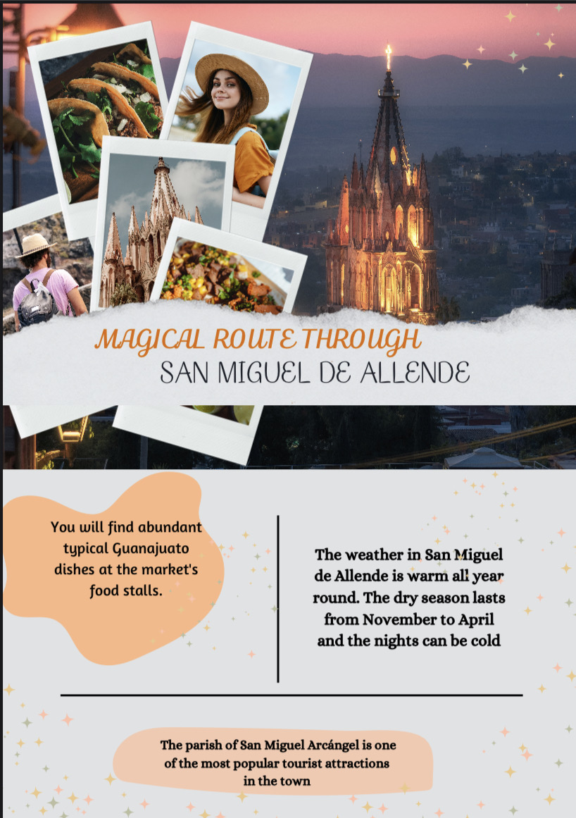

**Project unit 1 It´s a really great place!**

Instructions: Choose one place you want to go on vacation. Then answer   
these questions about that place.

What’s it like?

I like it because it is a tourist city, but quiet and romantic

What can you do there?

you should go to the taco market and take a walk through gunajuato

What should you see there?

You should see the city at night, its museums and the church of San Miguel De Arcangel

What’s the weather like?

From April to September they have a warm climate, it is not so hot

What’s the best time of the year to visit the place?

 definitely in summer

What things can you buy?

**you should buy crafts hand-woven shoes, clothes and bags**

Review the next rubric

|  |  |  |  |  |
| --- | --- | --- | --- | --- |
| Category | Unsatisfactory  2 | Satisfactory  3 | Proficient  4 | Excellent  5 |
| On time | Doesn’t deliver the project | Deliver the project out of time. | Deliver the project out of time but show a formal excuse. | Deliver the project on time |
| Creativity | Not creative or original | It is creative and original enough | It is quite creative and original | It is very creative and original |
| Contents | Insufficient or improper contents.  Doesn’t show evidence of knowledge. | Show evidence of knowledge.Enough contents. | Enough contents  Show mastery of knowledge. | Outstanding content  Show excellent knowledge. |
| Presentation | Information and ideas are poorly sequenced (the author jumps around). | Information and ideas are presented in an order that the audience can follow with minimum difficulty. | Information and ideas are presented in a logical sequence which is followed by the reader with little or no difficulty. | Information and ideas are presented in a logical sequence which flows naturally and is |