SCHOOL: ESCUELA NORMAL DE EDUCACIÓN PREESCOLAR

COURSE: BUILDING CONFIDENCE IN COMMUNICATION

TEACHER: GUADALUPE DEL ROCIO ROBLEDO CORPUS

PROJECT UNIT 1 IT´S A REALLY GREAT PLACE!

STUDENT: MELINA MARYVI MEDINA ROCHA

Instructions: Choose one place you want to go on vacation. Then answer   
these questions about that place.

|  |  |
| --- | --- |
| What’s it like? | Cancun is a city bordering the Caribbean Sea and is known for its beaches, numerous resorts and nightlife. |
| What can you do there? | Relax on the Beaches of Cancun  Visit Chitzen Itza  Get to know Cancun city.  Arrive by boat to Isla Mujeres and Isla Contoy  Tour the Hotel Zone  Visit the Ruins of Tulum  Take a bath in a cenote. |
| What should you see there? | You shouldn’t miss visit Chichen itza  It is one of the main Mayan archaeological sites of the Yucatan Peninsula, in Mexico |
| What’s the weather like? | Sub humid climate |
| What’s the best time of the year to visit the place? | Cancun is also a popular destination for students during the spring college break period.  February and March are good months to come to Cancun. With the exception of the days of Easter, when the “spring-breakers” from the United States come in masse to Cancun, prices are not so high and the weather remains ideal (not too hot, nor rain, nor the probability of hurricanes). |
| What things can you buy? | Clothing and beach items.  Underwear.  Shoes.  Bags.  Accessories.  Jewelry. |

Make a poster to advertise the place. Use photos or draw pictures to explain what you can do there.

Double sheet size, you can use sheet of paper, cardboard, magazines or and others materials.

You can make it using the computer and then printed, or it can be handmade.

You have to send the activity by school online, create a document, with the cover, the rubric, and the picture of your poster. Then present the poster the next Thursday September 28th

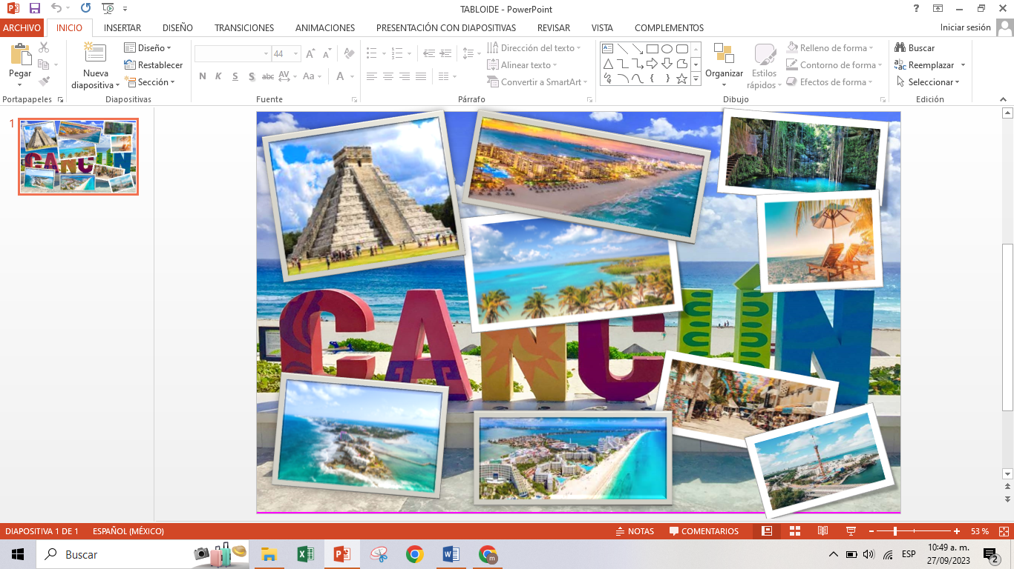

Review the next rubric

|  |  |  |  |  |
| --- | --- | --- | --- | --- |
| Category | Unsatisfactory 2 | Satisfactory 3 | Proficient 4 | Excellent 5 |
| On time | Doesn’t deliver the project | Deliver the project out of time. | Deliver the project out of time but show a formal excuse. | Deliver the project on time |
| Creativity | Not creative or original | It is creative and original enough | It is quite creative and original | It is very creative and original |
| Contents | Insufficient or improper contents.  Doesn’t show evidence of knowledge. | Show evidence of knowledge. Enough contents. | Enough contents  Show mastery of knowledge. | Outstanding content  Show excellent knowledge. |
| Presentation | Information and ideas are poorly sequenced (the author jumps around). | Information and ideas are presented in an order that the audience can follow with minimum difficulty. | Information and ideas are presented in a logical sequence which is followed by the reader with little or no difficulty. | Information and ideas are presented in a logical sequence which flows naturally and is engaging to the audience. |