SCHOOL: ESCUELA NORMAL DE EDUCACION PREESCOLAR |  | MAJOR-. LICENCIATURA EN EDUCACION PREESCOLAR
COURSE: STARTING BASIC COMMUNICATIONS | TERM: AUGUST 2023 -JANUARY 2024 |  | CLASS TIME HOURS / WEEK: 4
TEACHER: MARIA ELENA MEZA AGUADO |  | DATE: AUGUST 2023 JANUARY 2024
Purpose: to plan the content, the sessions and the dates for the development of the learning units of the course.
Instructions: complete the following chart with the appropriate information based on the course syllabus and considering the institutional calendar.
LEARNING UNIT (NUMBER AND NAME) | CONTENT | LEARNING OUTCOMES |  | NUMBER OF SESSIONS | DATE
Make up assignments  (for levelling) | Games to review prior knowledge. | Oral production |  | 1 | Aug 28th- Sept 1st
 | Diagnostic test (Cambridge language assessment)  https://www.cambridgeenglish.org/test-your-english/for-schools/ | test
 | Course presentation: purpose and contents | Course purpose and contents awareness |  | 1
 | Framework presentation | Course classroom coexisting rules and assessment criteria awareness.  Students’ assessment criteria agreement signature
LEARNING EVIDENCE(S):
Notetaking in the English notebook, assessment criteria format signed in Escuela en Red, diagnostic test participation.
PRESENTATION OF THE COURSE AND COURSE FRAMEWORK
LEARNING UNIT 1  Book unit 1  What’s your name? | Vocabulary: alphabet; greetings and leave- takings; names and titles of address; numbers 0 0–10, phone numbers, and email address.  Grammar: possessive adjectives my, your, his, her; the verb be; affirmative statements and contractions.  Speaking: introducing oneself and friends; saying hello and good-bye; asking for names and phone numbers.  Pronunciation/Listening: linked sounds, listening for the spelling of names, phone numbers, and email addresses.  Writing/Reading: writing a list of names, phone numbers, and email addresses. | - Saying hello and make introductions using my, your, his, and her  - Saying good-bye and exchange contact information using subject pronouns and the verb be  - Checking and confirming information  - Getting someone’s attention  - Thanking someone  - Expressing surprise  - Apologizing  - Giving an opinion | 3 |  | Sept. 4th - Sept. 15th
 | LEARNING EVIDENCE:  “Personal information cards “. Introduce themselves and ask questions using the personal card Ss created. |  | 1 |  | Sept 11th –  Sept 15th
LEARNING UNIT 1  Book unit 2  Where are my keys? | Vocabulary: possessions, classroom objects, personal items, and locations in a room.  Grammar: articles a, an, and the; this/these, it/they; plurals; yes/no and where questions with be; prepositions of place: in, in front of, behind, on, next to, and under.  Speaking: naming objects; asking for and giving the locations of objects.  Pronunciation/Listening: plural -s endings, listening for the locations of objects.  Writing/Reading: writing the location of objects. | - Identifying and discuss personal and classroom objects using the articles a/an, plurals, this/these, and it/they.  - Discussing the location of items using yes/no and where questions with be, the article the, and prepositions of place.  - Identifying the owner of something  - Thanking someone  - Expressing pleasure, disbelief and disappointment  - Thinking before responding  - Agreeing  Realizing something | 5 |  | Sept 18th –  Oct 6th
 | LEARNING EVIDENCE:  “My favorite things”. Create a book cover with drawings, pictures and photos of the favorite things. |  | 1 |  | Oct 2nd –  Oct 6th
LEARNING UNIT 2  Book unit 3  Where are you from? | Vocabulary: cities and countries; adjectives of personality and appearance; numbers 11–103 and ages.  Grammar: the verb be: affirmative and negative statements, yes/no questions, short answers, and Wh- questions.  Speaking: talking about cities and countries; asking for and giving information about place of origin, nationality, first language, and age; describing people.  Pronunciation/listening: syllable stress; Listening for countries, cities, and languages; listening to descriptions of people.  Reading and Writing: writing questions; requesting personal information. | - Discussing cities, countries, nationalities, and languages using yes/no questions with be.  - Discussing people´s appearances, personalities, and ages using Wh-questions with be.  - Getting someone’s attention  - Introducing a different topic and an explanation or idea  - Expressing surprise | 6 |  | Oct 16th –  Nov 10th
 | LEARNING EVIDENCE:  “Where are you from?”. A map and the partner’s picture to describe a hometown and the people in the photo. |  | 2 |  | Nov 6th – Nov 10th
LEARNING UNIT 3  Book unit 4  Is this coat yours? | Vocabulary: Clothing, colors, weather and seasons.  Grammar: Possessives: adjectives our and their, pronouns, names, and whose; present continuous statements and yes/no questions; conjunctions and, but, and so; placement of adjectives before nouns.  Speaking: asking about and describing clothing and colors; talking about the weather and seasons; finding the owners of objects.  Pronunciation/listening: Words with s and sh, listening for clothing and colors; listening about the weather and seasons.  Reading and writing: Writing questions; asking about clothing. | - Discussing work and free-time clothes and colors using possessive adjectives, possessive pronouns, and possessives with names.  - Discussing the weather and what people are wearing using the present continuous and conjunctions  - Talking about preferences  - Making a contrast and a suggestion  - Getting someone’s attention  - Asking about a problem  - Expressing distress and pleasure  - Agreeing with a suggestion |  | 4 | Nov 27th – Dec 1st  Dec 11th – 15th
 | LEARNING EVIDENCE:  “Fashion Show”. Perform your fashion show. Describe the clothes and colors the models wear. |  |  | 2 | Jan 8th – Jan 12th
INTEGRATIVE EVIDENCE  Units 1-4 |  |  |  | 2 | Jan 15th – Jan 19th
OBSERVATIONS:

TEACHER’S NAME AND SIGNATURE | ASSESSOR’S NAME AND SIGNATURE |  | ACADEMIC VICE-PRINCIPAL NAME AND SIGNATURE |  | DATE
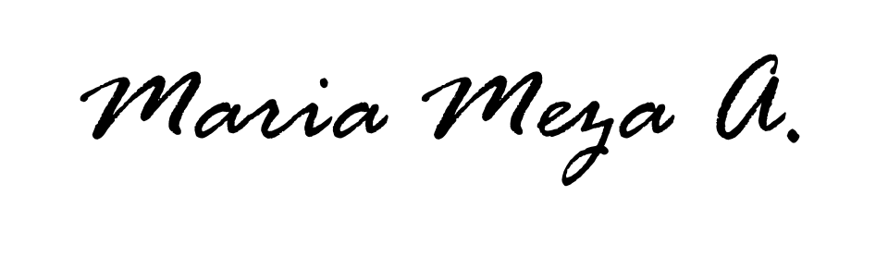 |  |  | Alina Lorena Arriola González. |  | 15/08/2023

Note: the number of sessions and date was based on the ENEP calendar

