LEVEL B1.1 Teacher: Maria Elena Meza Aguado

**UNIT 1 Sure! I’ll do it.**

**PROJECT:** “Pet Peeves”.

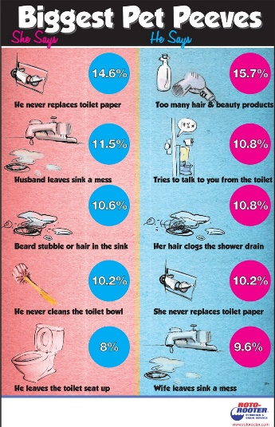**AIM:** Give students practice making complaints, using two-part verbs to make and respond to requests using modals and *would you mind…?*

**LEARNING INDICATORS:** The student can…

* Discuss common complaints.
* Make and respond to requests.
* Apologize and give excuses

|  |
| --- |
| **PRODUCT 1.** |

“What is a pet peeve?” *something that really annoys you*.

People can complain about: *friends, family, school, teachers, neighbors, traffic, cell phones, computers, etc*.

**GROUPS OF 4 PEOPLE.** Choose a category and complete the survey question below. As a group, asks 80 people the same question. Make sure to write their answers.

Start with this question:

*What is your biggest complaint about _____________________?*

***PRESENT******(Friday, September 27th, 2019)***

Compile the results in class, check the grammar and spelling. Then, put the answers in a list on a Word file, from most common to least common. Up load it in the project Unit 2 activity, in Escuela en Red.

Writing will be graded as:

|  |  |  |  |  |  |
| --- | --- | --- | --- | --- | --- |
| Did the student apply the new functions? | 0 | .5 | 1 | 1.5 | 2 |
| Did the student apply the new structures? | 0 | .5 | 1 | 1.5 | 2 |
| Did the student apply the new vocabulary? | 0 | .5 | 1 | 1.5 | 2 |
| The written work is neat, and understandable? | 0 | .5 | 1 | 1.5 | 2 |
| Does it contain the required elements? | 0 | .5 | 1 | 1.5 | 2 |
| total |  | | | | |
| General Comments | | | | | |
| Suggestions for improvement | | | | | |

|  |
| --- |
| **PRODUCT 2.** |

PAIR WORK. Imagine you are going to go on vacation. Make a conversation where you ask and answer questions about each other’s vacation plans. Use the example conversation in your book’s unit’s 1-2 progress check page, activity 2 DISCUSSION as a model.

PAIR WORK. Make four conversations. See the pictures in your book Progress check pages and make requests. Your partner responds by agreeing or refusing/objecting or to your request and giving an excuse. Use the expressions in the box and the vocabulary in the language summary unit 6. **You cannot repeat words within your four conversations**. Prepare to role-play without your notes.

|  |  |  |
| --- | --- | --- |
| * *Can you . . . ?* * *Could you . . . ?* * *Would you please . . . ?* * *Would you mind . . . ?* |  | |
| **Example:**  *A: Could you please turn down the music?*  *I’m trying to study.*  *B: Of course.*  *I didn’t realize it was so loud.* | | Request  Follow-up statement  Agreement/objection  Excuse |

**PRESENT** **(Friday, September 27th, 2019)**

Speaking will be graded as:

|  |  |  |  |  |  |
| --- | --- | --- | --- | --- | --- |
| Did the student apply the new functions? | 0 | .5 | 1 | 1.5 | 2 |
| Did the student apply the new vocabulary? | 0 | .5 | 1 | 1.5 | 2 |
| Was the student Fluent? | 0 | .5 | 1 | 1.5 | 2 |
| Was the student’s voice clear? | 0 | .5 | 1 | 1.5 | 2 |
| Did the student apply the new structures? | 0 | .5 | 1 | 1.5 | 2 |
| total |  | | | | |
| General Comments | | | | | |
| Suggestions for improvement | | | | | |