LEVEL B1.1 Teacher: Maria Elena Meza Aguado

**UNIT 3. What do I use this for?**

**PROJECT: “I HATE CLEANING!**

Student’s Name: __________________________________________Date___________________

|  |  |  |
| --- | --- | --- |
| **Aims**: Give students practice using infinitives and gerunds, and imperatives and infinitives. | | |
| **Learning indicators**: | Students can | * Describe uses and purposes of objects * Give instructions and suggestions |

|  |
| --- |
| **PRODUCT 1. Speaking** |

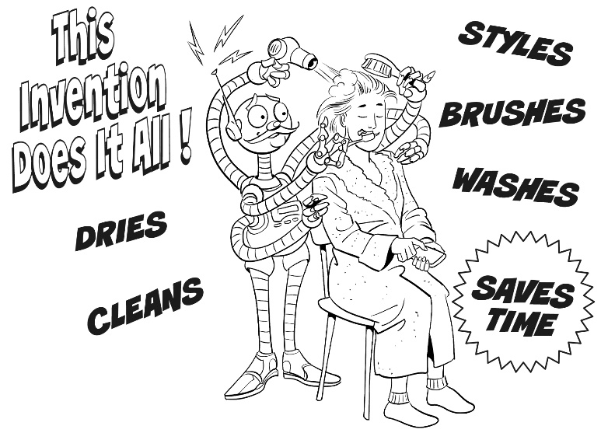**Plan**

What are some chores that you hate to do?

Example: wash the laundry

**Prepare**

In teams of two or three people, choose a chore that you dislike and **design an invention** to do it for you. Then make an advertisement. Be sure to **draw a picture of your invention and list its features. You may do it on paper or on the computer. Either way you must bring your image on paper and present it orally.**

**Present (Wednesday October 30th, 19’)**

CLASS ACTIVITY. Share your invention with the class. **Explain how it works and what it can be used for. Use gerunds and infinitives.**

Example: My robot works with solar energy. I has a remote control. I can be used for…

Speaking will be graded as:

|  |  |  |  |  |  |
| --- | --- | --- | --- | --- | --- |
| Did the student apply the new functions? | 0 | .5 | 1 | 1.5 | 2 |
| Did the student apply the new vocabulary? | 0 | .5 | 1 | 1.5 | 2 |
| Was the student Fluent? | 0 | .5 | 1 | 1.5 | 2 |
| Was the student’s voice clear? | 0 | .5 | 1 | 1.5 | 2 |
| Did the student apply the new structures? | 0 | .5 | 1 | 1.5 | 2 |
| total |  | | | | |
| General Comments | | | | | |
| Suggestions for improvement | | | | | |

|  |
| --- |
| **PRODUCT 2. Writing** |

**NOTE WITH INSTRUCTIONS AND ADVICE**

Louisa is going to take care of Emma’s house while Emma is on vacation. Read Emma's note.   
How does she organize the information? Think.

|  |
| --- |
| *Louisa,*  *Thanks for offering to house-sit for me while I’m on vacation! Here are a few things to remember.*  *1. Make sure to feed the goldfish every morning. The food is in a small blue box on top of the refrigerator.*  *2. Remember to leave the keys with the neighbor on Wednesday. My brother is going to fix my printer.*  *3. Don’t forget to water the plants every day.*  *4. Be sure to shop at the supermarket on Main Street. The smaller stores are very expensive.*  *Thanks again!*  *Emma* |

**ACTIVITY. Individual work.** Imagine a friend is going to house-sit for you while you’re on vacation. What does your friend need to know about your house or apartment and the neighborhood? **Write a note** to your friend with **10 instructions and advice. You may include pictures.** **Write it at the end of this word file. Upload it in the Activity**. Use your chart and Emma’s note as a model. **Use imperatives and infinitives.**

**Present (Wednesday, October 30th, 19’)**

Writing will be graded as:

|  |  |  |  |  |  |
| --- | --- | --- | --- | --- | --- |
| Did the student apply the new functions? | 0 | .5 | 1 | 1.5 | 2 |
| Did the student apply the new structures? | 0 | .5 | 1 | 1.5 | 2 |
| Did the student apply the new vocabulary? | 0 | .5 | 1 | 1.5 | 2 |
| The written work is neat, and understandable? | 0 | .5 | 1 | 1.5 | 2 |
| Does it contain the required elements? | 0 | .5 | 1 | 1.5 | 2 |
| total |  | | | | |
| General Comments | | | | | |
| Suggestions for improvement | | | | | |