English guide

Unit 2 quiz

Book units 8 & 9

**Study the following vocabulary:**

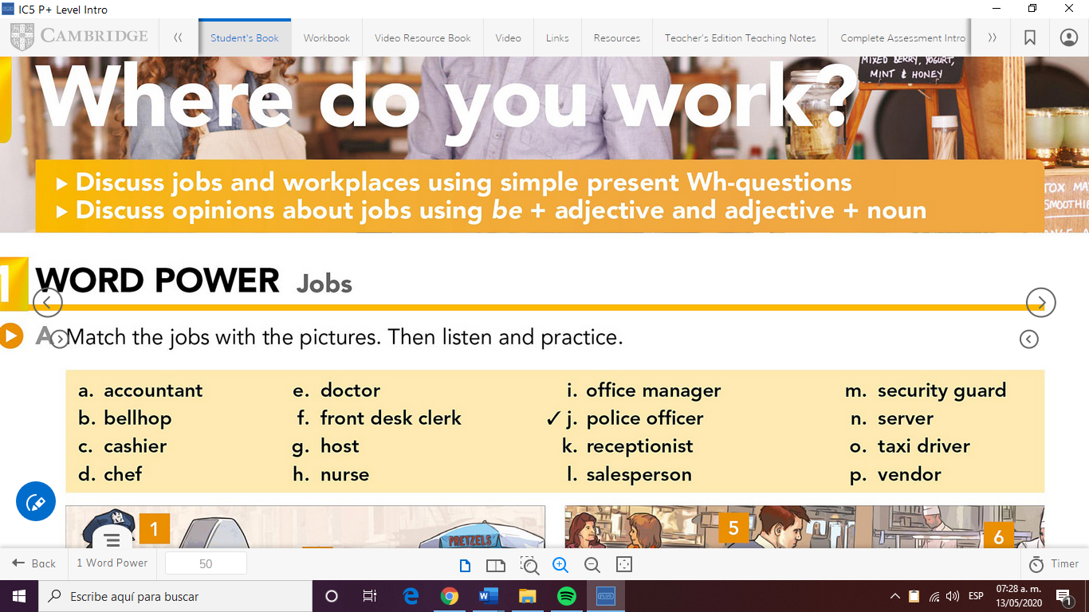**Jobs and places**

**PLACES: hospital, store, hotel, office, street**

**check THIRD PERSON ‘S : **

EXAMPLE: A nurse works in a hospital.

A police officer wears a uniform.

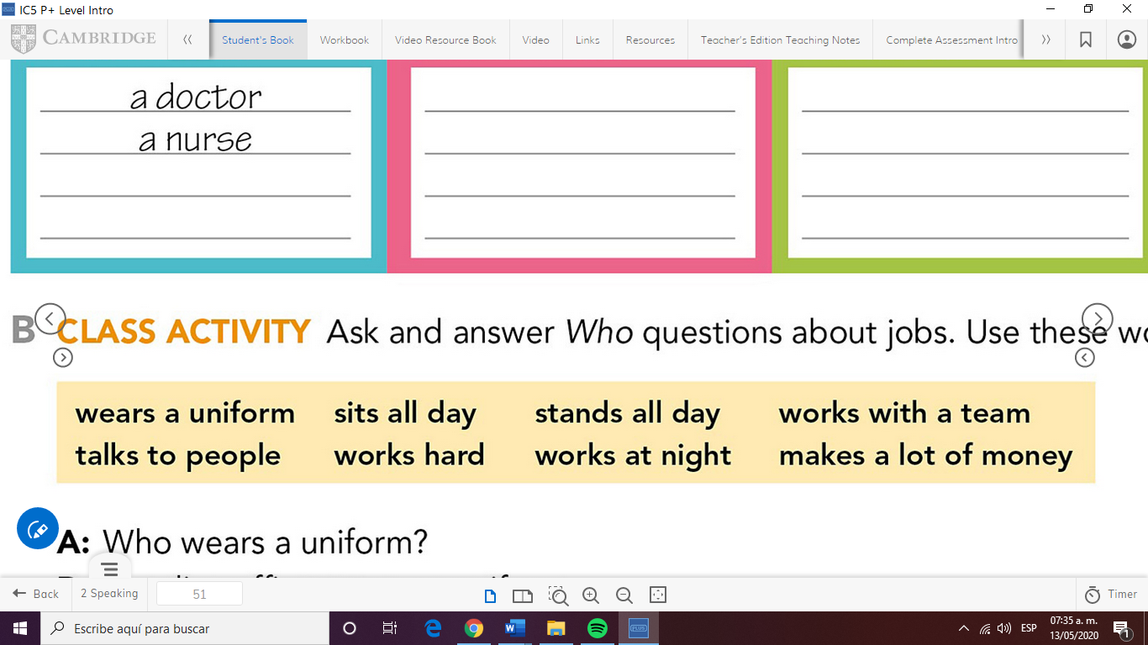

**Check WH-questions with DO/DOES**

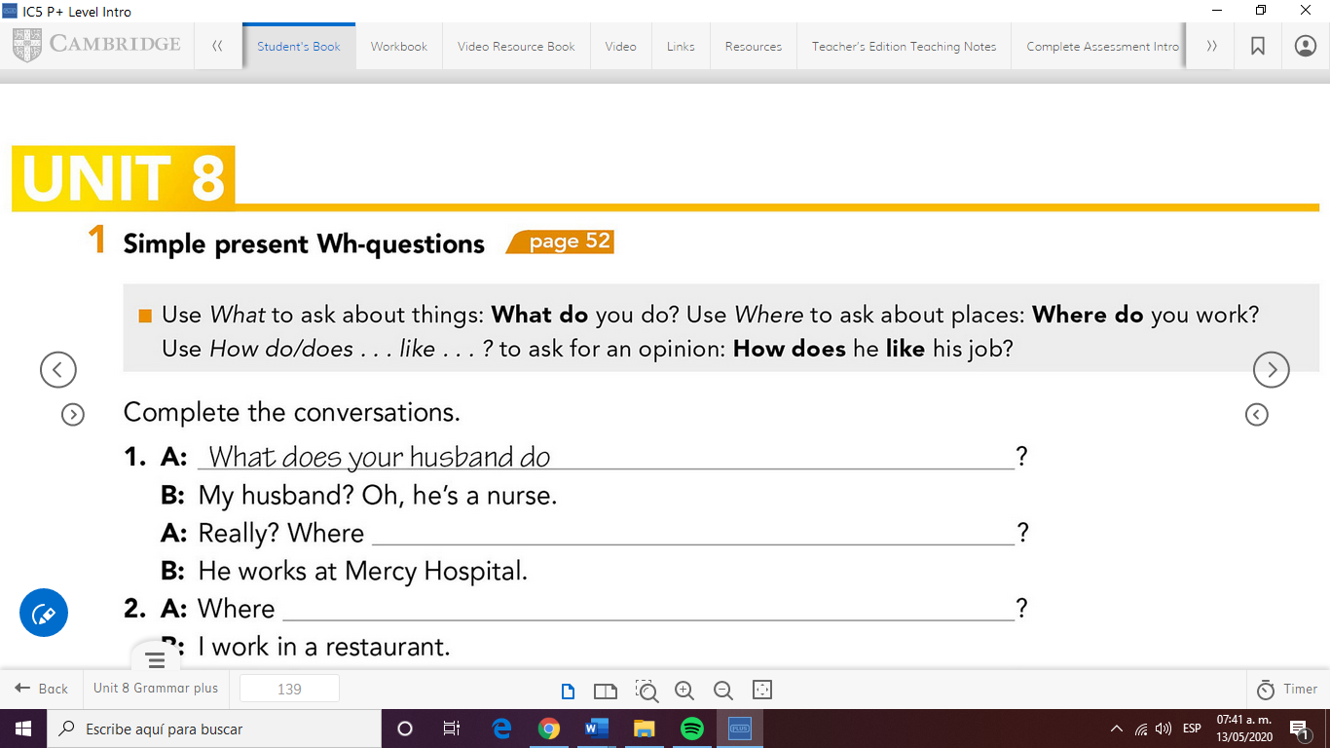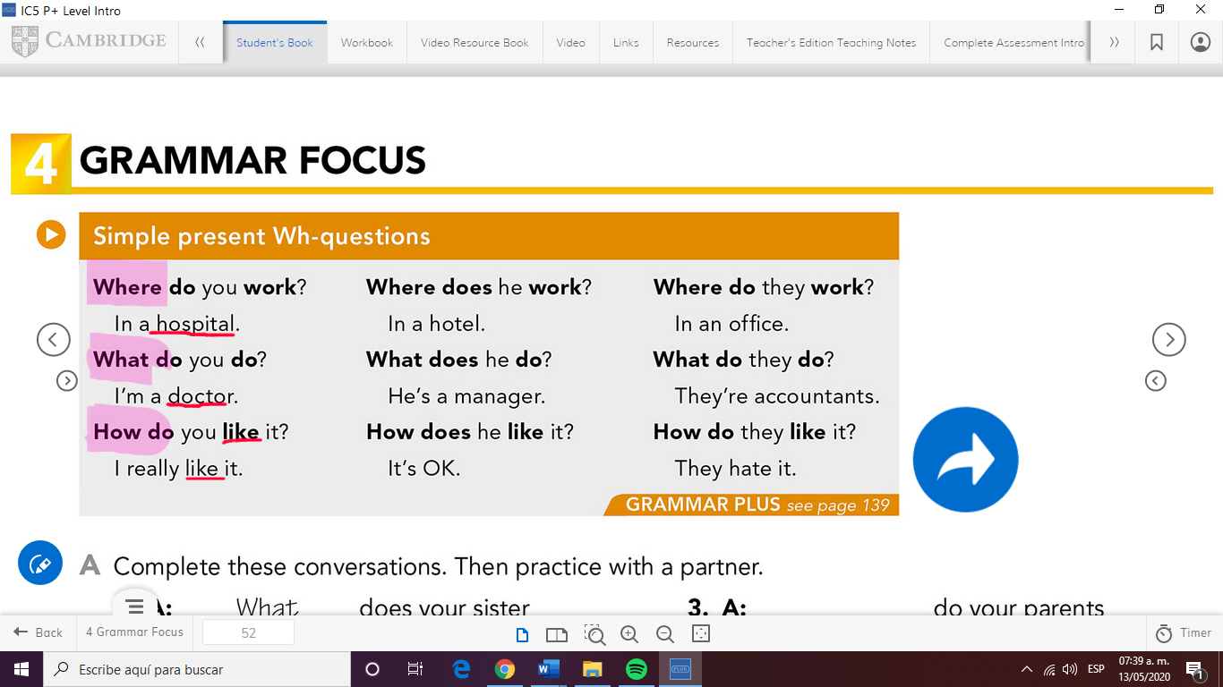

EXAMPLES:

Where does your sister work?

Remember the changes in the verb when we use DOES

She works in a hotel.



**Check the placement of ADJECTIVES to describe jobs:**

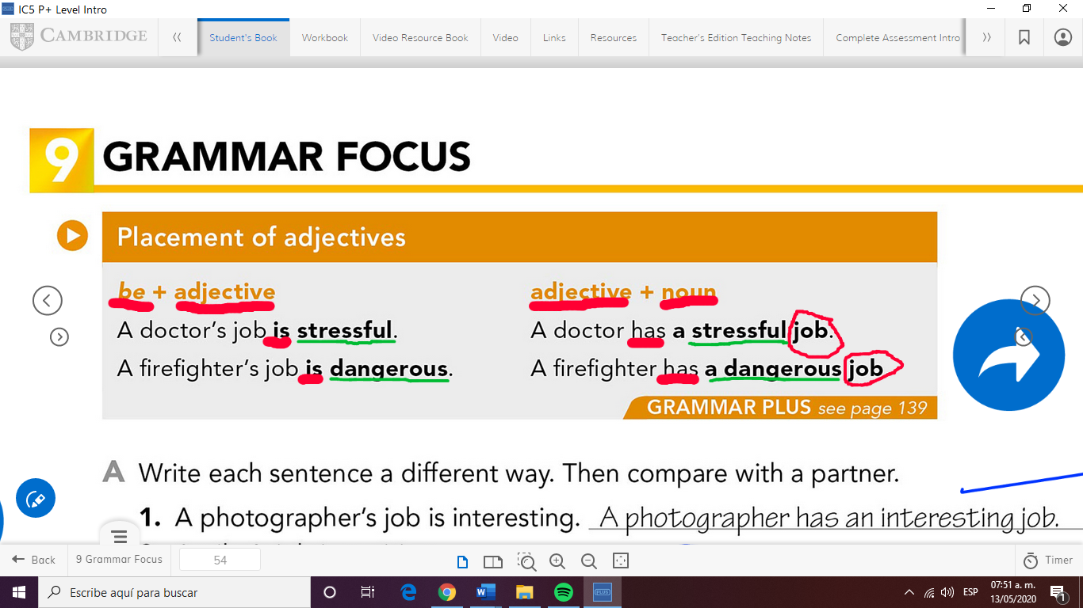

**Study FOOD vocabulary (book unit 9)**



**Check count and noncount nouns:**

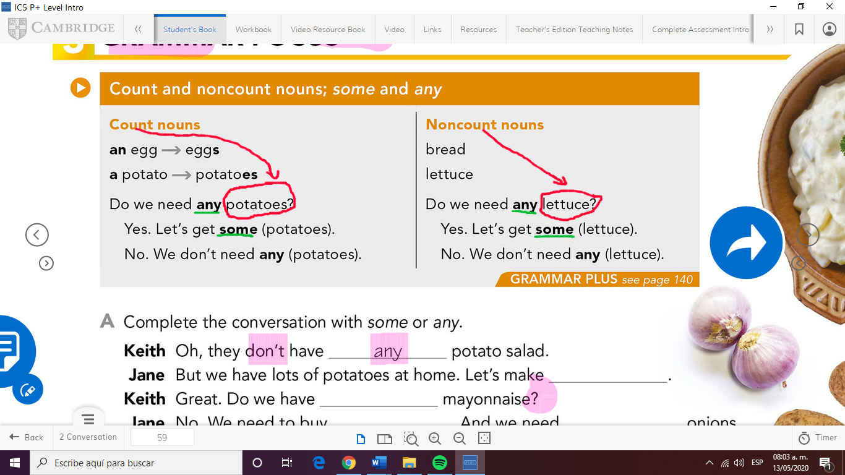

Remember: COUNT NOUNS take S in the plural form

Apple=apples / banana=bananas





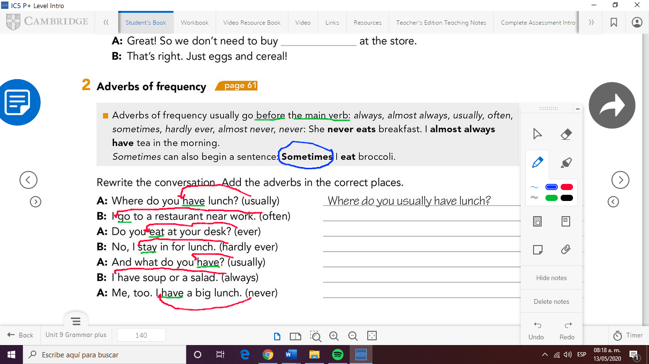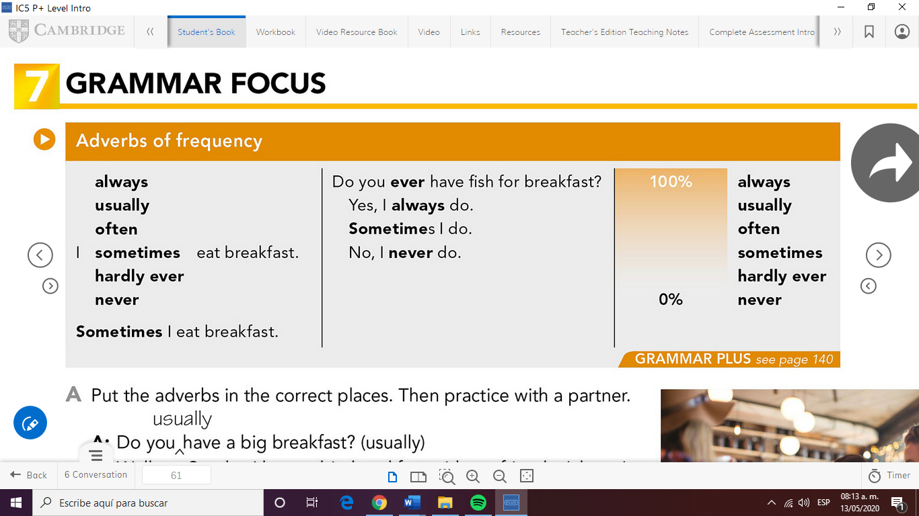**Check ADVERBS OF FREQUENCY :**

**EXAMPLES:**

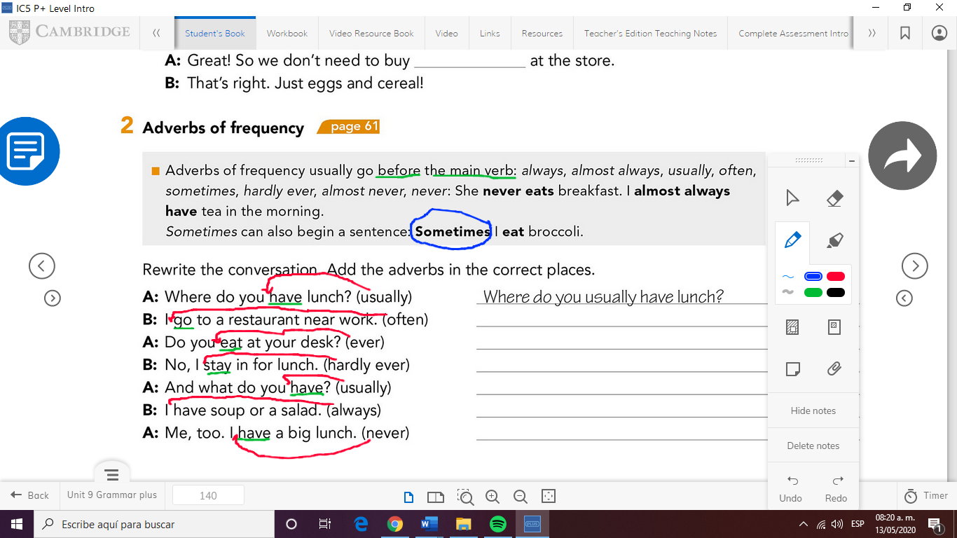

**GOOD LUCK!!**