**ESCUELA NORMAL DE EDUCACIÓN PREESCOLAR**

**ENGLISH B1.1.2**

**UNIT 8 – PRESENT PERFECT VS. PRESENT PERFECT CONTINUOUS**

**DURING THIS UNIT YOU WILL LEARN HOW TO USE THE PRESENT PERFECT AND THE PRESENT PERFECT CONTINUOUS TO TALK ABOUT YOUR EXPERIENCES AND YOUR CURRENT SITUATION.**

**ACTIVITY 1 – PRESENT PERFECT – READING PRACTICE**

* Circle the verbs in present perfect (have/has + verb in past participle)
* Read the conversation and answer the questions using the present perfect tense.

**This present perfect reading comprehension exercise is a story about two people doing job interviews.**

Bob and Darren work together. They are talking about interviews for a new sales manager position at their company.

**Bob:** We need to make a decision on who we are going to hire for the new salesperson position.

**Darren:** I know. There are a lot of good applicants. So far we have interviewed 10 people and have looked at over 50 resumes.

**Bob:** Well, let’s take a look at some of the best and make a decision.

**Darren:** OK, the first person is Phil. He has worked as a salesperson for 10 years in both The United States and Canada. Also, he has been the manager of the sales department of a large auto-parts company.

**Bob:**  Sounds interesting, but has he ever worked in the food sales industry?

**Darren:** No he hasn’t.

**Bob:** That might be a problem. We need someone with food experience.

**Darren:** OK, what about Karen? She has worked in the food industry for 6 years. She has been a manager of a major supermarket and worked in marketing for a large meat company.

**Bob:** OK. Has she worked in international sales before?

**Darren**: No, she has never worked in international sales.

**Bob:** Well, that could be a problem. This job will require a lot of international experience. I think we need someone who has worked in an international environment

**Darren:** Well what about Larry? We haven’t met him yet but his resume looks good. He has been a salesperson in the food industry for 13 years. He has worked in The United States, Canada and Mexico. In the past 4 years he has learned to speak Spanish and French.

**Bob:** Wow, sounds great!

**Darren:** The problem is we still haven’t had an interview with him. I have called him many times, but I haven’t been able to reach him.

**Bob:** Well, why don’t you send him an email? Perhaps he will respond that way.

**Darren:** OK, I will try that. I will let you know.

**Bob:** Great, thanks.

* Answer the following questions about the conversation. Write complete sentences using the present perfect tense.

Example: How many people have they interviewed?

*They have interviewed ten people.*

1. Who has worked in the food industry?
2. Who have they not met?
3. Who has learned to speak French?
4. Who have worked in different countries?
5. Why haven’t they interviewed Larry?

**ACTIVITY 2 – PRESENT PERFECT – LISTENING PRACTICE**

* Go to <https://avi.cuaed.unam.mx/repositorio/moodle/pluginfile.php/3579/mod_resource/content/9/contenido/index.html> , read the information and examples to use the present perfect tense.
* Complete exercises 5 and 6 (for/since and listening)
* Take a screenshot of your results and paste them here.

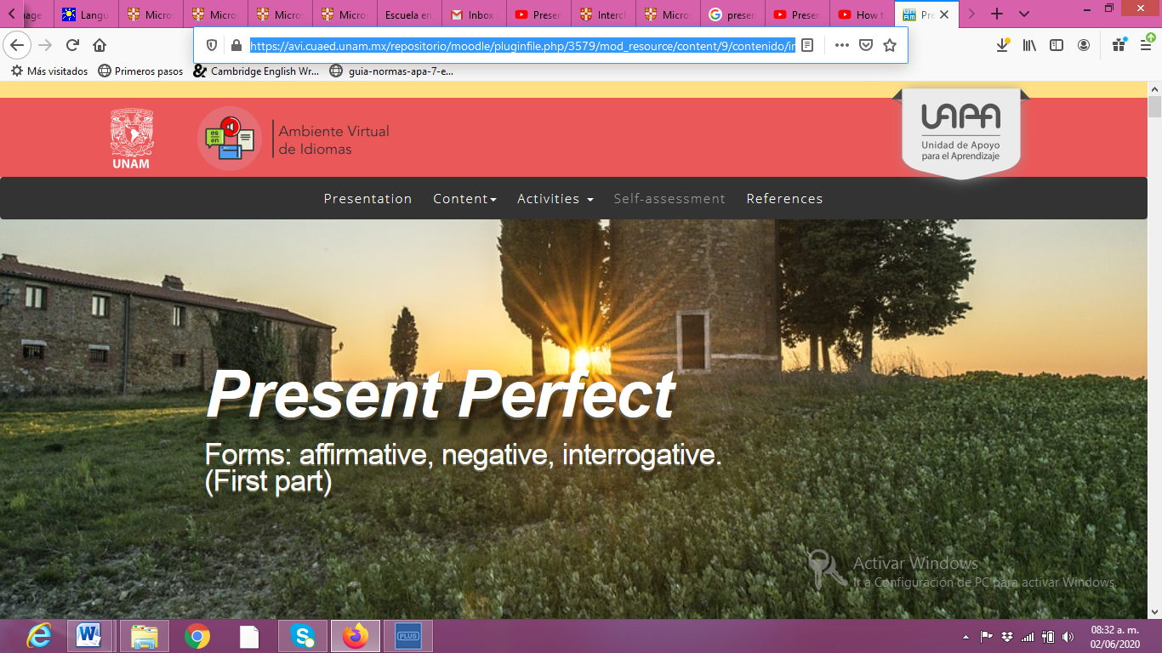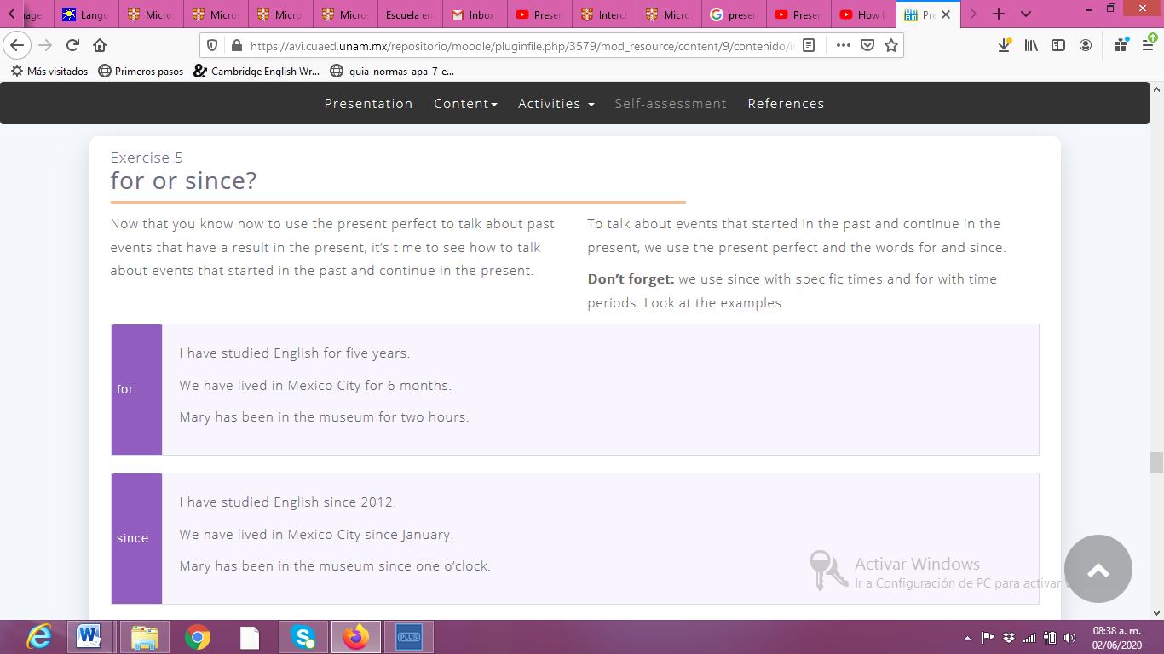

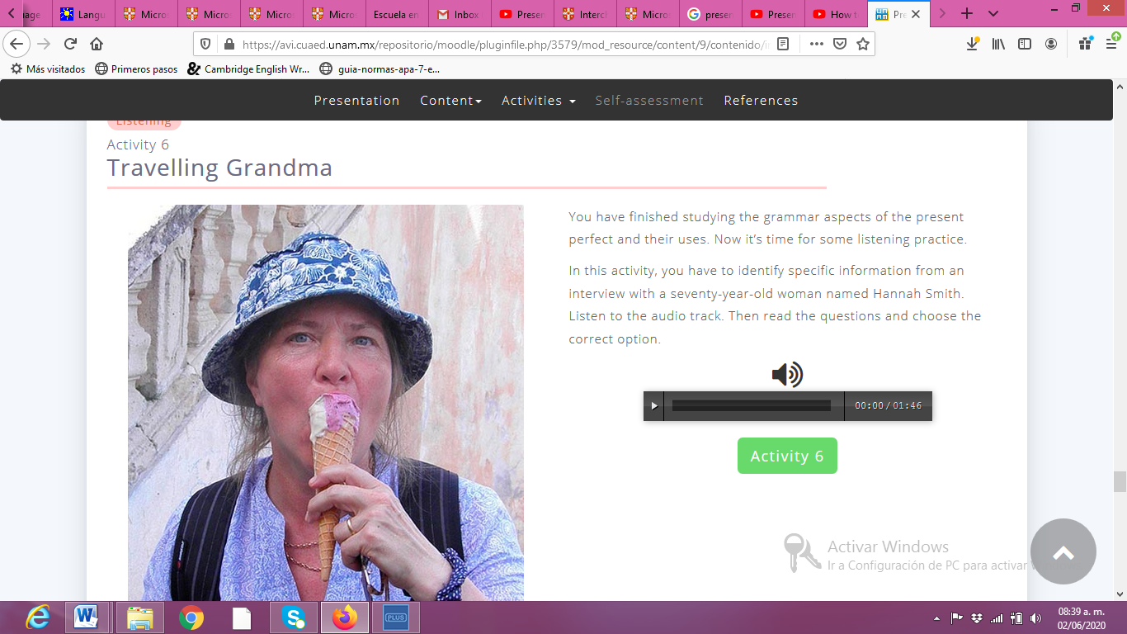

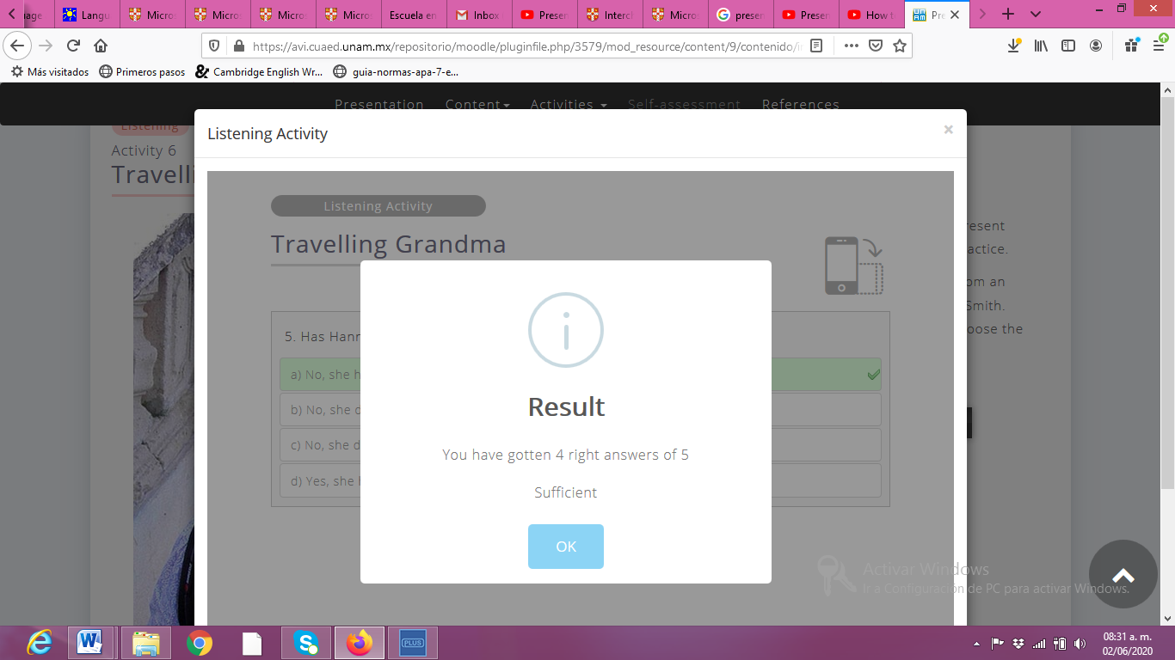

**ACTIVITY 3 – PRESENT PERFECT – WRITING PRACTICE**

* Look at the example, analyze the structure for questions and complete the activity.

**Let’s talk about you!**

**Put the words in order to form questions. Then answer the questions with your own information.**

|  |  |  |
| --- | --- | --- |
| **Example** | **Words:** | eaten ever you Mexican Have food ? |
| **Question:** | Have you ever eaten Mexican food? |
| **Your answer:** | *Yes, I have. I ate tacos last week.* |

|  |  |  |
| --- | --- | --- |
| **1** | **Words:** | you Have another country ever visited ? |
| **Question:** |  |
| **Your answer:** |  |

|  |  |  |
| --- | --- | --- |
| **2** | **Words:** | by plane you traveled ever Have ? |
| **Question:** |  |
| **Your answer:** |  |

|  |  |  |
| --- | --- | --- |
| **3** | **Words:** | live ever your family Has in a foreign country ? |
| **Question:** |  |
| **Your answer:** |  |

|  |  |  |
| --- | --- | --- |
| **4** | **Words:** | to Africa Have ever you been ? |
| **Question:** |  |
| **Your answer:** |  |

|  |  |  |
| --- | --- | --- |
| **5** | **Words:** | you What’s tasted have ever food the most delicious ? |
| **Question:** |  |
| **Your answer:** |  |

|  |  |  |
| --- | --- | --- |
| **6** | **Words:** | ever horseback riding Have been you ? |
| **Question:** |  |
| **Your answer:** |  |

|  |  |  |
| --- | --- | --- |
| **7** | **Words:** | your best friend Has another country visited ever ? |
| **Question:** |  |
| **Your answer:** |  |

|  |  |  |
| --- | --- | --- |
| **8** | **Words:** | ever you and your family have spent a holiday in the US ? |
| **Question:** |  |
| **Your answer:** |  |

|  |  |  |
| --- | --- | --- |
| **9** | **Words:** | cooked Have Chinese food ever you for dinner ? |
| **Question:** |  |
| **Your answer:** |  |

|  |  |  |
| --- | --- | --- |
| **10** | **Words:** | made friends you from another country ever Have ? |
| **Question:** |  |
| **Your answer:** |  |

**ACTIVITY 4**

Complete the sentences and questions using the present perfect tense.

Example:

We *haven’t gone* (not/go) to school in the last two months.

1. The coronavirus __________ (change) the way people interact.
2. Online shopping __________ (become) the safest way to buy things lately.
3. I __________ (not/ do) my English homework yet.
4. _______ you _________ (see) your friends lately?
5. _______ your mother _______ (drink) coffee this morning?

**ACTIVITY 5**

Answer the following questions about you. Use the present perfect in your answers. Check the example.

Example:

**How many countries have you traveled to?** *I have traveled to three different countries.*

1. What interesting food have you eaten?
2. What famous person have you seen?
3. Where have you lived?
4. What languages have you studied?
5. What dangerous things have you done?
6. How much money have you spent today?
7. Have you ever seen a ghost?